Spanish
We believe that learning a foreign language at an early age opens children's minds to language learning and broadens their understanding of grammatical structures. The educational tool used by teachers is Language Angels. Each unit introduces children to the basic vocabulary and scaffolds their learning so their fluency and understanding progresses. Those pupils where Spanish is their native language are also challenged as Language Angels provide opportunities to broaden their Spanish skills. There are also options for the Spanish units to link to themes which are covered in History and Geography e.g. Vikings (Year 5)
 | Autumn 1 | Autumn 2 | Spring 1 | Spring 2 | Summer 1 | Summer 2
Year 1 | 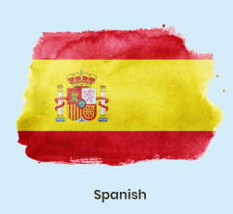 |  | 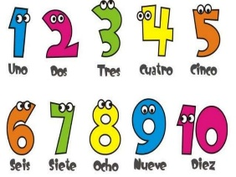 | 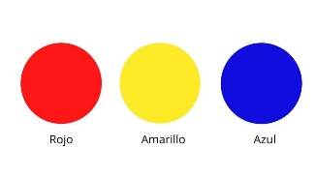 |  | 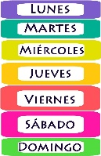
 | Aprendo español –  I am learning Spanish | Hola –  Greetings | Los números –  Numbers | Los colores –  Colours (primary) | las estaciones-  The seasons | Días de la semana- Days of the Week
Year 2 |  | 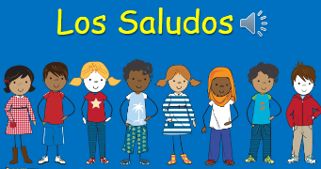 |  | 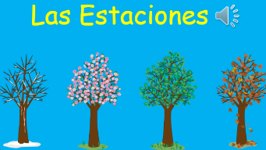 | 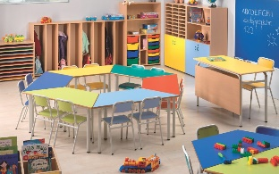
 | Aprendo español –  I am learning Spanish | Los Saludos – Greetings (KS1) | Los números –  Numbers (extended) | Las Estaciones –  The Seasons (KS1) | School equipment –Equipamiento escolar | School Subjects –Materias escolares
Year 3 |  |  | 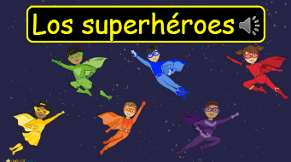 | 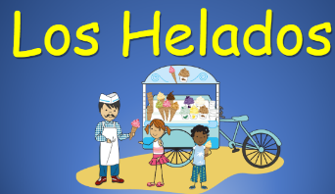 | 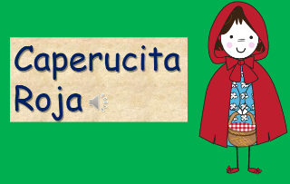 | 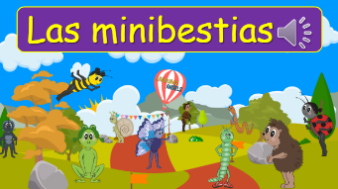
 | Aprendo español –  I am learning Spanish | Los Saludos – Greetings (Ks2) | Los superheroes -The Superheros | Los Helados-  Ice-creams | Little Red Riding Hood –  Caperucita Roja | Las minibestias –  Mini-Beats
Year 4 |  | 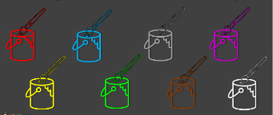 | 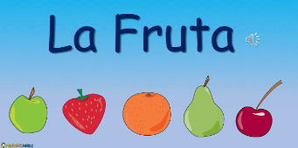 | 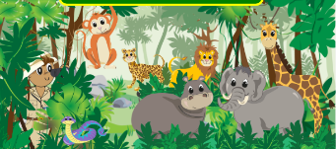 | 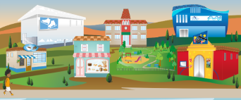
 | Aprendo español –  I am learning Spanish | Los Colores y Los Números -Colours and Numbers | La Fruta –  The Fruits | En la selva –  In the Jungle | En mi pueblo – My Town | Pudeo …I can…
Year 5 |  |  | 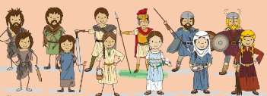 | 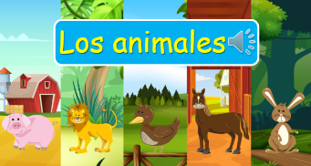 | 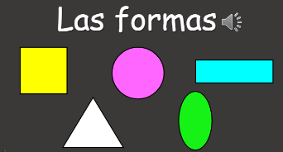 | 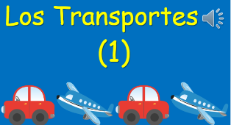
 | Aprendo español –  I am learning Spanish | Las Estaciones –  The Seasons (KS2) | La historia de la Antigua Gran Bretaña –  Great Britain | Los animals –  The Animals | Las Formas – The Shapes | Los Transportes – Transport
Year 6 |  | 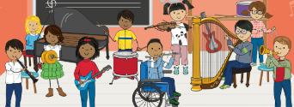 | 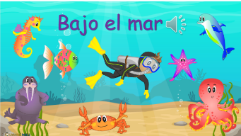 | 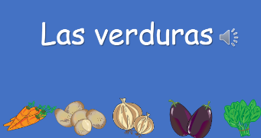
 | Aprendo español –  I am learning Spanish | Los instrumentos -Musical Instruments | Bajo el mar – Under the Sea | Las Verduras – The Vegetables | Las Formas – The Shapes (Extended) | Los Transportes – Transport (exteneded)

