Art and Design Technology
“To be an artist is to believe in life.” Henry Moore
Over time, children develop their skills in the key areas of painting, drawing, modelling, collage and printing for Art and food, textiles, construction, modelling and graphics/CAD (Computer aided design for DT. Teachers are free to teach these at any point in the year so as to best link the products made to the children’s work in History, Geography and Science. Each unit has featured artists/craftspeople that represent our school’s diverse community. The chosen artists use the techniques to be taught within their work. Alongside the skills in these discrete areas children are taught to explore and develop their ideas. They are also required to evaluate their work to see how it can be improved.
 | Art |  |  |  |  |  | Design Technology
 | Drawing |  | Painting |  | Collage |  | Food |  | Construction |  | Graphics/CAD
Year 1 | 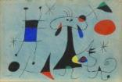  Joan Miro (1893-1983) | 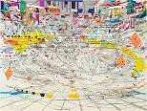  Julie Mehrutu (b.1970) | 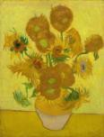  Van Gogh (1853-1890) | 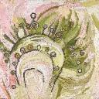  Wawiriya Burton (1920- ) | 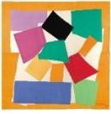  Henri Matisse (1869-1954) | 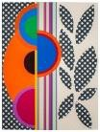  Beatriz Milhazes (1960- ) | Katy: I Can Cook | 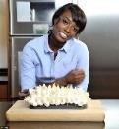  Lorraine Pascale | 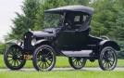  Henry Ford (1863-1947) | Danella Bagnall | 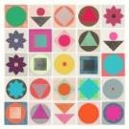  Garima Dharwan | 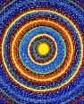  Alma Thomas (1891-1978)
 | We are draughtsmen  - different media  - line, shape, tone and space  - observational drawing  - imaginative drawing |  | We are painters  - secondary colours  - applying paint in different ways  - observational painting of objects, people and places |  | We are collage artists  - arranging pieces  - sorting and grouping materials  - fold, crumple, tear cut & overlap |  | We are cooks  - food vocabulary  - group food  - grate and cut  - measure and weigh  - Baked English Breakfast/ Savoury scones/ Fruit smoothies |  | We are constructors  - vehicles  - construction kits  - axles  - joins  - templates |  | We are graphic designers  - object printing  - repeated pattern  - paint package Computer
 | Drawing |  | Printing |  | Sculpture |  | Food |  | Textiles |  | Modelling
Year 2 | 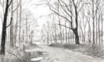  David Hockney (1937-) | Görkem Dikel | Orla Kiely (1963-) | 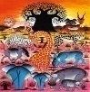  Edward Tingatinga | 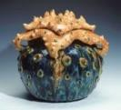  Kate Malone (1959-) | 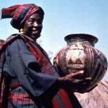  Ladi Kwali (1925-1984) | Sanjeev Kapoor | 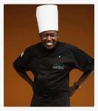  Chef Raphael | 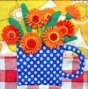  Clare Beaton (1947-) | 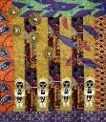  Carolyn Mazloomi (1948- ) | Fiona Watt  (1960 -) | Axel Scheffler  (1957 - )
 | We are draughtsmen  - line, shape, tone, space  - investigate tone  - different pencils  - computer drawing |  | We are printers  - mono printing with a range of materials  - repeating patterns  - simple printing blocks  - press print  - overprinting |  | We are sculptors  - roll, cut, coil, knead  - impressions  - coil and pinch pots  - clay tiles |  | We are cooks  - food vocabulary  - group food  - cut, grate, peel, chop  - measure and weigh  - African Vegetable/ Kelewele stew/Vegetable Biryani/chapatti |  | We are textile designers  - Puppets  - colour fabrics  - templates  - running stitch  - applied decoration |  | We are modellers  - Moving Pictures Sliders and levers  - cut along lines  - strengthen sheet materials  - fold, tear, cut

 | Painting |  | Collage |  | Sculpture |  | Food |  | Construction |  | Graphics/CAD
Year 3 | 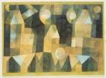  Paul Klee (1879-  1940) | 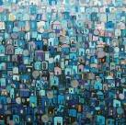  Mikeda Bizuneh | 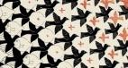  M C Escher (1898-1972) | 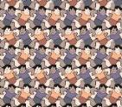  Makoto Nakamura (b.1970) | 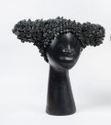  Simone Leigh (1967-) | 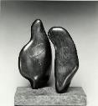  Henry Moore (1898-1986) | Jamie Oliver (1975- | 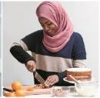  Nadiya Hussain | 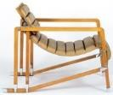  Eileen Gray (1878-1976) | 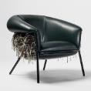  Stephen Burks | 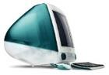  Jonathan Ive  (1967-) | 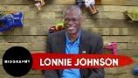  Lonnie Johnson (1978-2012)
 | We are painters  - primary, secondary and tertiary colours  - create tones  - colour wheel  - watercolour  - background washes  - create mood with colour |  | We are collage artists  - cut shapes  - tessellate shapes and patterns  - repeated patterns  - limited palette |  | We are sculptors  - revise clay techniques  - cultural decoration  - model in response to drawing  - observe artefacts  - coil, pinch, join, impress |  | We are cooks  - sensory vocabulary  - analyse taste and appearance  - follow instructions  - balanced diet  - join and combine ingredients  - measure & weigh  - Pizza/Focaccia bread |  | We are constructors  - Photo Frames  - shell & frame structures  - prototypes  - measure & mark to 1cm accuracy  - glue gun  - cut internal shapes |  | We are graphic designers  - Greeting Cards  - internet research  - software design  - create and print design  - repeating pattern
 | Drawing |  | Printing |  | Collage |  | Food |  | Textiles |  | Modelling
Year 4 | 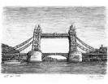  Stephen Wiltshire (1974-) | 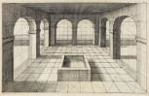  Vredeman de Vries (1527-1607) | 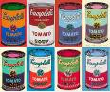  Andy Warhol (1928-1987) | 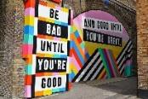  Lakwena Maciver | 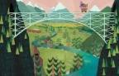  Alice Feagan | 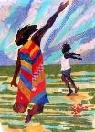  Ekua Holmes (1955- ) | 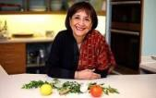  Madhur Jaffrey (1933-) | 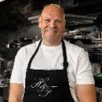  Tom Kerridge | 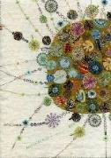  Nancy Nicholson | 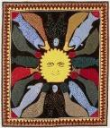  Marion  Tuu’luq  (1910-2002) | 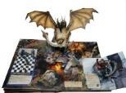  Bruce Foster | 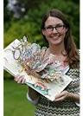  Jennie Maizels
 | We are draughtsmen  - line, shape, tone, depth, shadow  - experimental marks  - sustained drawing  - view finders  - 3D work |  | We are printers  - make own printing block  - 2 colour prints (overlay)  - polystyrene mono printing  - pattern in the past |  | We are collage artists  - explore materials  - curl, pleat, scrumple, overlap  - repeated images  - limited colour palette |  | We are cooks  - sensory vocabulary  - analyse texture and smell  - balanced diet  - join and combine ingredients  - measure & weigh  - Dutch Apple Crumble/Turkish apricot stuff apple bake/Welsh cakes |  | We are textile designers  - Bags/wallets/purses  - seam allowance  - simple pattern  - running stitch, over sewing, backstitch  - prototypes  - fastening  - decoration |  | We are modellers  - Pop up books  - slots  - internal shapes  - levers & linkages  - movement  - complex pop ups

 | Drawing |  | Painting |  | Sculpture |  | Food |  | Construction |  | Textiles
Year 5 | 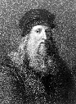  Leonardo Da Vinci  (1452 – 1519) | 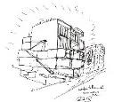  Sir David Adjaye (b.1966-) | 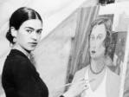  Frida Kahlo (1907-1954) | Sonia Boyce  (1962- ) | 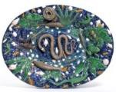  Bernard Palissy (c.1510- c.1589) | 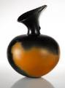  Magdalene Odondu (1950- ) | 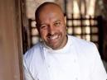  Sat Bains (1971-) | 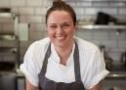  Selin Kiazim | 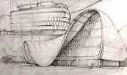  Zaha Hadid (1950-2016) | 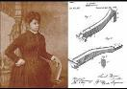  Sarah Boone (1832-1904) | 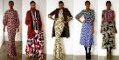  Duro Olowu | Alexander McQueen
 | We are draughtsmen  - select tools  - simple perspective  - hatching, shading  - sketches  - view finders  - observational drawing |  | We are painters  - complementary and contrasting colours  - atmosphere and light effects  - develop painting from a drawing  - foreground & background |  | We are sculptors  - model in response to drawing & painting  - plan work carefully  - coil, pinch, join, impress  - refine surface decoration  - incise, apply, glaze |  | We are cooks  - select & prepare food  - use scales  - cut and shape  - beat, rub in  - decorate  - balanced diet  - Honey vegetable kebabs/Greek salad/Yogurt &cucumber Tzatziki dip |  | We are constructors  - Moving?  - cut to 1mm  - join appropriately  - motor & switch  - frameworks  - bradawl  - hand drill  - glue gun |  | We are textile designers  - Slippers/ Clothes  - 3D products  - pattern  - seam allowance  - pin & tack  - blanket stitch  - machine stitching
 | Painting |  | Printing |  | Collage |  | Food |  | Modelling |  | Graphics/CAD
Year 6 | 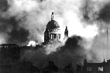  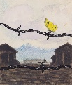 | 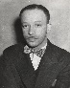  Charles Alston  (1907 – 1977) | 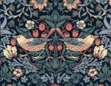  William Morris (1834-1896) | 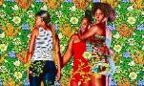  Kehinde Wiley (b.1977) | 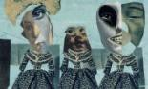  Hannah Hoch  (1889-1978) | 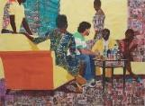  Njideka Akunyili Crosby (1983- ) | Ainsley Harriott (1957-) | 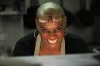  Andi Oliver | 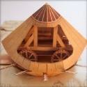  David Hawcock | 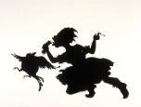  Kara Walker (b1969 | 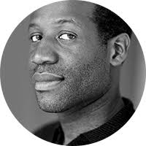Eddie Opara | Gail Anderson  (1962 - )
 | We are painters  War Artists: Paul Nash, Herbert Mason, Karl Robert Bodek, Kurt Conrad Law  - colour match  - mood  - Art to promote a change  - preliminary studies  - variety of stimuli |  | We are printers  - lino printing  - create printing blocks  - 3 colour overlays  - work into prints with other media |  | We are collage artists  - contrast  - add to other media  - veiling and layering |  | We are cooks  - select & prepare food  - use scales  - cut and shape  - beat, rub in  - decorate  - balanced diet  - Jamaican Jerk chicken/ Caribbean Salsa |  | We are modellers  - Fairgrounds  - slots  - sheet materials  - fixed and moving joinings  - craft knives  - cam mechanisms |  | We are graphic designers  - Create your own logo, business card or package label  - computer generate design  - plan to print and make  - investigate ideas  - model on computer

