**Our topics for RE this term are The Kingdom of God, where we will learn about how we can contribute to God’s Kingdom on Earth, and Justice, where we will consider social issues, centred around the Christian value of Justice.**

**Our Science topics this term are ‘Classifying Living things’ and ‘The Art of being Human’. We will start by thinking about different classification systems used by scientists, then moving on to understanding the human body.**

**In Maths, we will be recapping and developing our understanding of Place Value and the Four Operations. We will be working to develop fluency and reasoning skills, so that we can move onto understanding and solving more complex, varied problems.**

**Important days:**

**We have trips to the Imperial War Museum and to the World Wetland Centre in Barnes. Details will be released soon.**

**Homework is given out on a Friday and must be returned on a Tuesday so it can be marked.**

**All homework is set on the Google Classroom and it is to be completed in our homework books.**

**All children are expected to read from a challenging book every night. Our class library has an extensive collection to choose from.**

**Spellings will be given out on a Friday with a test the following Friday.**

**We will also be swimming this term.**

**Welcome to the Autumn Term! We have lots of new topics to learn about as well as exciting trips and visitors planned.**

**Have a look at the different topics we will be studying!**

**Please remember to read 📚 every day, it is incredibly important!**

**Year 6 Autumn Term 2022**



**English: This term our books are:**

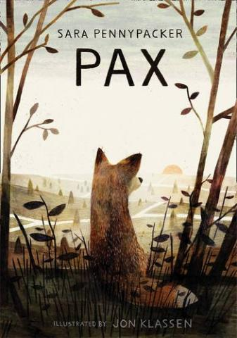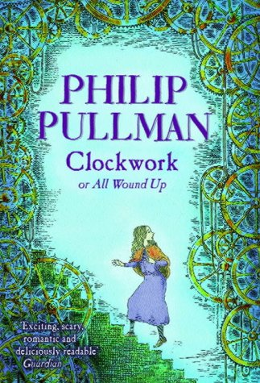

**We will be writing diaries and narratives, and we will also be working on the reading skills of inference and retrieval.**

**In Autumn 1, our History Topic is The World at War.**

**We will be looking at how war breaks out, and using the Second World War as a case study to help us better understand this complex topic.**

**In Autumn 2, our Geography topic is ‘Climb Every Mountain’. We will be learning about life at high altitude, and studying the life of Sherpas who work on Mount Everest. We will be considering the social issues around mountain tourism, and the benefits and costs for the local communities**

**This term in Art and Design, we will be studying art that links to World War 2. We will then move on to working with patterns and printing methods.**

