Computing
It is our intention at St Peter & St Paul to enable children to find, explore, analyse, exchange and present information. We also focus on developing the skills necessary for children to be able to use information in a discriminating and effective way. We want children to know more, remember more and understand more in computing so that they leave primary school computer literate. Computing skills are a major factor in enabling children to be confident, creative and independent learners and it is our intention that children have every opportunity available to allow them to achieve this.
 | Autumn 1 | Autumn 2 | Spring 1 | Spring 2 | Summer 1 | Summer 2
Essentials Curriculum:  Threshold Concepts for  Long-Term Memory | CONNECT  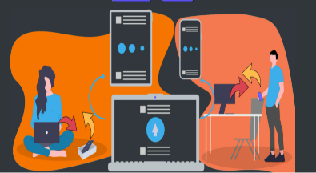 | COMMUNICATE | COMMUNICATE  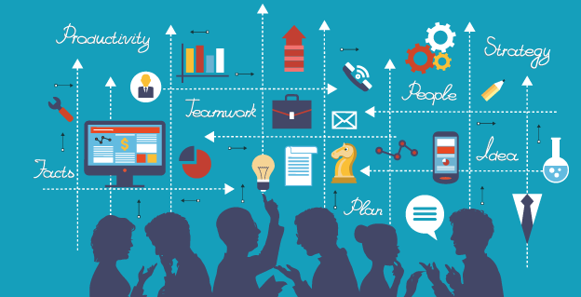 | COLLECT | COMMUNICATE | CODE  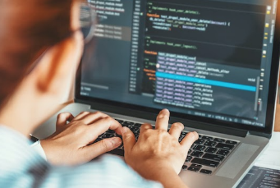
 | Digital Literacy - Online  Safety | IT- Digital Media –  Create,  Share, Respond | IT - Multimedia and  Digital  Writing | IT- Data | IT - Communication &  Collaboration | Computer Science  Coding
Year 1 | DL - Common Sense Media  (1 per half term)  Technology around Us (2 lessons) | Digital painting and Digital Writing - Busy Things and JIT (10 lessons - 2 half terms) | Digital painting and Digital Writing - Busy Things and JIT (10 lessons - 2 half terms) | Data - Busy Things (5 Lessons) | Home learning platformIntroduction (3 lessons) | Unit 1  Beebots - Moving a Floor  Robot  Unit 2  Busy Things - (Busy Code)
Year 2 | DL - Common Sense Media  (1 per half term)  The different uses of Computers (1 lesson + lesson starters) | Digital Photography (5 lessons) | Multimedia & Digital Writing J2 Write - Including Online research and typing skills  (5 lessons +) | Data – Pictograms (J2Data) (3 Lessons) | My Busy Things (Learning platform) (3 Lessons) Could be linked to topic | Unit 1 –  JIT turtle - Robot algorithms  Unit 2 –  Scratch Jr - Sequencing Animations (download)  Optional - Code.org
Year 3 | DL - Common Sense Media  (1 per half term)  Connecting Computers (4  Lessons) | J2 Animate (4 Lessons) | Home learning platformIntroduction (3 lessons) Google Classroom  Google Docs (5 lessons) | Data and information –  Branching database  (J2Data-J2Branch) (5  Lessons) | Creating media – Desktop publishing + Blogging (J25)  (4 Lessons including  Blogging Central) | Unit 1 – Code.org - Course  B  Unit 2 – Sequencing with Scratch Animation (5 lessons)
Year 4 | DL - Common Sense Media  (1 per half term)  Computing systems and networks – The Internet  (Lessons 1-4) | Creating media – Audio  editing - Audacity (5 Lessons)  (Chrome music lab in the future) | Google Slides (5 Lessons) | Data Logging - NCCE (6 Lessons) | Google Sites - (4 lessons) | Unit 1 – Multiple Scenes & Dialogue (5 Lessons)  Unit 2 Repetition Scratch shapes - (5 Lessons)
Year 5 | DL - Common Sense Media  (1 per half term)  History of Computing (5  Lessons) | iMovie - Camera angles, frames & editing (6 lessons) | Vector Drawing - Google Drawings (4 Lessons) | Data and information – J2E (5 Lessons) | Application of Skills  -Dragons Den - Plan,  Collaborate & Present  Cross Curricular Link | Unit 1 – Selection in  Quizzes  Unit 2 - Scratch-Variables in  Games  Optional - Selection in  Physical Computers Crumble Boards
Year 6 | DL - Common Sense Media  (1 per half term)  Computing systems +  Networks (6 Lessons) | Creating media – 3D Modelling - Tinkercad | Intro to Python - Code  Combat  Alternatively - Into to HTML  Websites | Data and information – Flat-file databases (Excel  +Sheets) (6 Lessons) | Application of Skills  -Dragons Den - Plan,  Collaborate & Present  Cross Curricular Link | Unit 1 – Scratch - Variables in games  Unit 2 – Sensing - Micro Bit  - Step Counter

