St. Peter and St. Paul Catholic
Primary School

English Policy
2023

‘The love of Christ impels us’
Live Love Learn

‘To love one another as I have loved you’

The overarching aim for English in the national curriculum is to promote high standards of literacy by equipping pupils with a strong command of the written and spoken word, and to develop their love of literature through widespread reading for enjoyment. The national curriculum for English aims to ensure that all pupils :
•​read easily, fluently and with good understanding
•​develop the habit of reading widely and often, for both pleasure and information
•​acquire a wide vocabulary, an understanding of grammar and knowledge of linguistic conventions for reading, writing and spoken language
•​appreciate our rich and varied literary heritage
•​write clearly, accurately and coherently, adapting their language and style in and for a range of contexts, purposes and audiences
•​use discussion in order to learn; they should be able to elaborate and explain clearly their understanding and ideas
•​are competent in the arts of speaking and listening, making formal presentations, demonstrating to others and participating in debate.”
Policy Statement
This policy sets out the arrangements for the leadership and delivery of the English curriculum at St Peter and St Pauls R.C. Primary School.
Overview
English is taught through the daily English lesson five days a week. English end of unit writing outcomes are planned in advance with two per half term covering all genres over the year. One of these is assessed and goes into the writing portfolio.
Reading books are organised by the ‘book bands’ scheme ranging from band pink to brown. Children whose reading level is below expected levels are heard reading usually daily, but at least once per week, in addition to the daily guided reading session.
English planning is based on the use of Power of Reading ‘Quality Texts ‘which are the core for all English teaching.
Home reading needs to be closely monitored for those children who are below ES. This can be done by means of a home /school reading diary which is signed by the teacher or TA daily. In addition, teachers may wish to check all children’s home/ school reading diaries daily (optional but recommended strongly for years 1-3). In Years 5/ 6 home school reading diaries are replaced by reading journals where an expectation of 5 reviews per half term is in place and monitored
Speaking and Listening is taught both through English lessons and across the entire curriculum. We teach children to use full sentences and encourage this by the use of partner talk. We have a whole school speaking rule and a lunchtime talk topic to encourage polite conversations and widen vocabulary.
Reading / Home Reading
In KS1 and EYFS we use decodable Rhino readers in line with the DfE approved Twinkl phonics scheme. In addition to these decodable books, children may receive other home readers with coloured book bands and/or library books according to their reading level, which is regularly assessed by teachers.
Guided Reading
Teachers in Years 1-2 and Year 3, depending on cohort, organise pupils into ability groups. At least one group per day works with an adult in a guided reading session. Record keeping forms are provided and a guided reading file is maintained. Guided reading books are stored on the Pallottine Level. Guided reading texts fulfil the broad range of texts covered by the English plans and teachers endeavour to link guided reading books to the work being studied in Literacy lessons wherever possible. Extracts from the Power of Reading text that half term may be utilised. In Years 4, 5 and 6 whole class guided reading is used in place of guided reading. In some cohorts and towards the end of the year, this may be used in Year 3. The discreet skills of reading comprehension are explicitly taught including: inference, making connections, prediction, evaluation, clarification. Every class has a dedicated reading area and display showcasing these skills and teachers will focus on a different skill every half term. Teachers in these whole class reading sessions will model, through ‘think-aloud’, the strategies. Children will then practise these. There is one written comprehension exercise per week although In addition teachers will model reading aloud once a day during a story time of at least twenty minutes.
Planning
English planning is based on the outcomes for each year group in the National Curriculum . Teachers base their medium term planning on the use of a quality text which links pupils’ learning effectively to the required outcomes. The Power of Reading planning is used as a starting point but teachers have flexibility to structure their teaching as they see fit in the best interests of the pupils and the broader curriculum on the understanding that all of the outcomes are covered in sufficient depth across the year. Teachers also ensure sufficient time is given within each week to cover the phonics, spelling, grammar and handwriting schemes.
Homework
Homework will be linked to work previously covered during class to provide consolidation and revision.
Exercise Books
Each child in KS1 and 2 has an English book, a spelling test practice/ test book and a home school reading diary. In EYFS children’s work in phonics, communication language and literacy are recorded in their Pupil Profile books
Handwriting and presentation
Children are expected to write in cursive script from Year 3 upwards when their handwriting in joined even and consistent. The scheme the school uses to teach is Nelson. In Years 5 and 6 children may develop an independent joining style as long as this is legible and fluent which deviates from Nelson. This is at the teachers’ discretion. LO is to be underlined in red and the date in pen or pencil.

Grammar
The school uses Alan Peat sentences to help children develop their writing and punctuation. Alan Peat is only used as a starting point the children are also taught the correct grammatical terms. The progress for the introduction of these sentences is outlined in a separate document.
Marking
See separate policy.
Writing
Writing should always have an audience in mind. Any writing outcome is directly linked to the Power of Reading text focus for that half term. In each unit of work, a ‘learning journey’ should be visible. English books have cover sheets at the start of each half term specifying the text focus and the Power of Reading text being used.
Display of Writing Exemplars
On the wall of every classroom from Year 1-6 there should be visible an extended piece of handwritten writing which models the end of year writing standard. On this permanent display all of the writing objectives for the year should be signposted. Teachers will refer to this throughout the year in writing sessions.
Three Stages of the Learning Journey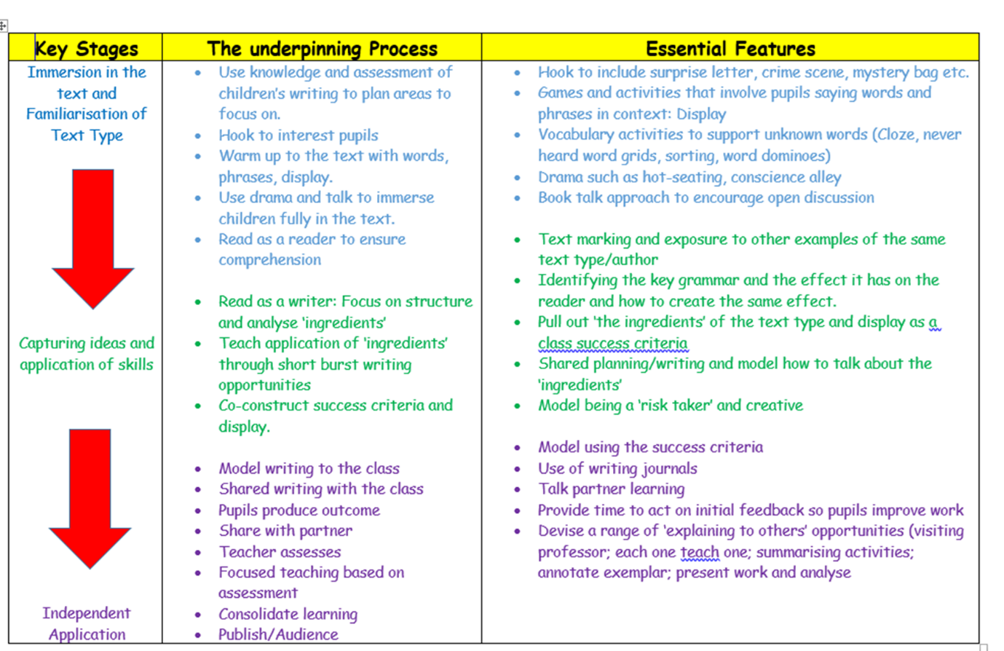
The first stage is to immerse children in the text type and to practise vocabulary and sentence structures associated with the text type through drama and talk. The second phase teaches the grammar needed and comprises of text marking and sentence work with the capturing of ideas and the application of these skills. The last part of the learning journey, the teacher demonstrates modelled writing and editing. The books during phase three of any learning journey show independent application of the skills learnt, through unsupported extended writing. One of these independent pieces is used for assessment purposes and should be transferred into the child’s writing portfolio. Teachers plan carefully and are clear about what each writing outcome will be from the outset of the learning journey. The end of unit outcomes are mapped out and available on the yearly overview along with the Power of Reading texts. Marking for the end of unit outcomes will identify strengths and areas for development and identify the next steps the child needs to take in order to achieve their targets. Writing may take place by using work from other curriculum areas such as R.E. and History where appropriate but should directly link to the text type focus or revisit one already taught.
Spelling and Phonics
DfE approved Twinkl planning for phonics is used throughout Foundation Stage and KS1. Teachers adapt the timetable to give a necessarily high priority to this work. In KS2 phonics development and retention is maintained where a cohort requires support.
KS2 Teachers may assign part or all of one English lesson per week to spelling, whilst most grammar work will be completed during taught English sessions not as discrete sessions. There are weekly words for each year group which may have a topic focus. Teaching of spelling is in KS2 is based on the school policy and scheme. Spelling lists given to children weekly for a weekly test are part of a taught session to embed learning effectively.
Speaking and Listening
Speaking and listening is planned as an integral part of the English teaching with due regard to the outcomes specified in the National Curriculum. Planning makes those outcomes explicit on the steps to success and will usually be present in phase 1 of any unit of work. Teachers also make careful links to speaking and listening in all other curriculum areas. Role play, assemblies, hot seating, discussions and debates all ensure these objectives are carefully met. Mid- term planning should make the links to speaking and listening in other curriculum areas.
Record Keeping
Each teacher maintains a file for pupils working at below expected levels who are heard reading daily / weekly as appropriate, and an up to date intervention and support folder, containing pupils test data and other assessment results. SEN files and Pupil Passports supplement these records. Phonics and spelling records are completed throughout the year and sent to the child’s next class.
Assessment
The school uses the Insight tracking system to make regular assessments of children.
Monitoring
English is monitored within the school’s framework for monitoring the core subjects. The co-ordinator and SLT are responsible for ensuring the findings of monitoring lead to positive change and improvement.
Resources
The co-ordinator is responsible for ensuring the subject is well resourced but teachers must also bring their resource needs to his or her attention.
Policy Update
This policy was produced in June 2020 and updated in 2023

Jane Manzone

