History and Geography
Discovering the past, present, here, there and now
Our thematic curriculum supports children to develop their key skills in History and Geography. These can then be transferred into other situations; ICT, applied Maths and Literacy skills are also developed alongside each theme. Our units are carefully chosen to match the
national curriculum and best support our cohorts of children to learn about their own heritage and that the their immediate locality.
 | Autumn 1 | Autumn 2 | Spring 1 |  | Spring 2 | Summer 1 | Summer 2
Year 1 |  | 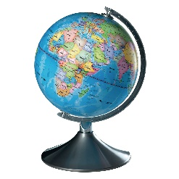 | 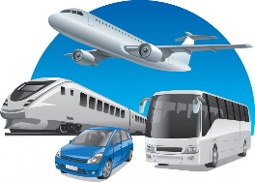 |  | 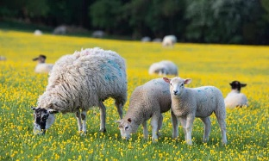 | 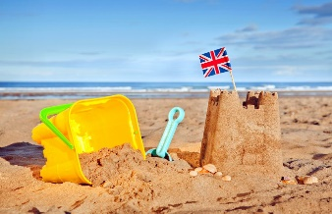
 | Let Your Light Shine Brightly  - People who have made and still make a difference in society and the world including:  - Edith Cavell  - Pascal Soriot  - Sarah Gilbert  - Grace Nichols  - lemn Sissay  - Claudia Jones  - Marcus Rashford  - Emmeline Pankhurst  - Sophia Duleep Singh | Poles Apart!  - Seven Continents  - Hot and Cold Countries  - Equator/Poles  - Climate & clothing  - Different lives of people in other continents. | Planes, Trains and Automobiles  - Main focus on ‘Change’  - Transport & forms of travel  - Transport changes in their, parents, G/parents lifetime  - Bristol bus boycott compare/contrast with Rosa Parks  - First aeroplane flight  - Artefacts – to show change |  | Springing Into Life!  - Where our food comes from – supermarkets etc.- imported – world food.  - Farms & farming in UK – dairy, arable, livestock etc.  - Farm animals, wool/milk etc  - use simple compass directions (North, South, East and West) and locational and directional language [for example, near and far; left and right], to describe the location of features and routes on a map. | Oh I Do Like To Be Beside the Seaside!  - Use basic geographical vocabulary to refer to key physical features, including: beach, cliff, coast, forest, hill, mountain, sea, ocean, river, soil, valley, vegetation, season and weather.  - Use photographs to identify features of an old seaside holiday  - Know what seaside holidays were like 100 years ago  - Place significant seaside events on a timeline. | There’s No Place Like Home!  - My route to school, my school, my locality, shops  - Where do I live- street, city/town?  - UK – Countries, capital cities, landmarks etc.  - My home, my family, simple family tree.  - Photographic history  - Counting back in time – G/parents World War II  - Timeline of recent events
 | Autumn 1 | Autumn 2 | Spring 1 | Spring 2 |  | Summer 1 | Summer 2
Year 2 | 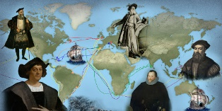 | 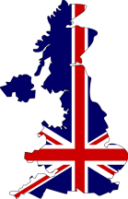 | 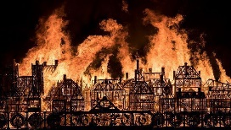 | 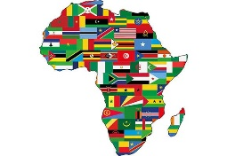 |  | 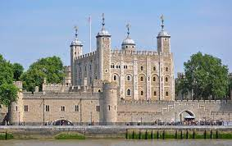 | 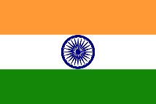
 | Intrepid Explorers!  How have they made an impact on life today?  - People who have made and still make a difference in society and the world including:  - Francis Drake  - Matthew Henson - North Pole  - Tenzing Norgay- Everest  - Ibn Battuta -  - Dwayne Fields – North pole  - Neil Armstrong  - Mae Jemison – Astronaut | Home and Away!  - The UK – countries, capitals national flags, major towns and cities, rivers. Industry  - Compare food from each country in the UK eg: scone, soda bread, rock cake  - Exploring the continents and major countries of the world and capital cities  - Oceans, mountain ranges, islands, deserts, rivers – physical geography | London’s Burning!  - Compare different paintings of the Great Fire of London. Why are they different? Eg different sources, no evidence  - Use picture of the Great Fire of London to establish why the fire spread.  - To understand what happened as a result of the Great Fire of London.  - To compare differences in London, before and after the Great Fire.  - Children can use a variety of different sources of evidence to ask and answer questions about the GFoL | Let’s Explore Africa  How different our two continents are?  - Make comparisons between their own locality and that of a non-European country.  - Suggested 2 – 3 countries represented in the class  - Describe the physical and human characteristics of an area by referring to regions, countries and continents and consider how similarities and differences in environments affect the lives of people who live there  - Consider how communities adapt to hot or cold environments.  - Investigate differences in housing, food, clothing and say how these are influenced by where we live. |  | Castles and Ruins!  - Finding out who built the first castles in the UK. Exploring the features of Norman castles.  - Exploring the structure of medieval castles.  - Finding out who lived in medieval castles. Discovering how common people were treated in medieval times.  - Exploring how the Tower of London’s uses have changed over time. | Around the World-  Indian Spice!  - Children will make comparisons between their own locality and that of a non-European country.  - Children will describe the physical and human characteristics of an area by referring to regions, countries and continents and consider how similarities and differences in environments affect the lives of people who live there  - Pupils will consider how communities adapt to hot or cold environments.  - Children will investigate differences in housing, food, and clothing and say how these are influenced by where they live.

 | Autumn 1 |  | Autumn 2 |  | Spring 1 | Spring 2 | Summer 1 | Summer 2
Year 3 | 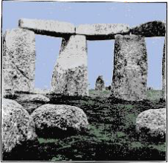 | 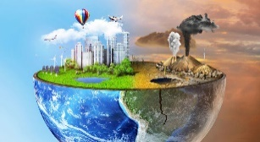 |  |  | 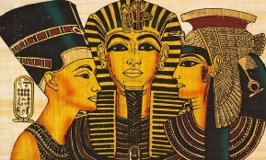 | 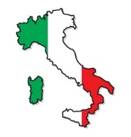 | 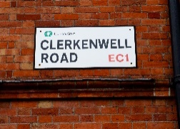 | 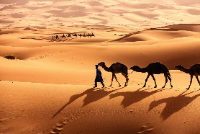
 | Meet the Flintstones!  Changes from Stone Age to Iron age.  - Neolithic hunter- gatherers early farmers – Scara Brae  - Bronze age – religion, technology, travel- Stonehenge  - Iron age hill forts, tribal kingdoms, farming, art etc  - Cheddar Man | Pollution Solution!  - To understand what biodiversity is and how it benefits nature.  - To understand how human populations can threaten the biodiversity of different areas  - To reflect on the ways in which we can help and encourage biodiversity locally and globally  - Plastic pollution |  |  | Walk like an Egyptian!  - The achievement of the Ancient Egyptians  - Context of Ancient Egypt – early civilisation. River Nile, Pyramids, Valley of the Kings. Gods & beliefs, farming, art, culture  - Pharaohs –Tutankhamun  - The Nubian Pharaohs of Kush | Ciao, Come Stai?  - Italy as major European country  - Physical geography, landscape  - Major rivers, mountains, regions, Human geography – major cities – Rome  - History, culture, industry etc  - Vatican City? Own country, currency, police etc? | Close to Home!  Local History  - History of Clerkenwell  - Migration (including the Italian community in Clerkenwell)  - To be able to locate the local area on a map and to give directions.  - To identify different types of services in the local area. | Sand Is My Favourite Colour!  - What deserts are and where in the world and why  - Location using a world map or atlas Hot and Cold deserts  - Weather & climate of deserts. Sahara, Gobi,
 | Autumn 1 |  |  | Autumn 2 | Spring 1 | Spring 2 | Summer1 | Summer 2
Year 4 | 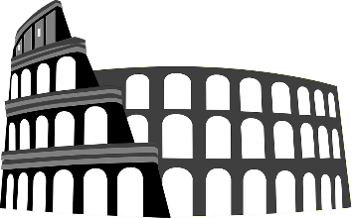 |  |  | 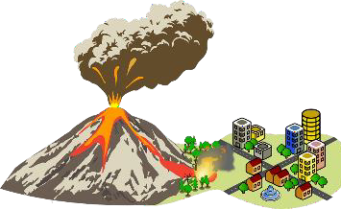 | 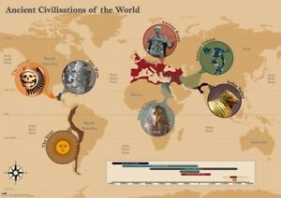 | 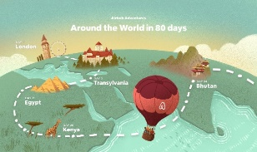 | 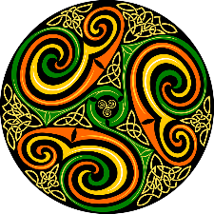
 | Divide and Conquer! Carpe Diem! (ROMANS)  - Why were the Romans so powerful and what did we learn from them?  - Julius Caesar’s attempted invasion of Britain 55BC  - Power of the Roman army,  - Claudius’ successful invasion & conquest  - Hadrian’s wall The garrison of African soldiers at Hadrian’s wall; British resistance, Boadicea  - Roman roads communications  - Romanisation of Britain  - To include Septimus Severus, The Beachy Head Lady. |  |  | The World Erupts!  - What causes Earthquakes -tectonic plates,  - Earthquake ‘zones’ – link to Tsunami’s  - What is a Volcano? -Structure – Vesuvius and Pompeii, Mount St. Helens.  - Volcanic Islands – Galapagos, Hawaii | Learning From the Past!  - Great Civilisations Sumeria, Egypt, Shang or Benin  - To explore where and when the first civilisations began  - To find out about the first writing systems.  - To explore trade in early civilisations.  - To find out about mathematical understanding in early civilisations.  - To explore the technology and inventions of early civilisations.  - To explore the buildings and architecture of early civilisations | Around the World in 80 Days!  - To be able to identify the continents of the world.  - To be able to locate countries on a world map.  - To find out about some of the key geographical features of each continent.  - To be able to locate major capital cities of the world  - To be able to use a variety of sources to identify human and physical features in a particular country.  - To be able to find similarities and differences between different countries. | Sensational Saxons, Scots and Picts!  - Roman withdrawal from Britain and arrival of Anglo-Saxon and Scots  - Anglo Saxon invasion settlement and kingdoms;  - Place names & village life.  - Anglo- Saxon art & culture  - Christian conversion – Canterbury, Iona and Lindisfarne.  - African Abbot | All the World’s a Kitchen!  - Distribution of the world’s natural resources, energy, food, minerals, water.  - Major food producers of the world – link to climate and bio-zones.  - Compare to areas of drought and famine.  - Trade links and food distribution – Fair Trade  - Compare fairtrade food – bananas, jam, chocolate.

 | Autumn 1 | Autumn 2 | Spring 1 | Spring 2 | Summer 1 | Summer 2
Year 5 | 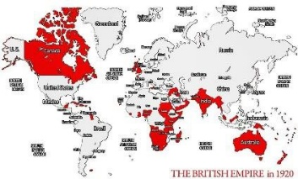 | 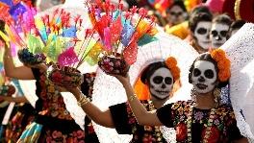 | 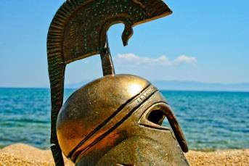 | 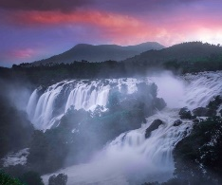 | 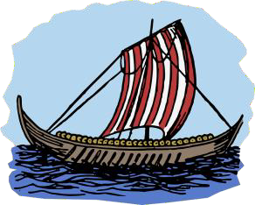
 | The Empire Strikes Back!  - What is an Empire? – British Empire.  - To understand when, how and why Britain's 'first' empire was established in the Americas and Africa.  - To understand why British influence in India, China and Southeast Asia grew during the early years of the British Empire. Is this still evident today?  - To begin to understand how trade (and therefore British control) in India grew, and how people resisted the East India Company.  - The Victorians exploration, colonies, slavery. Legacy Commonwealth; compare to Roman Empire.  To include  - Sarah Forbes Bonetta  - Pablo Fanque  - William Wilburforce  - Olaudah Equiano | Day of the Dead!  South America  (Mexico)  - Physical and human geography of the Americas  - Mountain ranges, rivers, countries, capital cities etc.  - Can include a specific focus e.g Mexico | Eureka!  - Three main periods -Archaic, Classical, Hellenistic.  - Difference between Athens & Sparta.  - Black presence  - Greek warfare, beliefs, mythology, daily life, democracy Ancient Olympics, Marathon. | The Power of Nature!  (Water)  - To explore water on our planet.  - To understand and explain the water cycle.  - To explore why we need water and how we use it.  - To compare the difference in water availability and usage in the UK and another relevant country  - To explore how water can be used for power to contribute to a sustainable future.  - To investigate and explore a local body of water | Raiders or Traders!  Vikings  - Who were the Vikings? -Where they come from and why. As invaders, explorers, traders.  - Family Viking life as settlers  - Viking place names – Danelaw  - Alfred Great -Gods /myths  - Slavery | Is the Kingdom Still United?  - Physical and man-made landscape of the UK – rivers, mountain ranges, major cities/towns, Motorways Industry etc.,  - The people of the UK
 | Autumn 1 | Autumn 2 | Spring 1 | Spring 2 | Summer 1 |  | Summer 2
Year 6 | 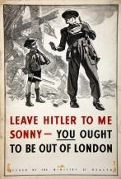  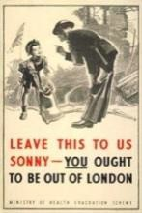 | 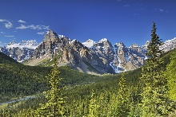 | 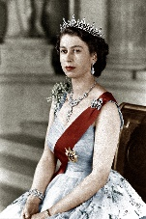 | 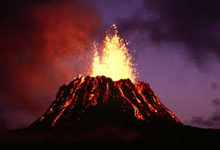 | 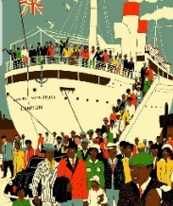 |  | 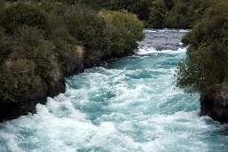
 | The World at War!  - Include the role of African, Asian and Caribbean people.  - How were soldiers treated differently because of their race?  - To include Lilian Bader,  - Walter Tull, Noor and Inayat Khan  - Evacuees | Climb Every Mountain!  - Discover what mountains are and where the major mountain ranges are in the world.  - Learn the names of famous mountains and find key facts about each one.  - Investigate why mountains have their own climate and explore data for particular mountains.  - Investigate what makes mountains popular tourist destinations and compare these destinations between seasons.  - Evaluate the positive and negative impacts tourism has on mountain environments. | A Game of Thrones!  - What we mean my ‘monarchy’  - How Britain differs from a country with a ‘President’ – USA  - Study 3 great British monarchs and the changing power of the monarchy – e.g King John, Henry VIII, Queen Elizabeth I, Anne or Victoria. | Extreme Earth  - Impact of global warming on climate & weather; flood, drought, (Australian bush fires); also, hurricanes/tornadoes, earthquakes tsunamis etc. | Building a New Britain!  (The call from the Mother country!)  - Rebuilding after WWII –Regeneration  - Include migration,  - Also, the Windrush generation.  - John Agard ‘Windrush Child’ poem |  | Raging Rivers!  - River Amazon and its biozone, Amazonia.  - Compare to other great rivers – e.g. Nile, Ganges, Mississippi, and our own UK Rivers Thames – Severn, Clyde.  - Properties of a river – source, flow, freshwater, estuary, delta, water cycle  - Lost rivers of London

