Physical Education
At St Peter and St Paul, we deliver a curriculum which is accessible to all and maximises the development of every child’s ability and achievement in PE enabling them to know more about physical activity and keeping healthy, remember more about the physical activity they participate in and learn about and understand how to use and apply this knowledge to impact upon their own physical activity, participation and healthy lifestyle.
 | Autumn 1 | Autumn 2 | Spring 1 | Spring 2 | Summer 1 | Summer 2
Year 1 | 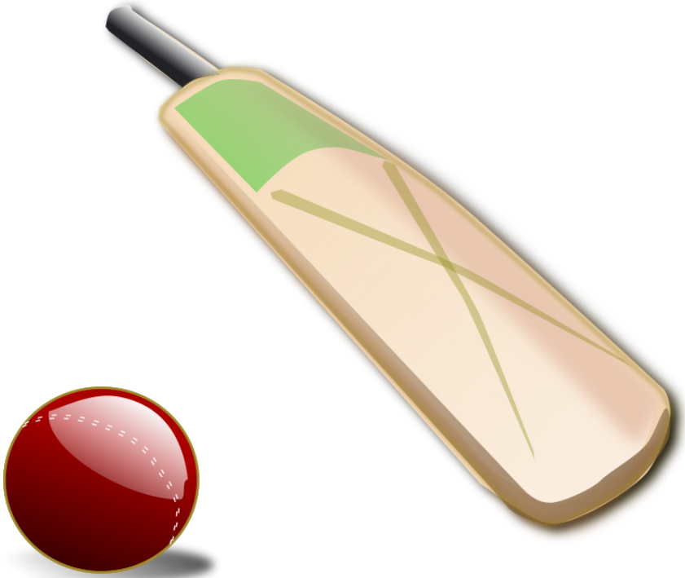 | 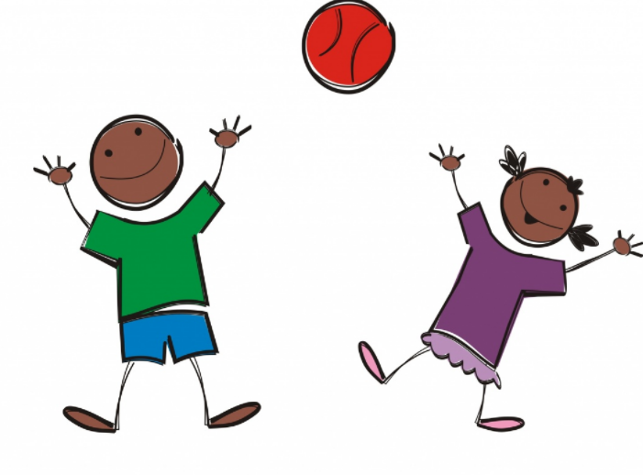 | 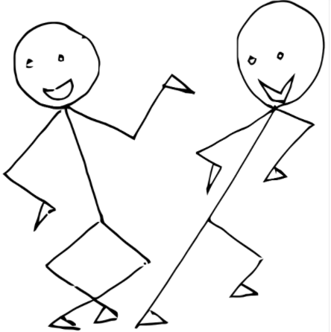 |  |  | 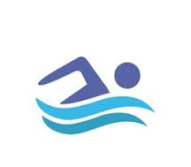
 | We love to run, jump  and  play cricket  Fundamental Movement Skills- Running and jumping  Agility  Cricket | We are great at games  Throwing  Catching  Co-ordination | We are dancers and gymnasts  Movement  Flexibility  Balance  Strength | We are tennis players  Racket Skills  Space  Movement  Coordination | We are great at Multi-Sports and football  Throwing  Catching  Fundamental skills  Passing  Receiving | We are great at football and swimming  Passing  Receiving  Swimming
Year 2 | 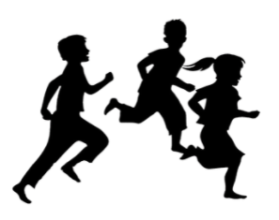
 | We love to run and jump  Fundamental Movement Skills- Running and jumping  Agility | We are great at games  Passing  Positioning  Attacking  Defending  Throwing  Catching  Cricket | We are dancers and gymnasts  Movement  Flexibility  Balance  Strength | We are great at tennis and swimming  Swimming  Racket Skills  Space  Movement  Coordination | We are great at Multi-Sports and football  Throwing  Catching  Fundamental skills  Passing  Receiving | We are fit and athletic  To get ready for sports day we focus on:  Throwing  Running  Sprinting  Passing  Receiving

 | Autumn 1 | Autumn 2 | Spring 1 | Spring 2 | Summer 1 | Summer 2
Year 3 |  |  |  |  | 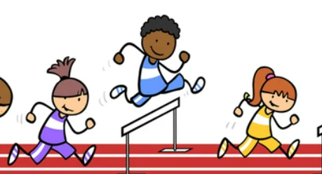
 | We are Football players  Passing  Receiving  Defending  Shooting | We are great at games  Football  Throwing  Catching  Passing  Positioning  Attacking  Defending | We are Dancers and Gymnasts  Flexibility  Movement  Balance  Strength | We are Super Athletes  Fundamental Movement Skills- Running and jumping  Agility | We are fit and athletic  To get ready for sports day we focus on:  Throwing  Running  Sprinting | We love adventures and swimming  Swimming  Communication  Teamwork  Problem Solving  Decision Making
Year 4
 | We are Football Players  Passing  Receiving  Defending  Shooting | We are great at games  Football  Throwing  Catching  Passing  Positioning  Attacking  Defending | We are Dancers and Gymnasts  Flexibility  Movement  Balance  Strength | We are Super Athletes  Fundamental Movement Skills- Running and jumping  Agility | We love athletics and swimming  Swimming  To get ready for sports day we focus on:  Throwing  Running  Sprinting | Outdoor and Adventure  Communication  Teamwork  Problem Solving  Decision Making

 | Autumn 1 | Autumn 2 | Spring 1 | Spring 2 | Summer 1 | Summer 2
Year 5
 | We love to run, jump and swim  Fundamental Movement Skills- Running and jumping  Agility  Swimming | We are great at invasion games and Cricket  Passing  Receiving  Defending  Shooting  Cricket | We are Dancers and Footballers  Passing  Receiving  Defending  Shooting  Flexibility  Movement  Balance  Strength | We are Football players and Gymnasts  Passing  Receiving  Defending  Shooting  Flexibility  Movement  Balance  Strength | We are fit and athletic  To get ready for sports day we focus on:  Throwing  Running  Sprinting | Outdoor and adventure  Communication  Teamwork  Problem Solving  Decision Making
Year 6 |  | 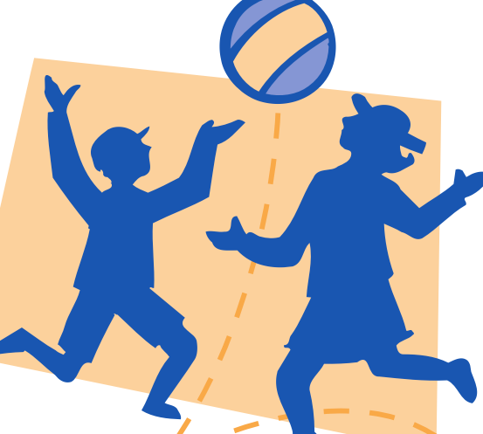
 | We love to run,  jump and play  cricket  Fundamental Movement Skills- Running and jumping  Agility  Cricket | We are great at invasion games  Passing  Receiving  Defending  Shooting | We are Football players and swimmers  Swimming  Passing  Receiving  Defending  Shooting | We are Football players and gymnasts  Passing  Receiving  Defending  Shooting  Flexibility  Movement  Balance  Strength  Swimming | We love to dance  Flexibility  Movement  Balance  Strength | Outdoor and adventure  Communication  Teamwork  Problem Solving  Decision Making

