Personal, Social, Emotional and Economic Education
RSE (Ten Ten) and the Science topics have been linked to the PSHE (Islington You, Me PHSE 2020) overview these are the resources that will support learning across the school. This brings together emotional literacy, scientific understanding, social skills and spiritual development in a comprehensive overview of learning .
Autumn 1 |  | Autumn 2 | Spring 1 | Spring 2 | Summer 1 | Summer 2
Year 1 | 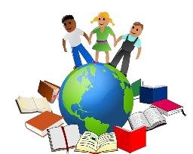 |  | 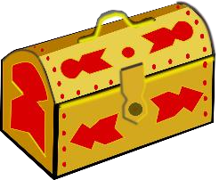 | 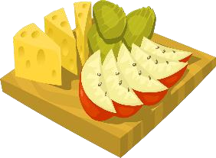 | 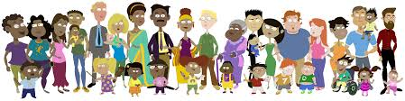
 | My world - Fun times  - Feeling special - What food is associated with special times in different cultures  - My class – what active playground games from around the world do we play  - Sun safety  - Feeling proud  - Mission Statement & values  Islington PHSE | Celebrating our Differences - Me and others  - What makes themselves and others special  - Roles and responsibilities at home and school  - Being co-operative with others  - Bullying  - New friends  Islington PHSE | Who am I and what will I be - My money  - Treasure chest of success - where money comes from and making choices when spending money  - Steps to goals – saving money and how to keep it safe  - Achieving together - different jobs people do  - Overcoming obstacles  Islington PHSE | Healthy Me – what do we put into and onto bodies/  - Being healthy  - Healthy choices  - Clean and healthy  - Medicine safety  - Road safety  Islington PHSE | Relationships - Feeling Safe  - Families - safety in familiar situations  - Making friends – personal safety  - Greetings  - People who help us and keep them safe outside the home  - Being my own best friend  Islington PHSE | I am Changing - Feelings  - Life cycles  - Changing me - managing different types of feelings  - My changing body  - Learning and growing – change or loss and how this can feel  - To know that they are entitled to bodily privacy;  - That there are different people we can trust for help, especially those closest to us who care for us, including our parents or carers, teachers.  Science overview  TenTen KS1 Module 2 created to love others – Physical contact
Year 2 | 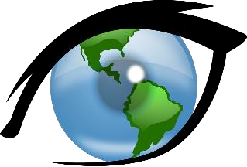 |  | 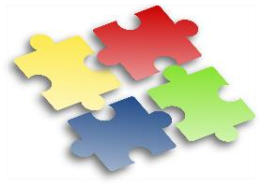 | 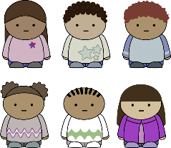 |  | 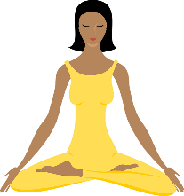
 | My World – Indoors and outdoors  - Hopes and fears - keeping safe in the home, including fire safety  - Rights and  responsibilities - keeping safe online, including the benefits of going online  - Rewards and consequences  - Keeping safe outside - road safety  - Mission Statement & values  Islington PHSE | Relationships-  Families - To identify ‘special people’ (their parents, carers, friends) and what makes them special;  - The importance of nuclear and wider family;  - The importance of being close to and trusting special people and telling them if something is troubling them.  - Friends and conflict - How their behaviour affects other people, and that there is appropriate and inappropriate behaviour;  - The characteristics of positive and negative relationships;  - Different types of teasing and that all bullying is wrong and unacceptable.  To recognise when they have been unkind and say sorry;  To recognise when people are being unkind to them and others and how to respond;  To know that when we are unkind to others, we hurt God also and should say sorry to him as well;  To know that we should forgive like Jesus forgives.  - Secrets/Trust –The difference between ‘good’ and ‘bad’ secrets and that they can and should be open with ‘special people’ they trust if anything troubles them;  How to resist pressure when feeling unsafe.  TenTen – KS1 – module 2 Created to love others  Special people, treat others well Good Secrets/Bad Secrets | Who am I and what will I be – Our gifts and talents  - Goals to success  - Learning strengths  - Learning with others  - Assertiveness  - Looking ahead  Independent teaching | Celebrating our Differences - Friendship  - Importance of special people in their lives  - To understand and respect the differences and similarities between people  - Bullying- solving problems that might arise with friendships  - Standing up for myself and others  - New friends – making friends and who can help with friendships  - (included on and offline)  Islington PHSE | I am Changing - I am Unique  - What makes us special?  - The names of the parts of our bodies (please refer to the Module Overview for important guidance on discussing genitalia);  - That girls and boys have been created by God to be both similar and different and together make up the richness of the human family.  - Life cycles in nature the biological differences between male and female animals and their role in the life cycle  - Growing up – growing from young to old and that they are growing and changing  Our bodies are good and we need to look after them;  What constitutes a healthy lifestyle, including physical activity, dental health and healthy eating;  The importance of sleep, rest and recreation for our health;  How to maintain personal hygiene.  - Everybody needs to be cared for and ways in which they care for others  Science Overview  TenTen – KS1 Module 2 Created & loved by God  Clean and Healthy, girls and boys  Independent Teaching | Healthy Me  What keeps me Healthy?  - The importance of physical activity, sleep and rest  - How germs are spread, how we can prevent them spreading and people who help us to stay healthy and well.  - Medicine safety – why medicines are taken  - Where medicines come from  - Keeping safe around medicines  Science overview  Islington PHSE  Includes Medicines and ME

 | Autumn 1 | Autumn 2 | Spring 1 | Spring 2 | Summer 1 | Summer 2
Year  3 | 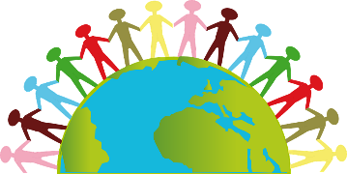 | 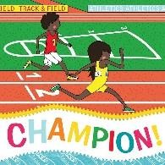 | 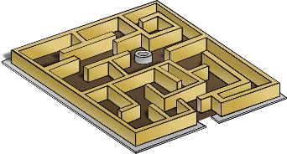 | 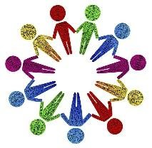 | 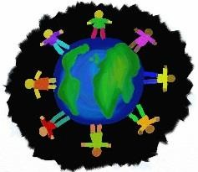
 | My World – Saving, spending and budgeting  - Getting to know each other  - Rewards and consequences  - What influences people’s choices about spending and saving money  - How people can keep track of their money  - About the world of work  - Mission Statement & values  Islington PHSE | Healthy Me - What helps me choose? RSE  - Being fit and healthy- making healthy choices about food and drinks  - How branding can affect what foods people choose to buy  - My amazing body – keeping active and some of the challenges  Science Overview  Islington PHSE | Who am I and what will I be – strengths and challenges  - My dreams and ambitions - celebrating achievements and setting personal goals  - A new challenge – dealing with put-downs  - Overcoming obstacles- positive ways to deal with setbacks  Islington PHSE | Celebrating our Differences-identity, society and equality  - Learn about valuing the similarities and differences between themselves and others made in the image and likeness of God  - Learn about what is meant by community  - Learn about belonging to groups  - Witness and feelings  - Words that harm  - Compliments  Islington PHSE | Relationships – Bullying –see it, say it stop it  - Different types of bullying and how to respond to incidents of bullying  - Friendship – what to do if they witness bullying  - Keeping myself safe – recognise bullying(including online)and how it can make people feel  Islington PHSE | I am Changing - Making the right choice?  Drugs, alcohol and tobacco  What do I know about drugs – definition of a drug and that drugs including medicines can be harmful to people  - Being safe – effects and risks of smoking tobacco and second –hand smoke  - Help available for people to remain smoke free or stop smoking  Islington PHSE
Year  4 | 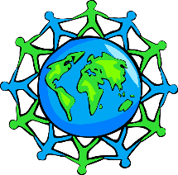 | 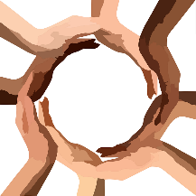 | 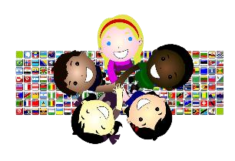 | 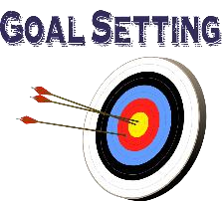
 | My World- identity, society and equality  - Britain as a democratic society  - School citizen - what does that mean to you?  - How laws are made  - Rewards and consequences  - What is a local council  - Mission Statement & values  Islington PHSE | Celebrating our Differences – What is important to me?  - Judging by appearances  - Understanding influences – why people may eat or avoid certain foods(religious, moral, cultural or health reasons)  - Other factors that influence us – media, peers, ethical reasons ie fair trade,  - Special me - the importance of getting enough sleep  Islington PHSE | Healthy Me – Making choices  - Medicines are drugs, but not all drugs are good for us.  • Alcohol and tobacco are harmful substances.  • Our bodies are created by God, so we should take care of them and be careful about what we consume.  - Asthma lesson - (Islington PHSE)  - Healthy friendships -  Develop a greater awareness of bullying (including cyber-bullying), that all bullying is wrong, and how to respond to bullying;  - Learn about harassment and exploitation in relationships, including physical and emotional abuse and how to respond.  - What to do in an emergency and basic emergency first – aid procedures  Science Overview  Tenten LKS2 Module 2 created to love others- Safe in my body, Drugs, alcohol, tobacco, sharing online /chatting on line | Who am I and what will I be  - Hopes and dreams  - Broken dreams  - Overcoming disappointment  - Creating new dreams  - Achieving goals  Independent teaching | Relationships – families, friends and others  - Ways to maintain and develop good, positive, trusting relationships; strategies to use when relationships go wrong;  - That there are different types of relationships including those between acquaintances, friends, relatives and family;  - That good friendship is when both persons enjoy each other’s company and also want what is truly best for the other;  - The difference between a group of friends and a ‘clique’.  Tenten LKS2 module 2 created to love others - Friends, family and others | I am Changing  Unique me - Similarities and differences between people arise as they grow and make choices, and that by living and working together (‘teamwork’) we create community;  Self-confidence arises from being loved by God (not status, etc.).  - What is Puberty? Learn what the term puberty means;  - Learn when they can expect puberty to take place;  - Understand that puberty is part of God’s plan for our bodies.  Learn correct naming of genitalia;  - Learn what changes will happen to boys during puberty;  - Learn what changes will happen to girls during puberty.  Circle of change - That they were handmade by God with the help of their parents;  - How a baby grows and develops in its mother’s womb including, scientifically, the uniqueness of the moment of conception;  - How conception and life in the womb fits into the cycle of life;  - Accepting change - the need to respect and look after their bodies as a gift from God through what they wear, what they eat and what they physically do.  Science overview  TenTen-LKS2 module 1 – Created and loved by God  We don’t have to be the Same, Respecting our bodies, What is puberty?  Changing bodies, Life Cycles

 | Autumn 1 | Autumn 2 | Spring 1 | Spring 2 | Summer 1 | Summer 2
Year  5 |  |  |  | 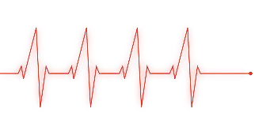 |  | 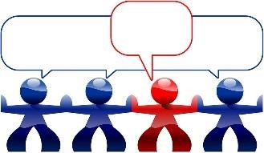
 | My World – In the media  - What is a role model?  - That messages given in adverts can be misleading  - How the media can manipulate images and that these images may not reflect reality  - Responsibilities  - Rewards and consequences  - Mission Statement & values  PHSE Islington | Celebrating our  Differences – Stereotypes, discrimination and prejudice  - Different cultures  - Racism  - Rumours and name calling  - Types of bullying  - How this can make people feel  PHSE Islington | I am Changing -  Self & body image  That human beings are different to other animals;  About the unique growth and development of humans, and the changes that girls/boys will experience during puberty;  About the need to respect their bodies as a gift from God to be looked after well, and treated appropriately;  The need for modesty and appropriate boundaries.  Puberty/Menstruation - About the nature and role of menstruation in the fertility cycle, and that fertility is involved in the start of life;  - Some practical help on how to manage the onset of menstruation.  Conception -How a baby grows and develops in its mother’s womb.  Science overview  TenTen - UKS2 -Module 1 –Created and loved by God –girls/boys bodies, Menstruation, Making babies pt. 1 | Healthy Me - different influences  - Smoking/Alcohol - Understand the effect that a range of substances including drugs, tobacco and alcohol can have on the body.  • Learn how to make good choices about substances that will have a positive impact on their health.  • Know that our bodies are created by God, so we should take care of them and be careful about what we consume.  - Recognise how they may come under pressure when it comes to drugs, alcohol and tobacco  • Learn that they are entitled to say “no” for all sorts of reasons, but not least in order to protect their God-given bodies  TenTen –  UKS2 Module 2 – impacted lifestyles  Making Good Choices | Relationships – Making safer choices  - Recognising me  - Getting on and falling out  - Relationships – violence within relationships is not acceptable  - Technology – Keeping safe on line  - Social media - how to keep safe when communicating with other people online  - Problems that can occur when someone goes missing from home  Islington PHSE | Who am I and what will I be - Borrowing and earning money  - When I grow up  - Jobs and careers - what influences people’s decisions about careers  - My dream job – what is enterprise  - Other cultures  - Supporting each other  - Rallying support – money can be borrowed but there are risks associated with this  Islington PHSE
Year  6 |  |  | 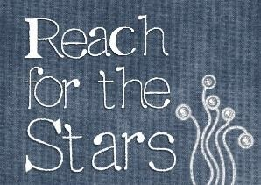 | 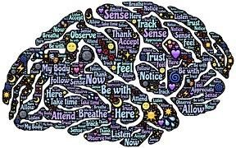 | 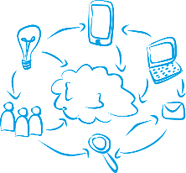
 | My World – Human rights  - Global citizens –  - about people who have moved to Islington from other places, (including the experience of refugees)  - about human rights and the UN Convention on the Rights of the Child  - about homelessness  - Mission Statement & values  Islington PHSE | Celebrating our  Differences  - Gifts and talents  - Understanding disability  - Power struggles  - Why bully?  Independent teaching | Who am I and what will I be -  - Personal learning goals  - Steps to success  - My dream for the world  - Making a difference  Independent teaching | Healthy Me – Healthy minds/weighing up risk  - Drugs/Alcohol - about the risks associated with using different drugs, including tobacco and nicotine products, alcohol, solvents, medicines and other legal and illegal drugs about assessing the level of risk in different situations involving drug use  about ways to manage risk in situations involving drug use  - Emotional & mental health - Love and loss  - what mental health is about what can affect mental health and some ways of dealing with this about some everyday ways to look after mental health  - about the stigma and discrimination that can surround mental health  Islington PHSE | Relationships - Power and control  - Understand what consent and bodily autonomy means;  - Discuss and reflect on different scenarios in which it is right to say ‘no’.  - Being safe with technology - To recognise that their increasing independence brings increased responsibility to keep themselves and others safe.  - How to use technology safely.  - That just as what we eat can make us healthy or make us ill, so what we watch, hear, say or do can be good or bad for us and others.  - How to report and get help if they encounter inappropriate materials or message  to judge well what kind of physical contact is acceptable or unacceptable and how to respond.  That there are different people we can trust for help, especially those closest to us who care for us, including parents and teachers  Tenten - UKS2 Module 2 Created to love others – Sharing Isn’t always caring. Types of Abuse | I am Changing -  My self-image - How to make good choices that have an impact on their health: rest and sleep, exercise, personal hygiene, avoiding the overuse of electronic entertainment, etc.  To recognise that images in the media do not always reflect reality and can affect how people feel about themselves  That thankfulness builds resilience against feelings of envy, inadequacy, etc. and against pressure from peers or media  - Puberty/ Menstruation (Revision)  - Girl/boy differences (Revision)  - Babies: conception to birth (Revision)  - Making babies part 2 – may be omitted or set as a homework task with parents unless it is a science lesson  To deepen their understanding of the range and intensity of their feelings; that ‘feelings’ are not good guides for action.  That some behaviour is wrong, unacceptable, unhealthy or risky. (Peer pressure/  Consequences of anti-social behaviour)  - Attraction - Emotions change as they grow up (including hormonal effects);  - To deepen their understanding of the range and intensity of their feelings; that ‘feelings’ are not good guides for action;  - About emotional well-being: that beauty, art, etc. can lift the spirit; and that also openness with trusted parents/carers/teachers when worried ensures healthy well-being.  The difference between harmful and harmless videos and images;  The impact that harmful videos and images can have on young minds;  Ways to combat and deal with viewing harmful videos and images.  Science overview  TenTen - UKS2 -Module 1 –Created and loved by God  Spots & sleep, Body image, Peculiar feelings, Emotional changes, Seeing stuff online  - Junior Citizen Secondary school transition

FGM in Year 6 (Relationships summer 1- Power and control)
The CES Model Curriculum states that pupils in KS2 should be taught:
2.3.3.1. That there are some cultural practices which are against British law and universal rights (e.g. honour-based violence and forced marriage, human trafficking etc.)
2.3.3.2. That actions such as female genital mutilation (FGM) constitute abuse, are crimes and how to get support if they have fears for themselves or their peers
Learning intention (p719 – Year 6 Islington PHSE)
Pupils learn about the importance for girls to be protected against female genital mutilation (FGM)
Outcomes - pupils
• know that FGM is a form of abuse
• understand everyone has a right to be protected against harm to their bodies
• know where and how someone can get help and support.

