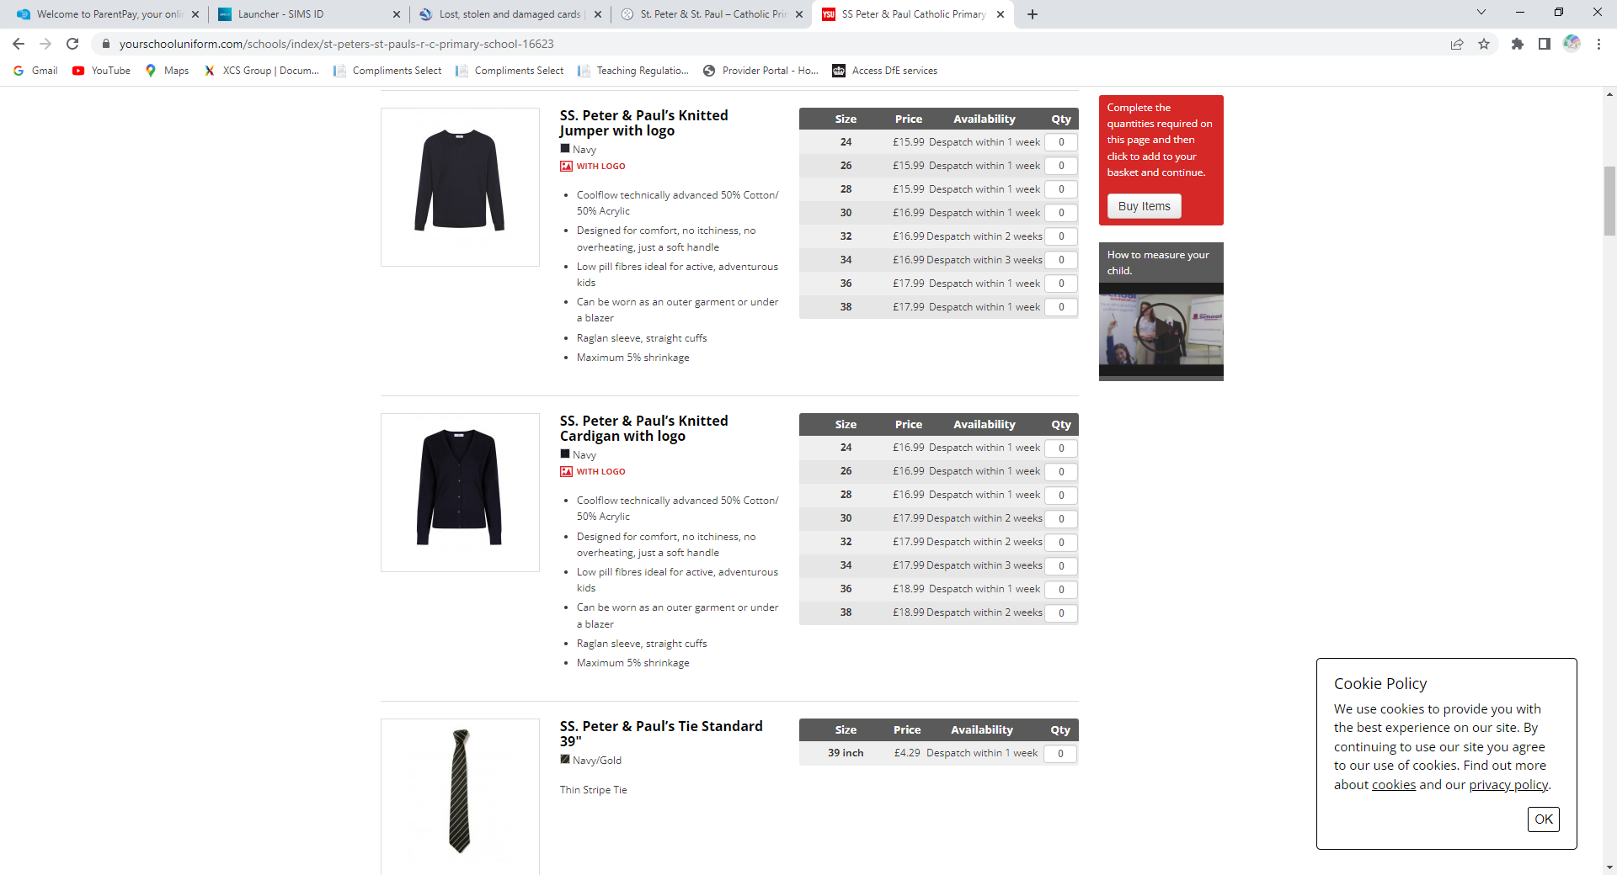

Jumper or cardigan **with school logo**

**P.E. Bag**

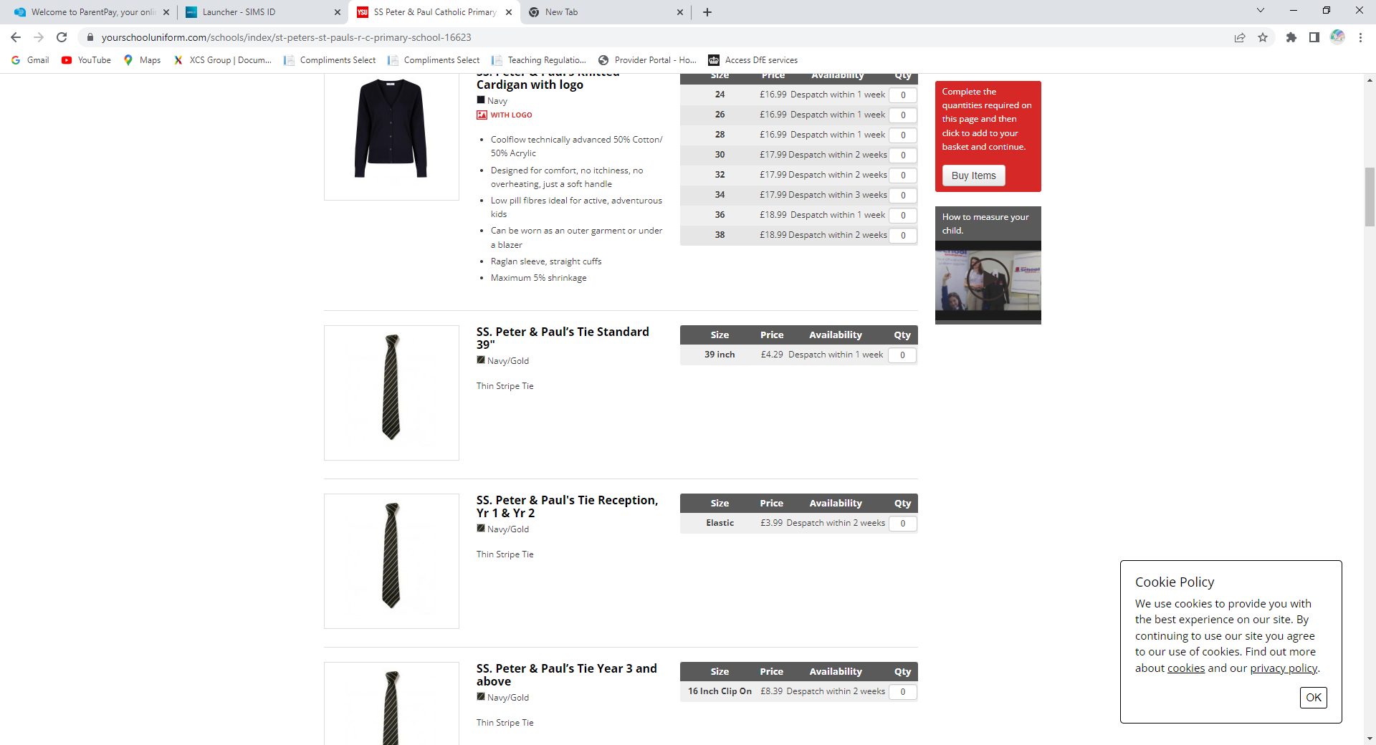

School Tie

White Short Sleeve Shirt

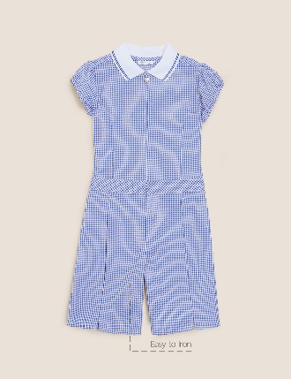

Summer Gingham Playsuit

Summer Gingham Dress

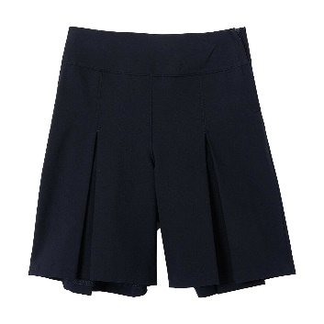

Navy Culottes/Navy skirts

Grey School Shorts

BLACK SCHOOL SHOES



