**In RE, Spring 1, we will be studying and exploring the Mass, and the central role it plays in Catholic life. We will then move on to studying Jesus’s life, and delving deeper in our understanding of who He is, as both human and God.**

**Our Science topics this term are ‘Evolution and Inheritance’ and ‘Let there be Light’. We will start by thinking about how living things evolve over time, then we will move on to learning about how light works.**

**In Maths, we will be looking at Fractions, Decimals and Percentages. We will be learning how to calculate with these, and apply our understanding and reasoning skills when solving complex problems. We will also be learning Algebra, and Shape, Space and Measure**

**Important days:**

**We have a trip to the Tower of London – details to be confirmed.**

**Homework is given out on a Friday and must be returned on a Tuesday so it can be marked.**

**All homework is set on the Google Classroom and it is to be completed in our homework books.**

**All children are expected to read from a challenging book every night. Our class library has an extensive collection to choose from.**

**Spellings will be given out on a Friday with a test the following Friday.**

**Welcome to the Spring Term! We have lots of new topics to learn about as well as exciting trips and visitors planned.**

**Have a look at the different topics we will be studying!**

**Please remember to read 📚 every day, it is incredibly important!**

**Year 6 Spring Term 2022**

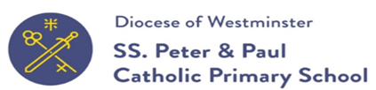

**English: This term our books are:**

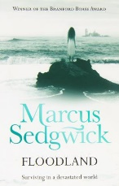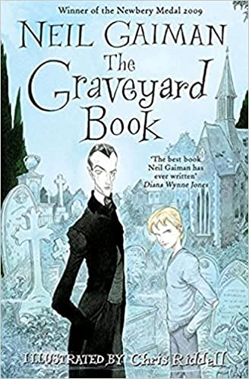

**We will be writing letters and persuasive brochures, and we will also be working on the reading skills of evaluation, explanation, inference and retrieval.**

**In Spring 1, our Geography Topic is Angry Earth**

**We will be looking at Earthquakes and Volcanoes, and carrying out case studies on the areas that are in the Ring of Fire.**

**In Spring 2, our History topic is A Game of Thrones. We will be learning all about different monarchs, and building an understanding of their lives and reigns using a range of primary and secondary sources.**

**This term in Art and Design, we will be studying Collage techniques. We will also be cooking.**

