**Year 2 Summer Term 2023**

**In Maths this term we will be looking at number and place value and the four operations; addition, subtraction, multiplication and division. We will be looking at word problems, statistics, and geometry: position and direction.**

**Welcome to the Summer Term! We have lots of new topics to learn about as well as exciting trips and visitors planned.**

**Have a look at the different topics we will be studying!**

**Please remember to read 📚 every day, it is incredibly important!**

**This spring term in Art and DT, we will be studying textiles and in summer 2, we will be looking at different moving pictures.**

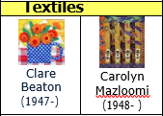

**In Summer 1, our History topic is ‘Castles and Ruins!’. We will be finding out who built the first castles and what life was like in a medieval castle.**

**In Summer 2, our Geography topic is ‘Around the World – Indian Spice’. We will be comparing cities in the UK and India, thinking about lifestyles and different climates. The children will learn about physical and human characteristics.**



**Our Science topics this term is ‘My Body’ and ‘My Healthy Body’. We will be learning about life cycles and what our bodies need to be healthy. We will also be thinking about the importance of exercise.**

**English: This term our books are:**

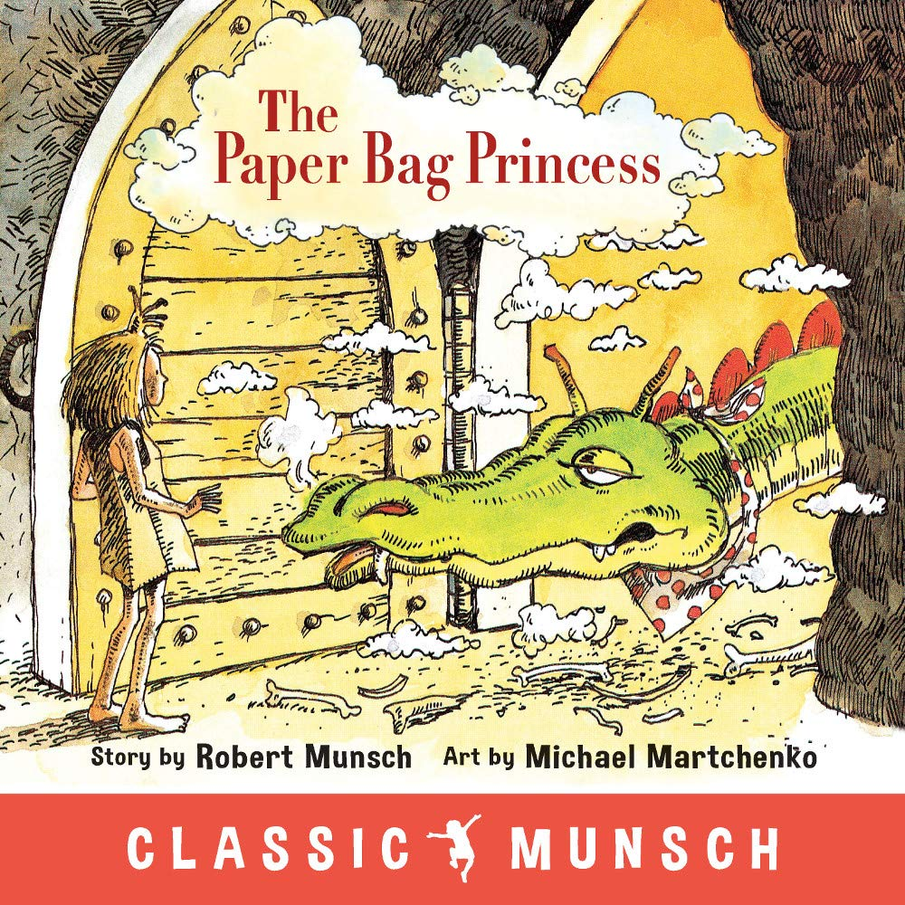**and**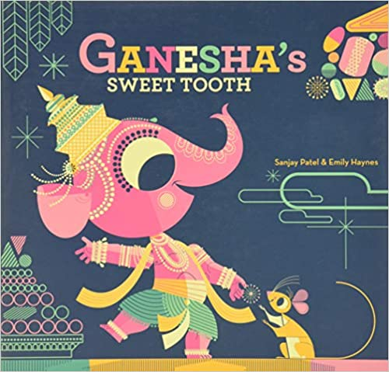

**We will be writing stories, plays, reports and captions.**

**Important days:**

**Homework is given out on a Friday and must be returned on a Tuesday so it can be marked.**

**All homework is set on the Google Classroom and it is to be completed in our red homework books.**

**Reading books are changed every Monday and Thursday. Please ensure you sign your child’s reading record so that their book can be changed.**

**Spellings will be given out on a Friday with a test the following Friday.**

**For this half term, PE is swimming and football with Arsenal. Next half term we will be practising our athletic skills ready for Sports Day (date tbc). PE will be on Wednesday for the first half term.**

**Our topics for RE this term are: ‘Eastertide’ and ‘Birth of the Church’. We will also be looking at different Holy books and important symbols in Judaism.**

