**In RE, we will be studying and exploring the Holy Spirit. We will be looking at what the Holy Spirit means, and studying the different ways that it is represented in art.**

**Our Science topic in Summer 1 is ‘It’s Electric’. In this topic, we will be studying circuits and electricity. We will then move on to ‘Let’s Investigate’ where we will wrap up our Key Stage 2 Science with some investigations.**

**In Maths, we will be continuing to develop our understanding of Shape, Space and Measure. We will also be looking at Data and Statistics. We will then explore all the covered topics and hone our reasoning and problems solving skills, working on thinking systematically and algebraically.**

**Important days:**

**We have our residential trip this term. We also have a few more fun surprises to look forward to!**

**Homework is given out on a Friday and must be returned on a Tuesday so it can be marked.**

**All homework is set on the Google Classroom and it is to be completed in our homework books.**

**All children are expected to read from a challenging book every night. Our class library has an extensive collection to choose from.**

**Spellings will be given out on a Friday with a test the following Friday.**

**Welcome to the Summer Term! We have lots of new topics to learn about as well as exciting trips and visitors planned.**

**Have a look at the different topics we will be studying!**

**Please remember to read 📚 every day, it is incredibly important!**

**Year 6 Summer Term 2022**



**English: This term our books are:**

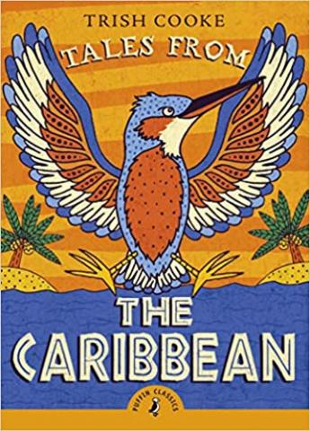

**We will be writing informal letters and reports, and we will also be working on the reading skills of evaluation, explanation, inference and retrieval.**

**In Summer 1, our History Topic is the 20th Century.**

**We will be studying major events, such as the Suffragette movement and the arrival of the Windrush, which have contributed to the diverse cultural fabric of modern Britain.**

**In Summer 2, our Geography topic is Raging Rivers. We will be doing a case study on sections of the world that rely on rivers for survival, and those that are prone to flooding.**

**This term in Art and Design, we will be putting our design and modelling skills to the test. We will also be creating digital art.**

