**Year 2 Autumn Term**

**A Message from the Teacher**  
I am really looking forward to teaching this year’s Year 2. The children are settling into their new class and have already made a brilliant start!

If you have any questions or queries throughout the term, you can see me at the gate at home time or make an appointment through the office.

**English**

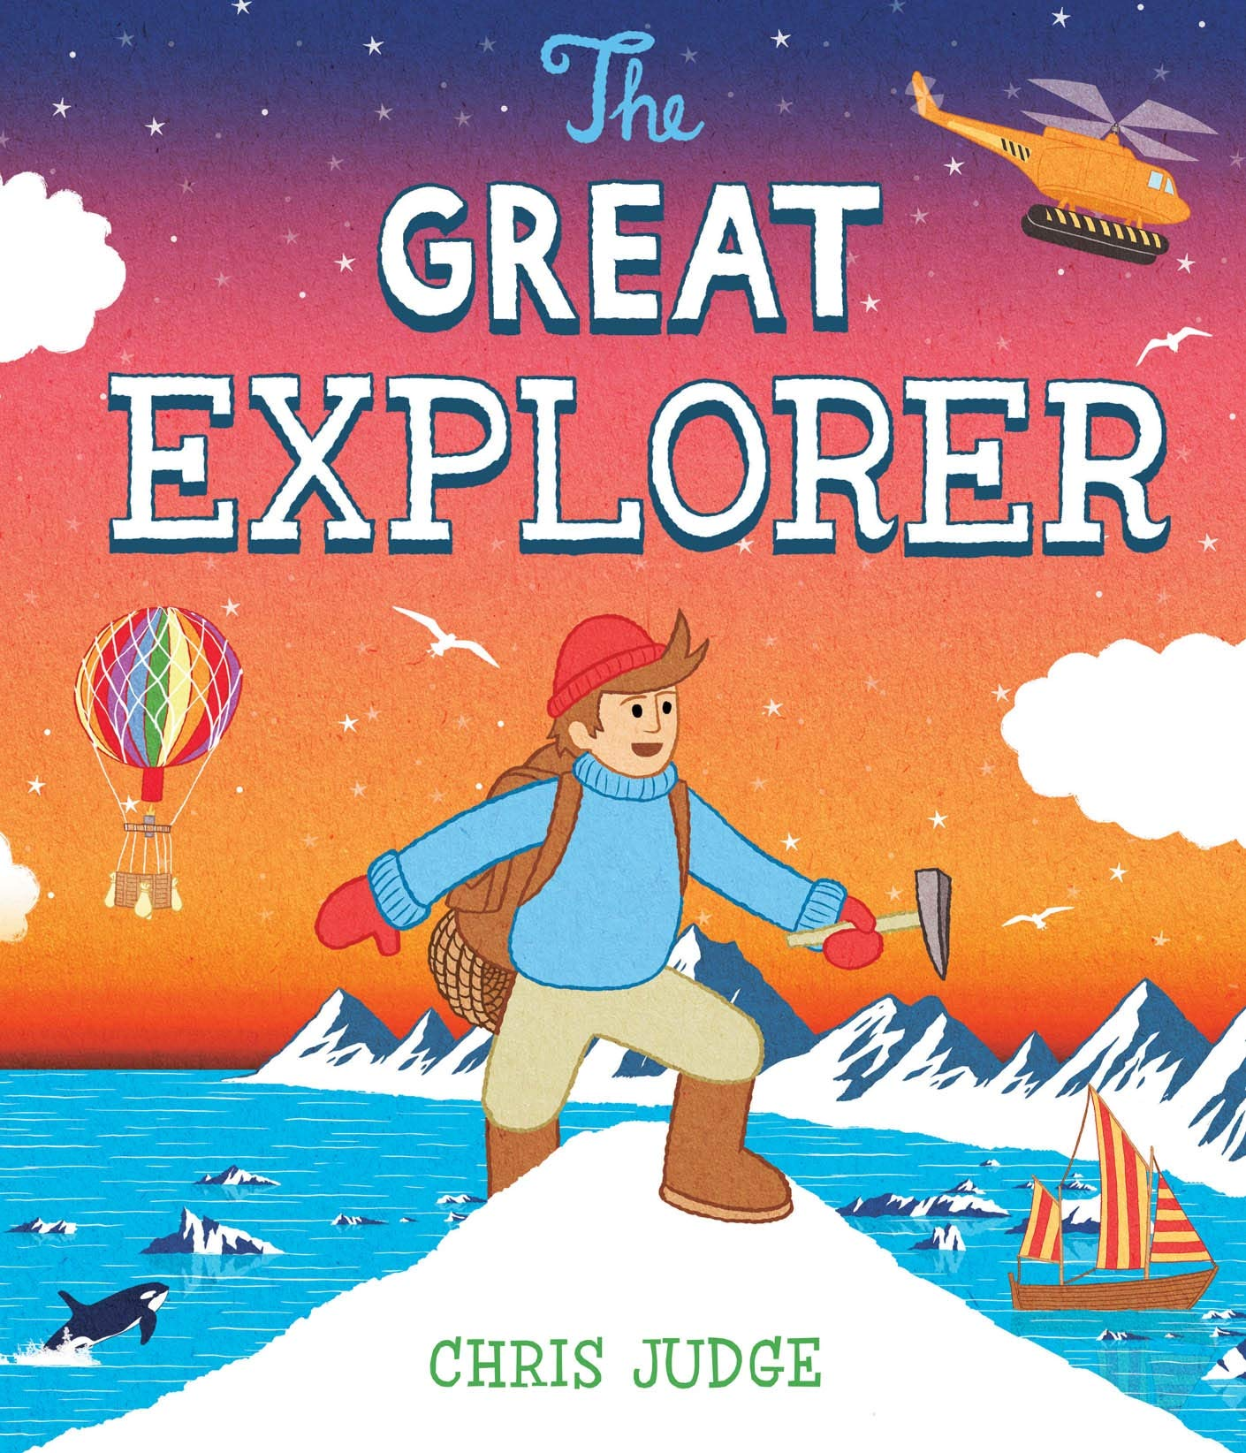 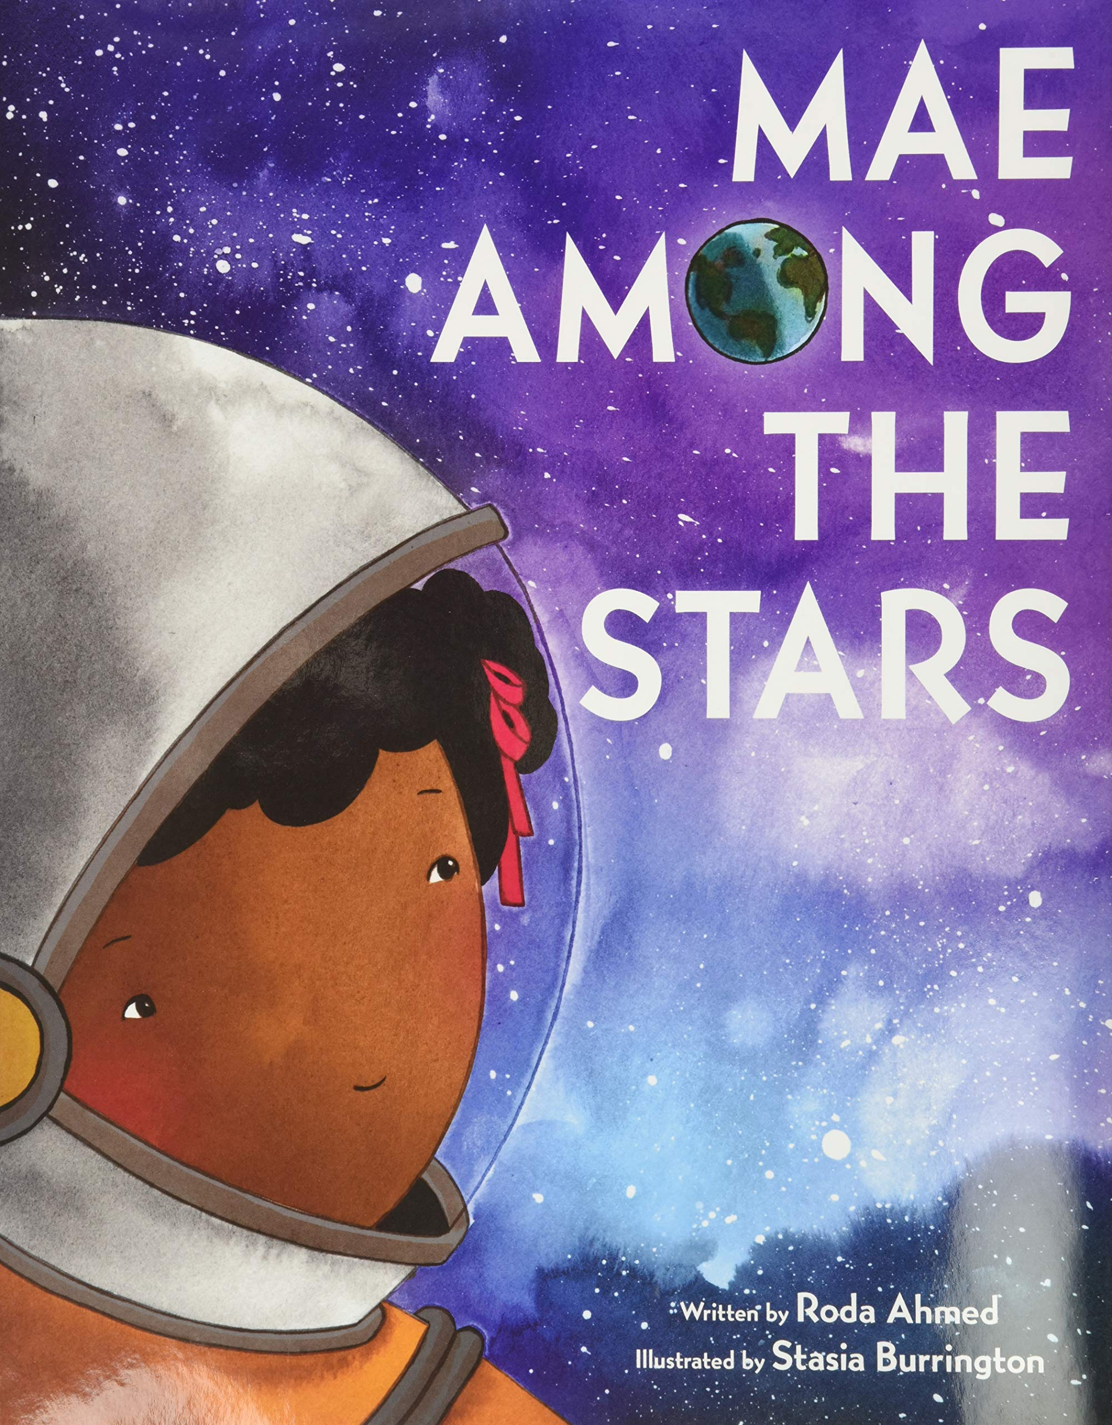 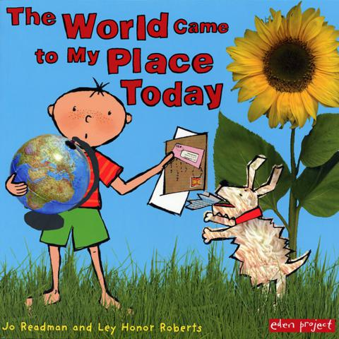

Our key texts this term are **The Great Explorer**, **Mae Among the Stars** and **The World Came to My Place Today**. These texts will be used as a springboard for our learning in English and will act as a stimulus for our writing.   
  
Year 2 are taught phonics daily. They will continue to read common exception words and blend and segment sounds to be independent readers and writers.

The children practice handwriting throughout the week. The focus is to begin to join letters and progress to consistently use this in their work.

**Uniform:** May I take this opportunity to remind you that children are not permitted to wear jewellery or nail varnish as part of the school uniform.  
Please **label all parts of your child’s uniform** to ensure there are no mix ups with jumpers, coats etc.

**Homework:** Homework will be posted on Google Classroom on **Fridays**. Children should complete the work in their homework book and return it to school by the following **Tuesday**.  
Spelling tests will begin after half- term and will be on **Friday** mornings. The children will take home their spelling notebook so that you can see your child’s progress. Please sign at the bottom of the test and return the spelling book to school on **Monday**.

**P.E.:** This half-term our PE days are **Mondays** and **Fridays**. Children should come to school in their PE kit on those days.

**Reading books:** Reading books will be changed every **Monday** and **Thursday** but we encourage children to read with an adult every night for 10 minutes. Please sign your child’s reading record so that we know the book is ready to be changed. Some children will read every day in school so please ensure books are in the book bags every day.

**Trips:** Year 2 have a fantastic upcoming trip to the Hampstead Heath Education Centre to support their learning in Science date to be confirmed**.**

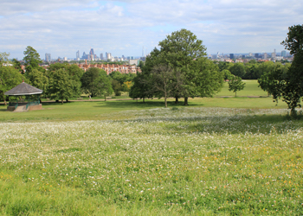

The topics we will be learning this term:

|  |  |
| --- | --- |
| **Religion** | **Chosen People**  **Mysteries of the World** |
| **English** | **The Great Explorer**  **Mae Among The Stars** |
| **Maths** | **Number**   * Composition of number up to 100 * Bridging 10 * Subtraction as difference |
| **Science** | **What does it mean to be alive?** – Exploring, understanding and identifying living things and their habitats.  **Roots and Shoots** – Observing and describing the growth of plants. |
| **Art** | **We are Draughtsmen** – David Hockney & Görkem Dikel  **We are Printers** – Orla Kiely & Edward Tingatinga |
| **Geography** | **Home and Away** – Countries in the UK, continents and major cities of the world. |
| **History** | **Intrepid Explorers**   * Matthew Henson - North Pole * Mae Jemison – Astronaut |
| **PE** | Fundamental Movement Skills – Running and Jumping  Agility |
| **Music** | Song singing and music literacy lessons with Miss Reeves. |

**Maths**

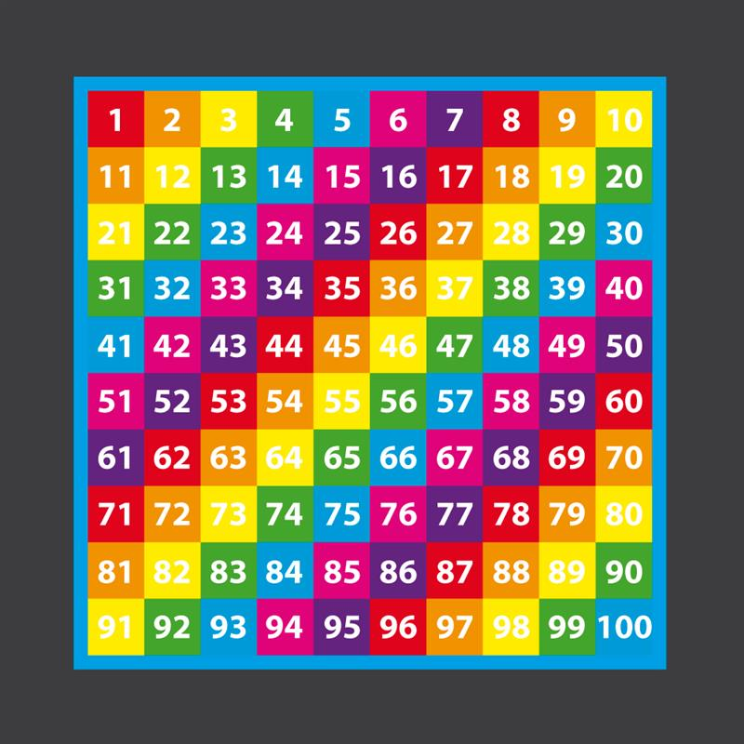 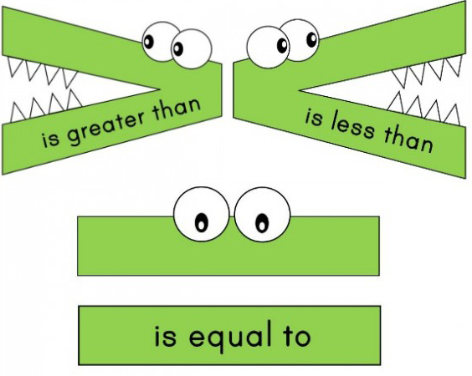

The focus this term will be on the composition of numbers up to 100, comparing numbers, ordering numbers, and adding and subtracting using their number bonds to 10.

Year 2 will practise counting forwards and backwards to 100 and begin learning their 2, 5, 10 timetables.

**How can my parent or carer help me with my learning?**Please continue to read with your child every day. You can read their reading book together and visit the library. You can help develop their vocabulary by explaining the meaning of any new words they see.

For Maths, some ideas include practising counting forwards and backwards, using number skills to solve real life problems such as purchasing items and using money.

**Some useful websites for Year 2**  
topmarks.co.uk  
[www.bbc.co.uk/bitesize](http://www.bbc.co.uk/bitesize)  
busythings.co.uk