Year 1 | Autumn 1 |  | Autumn 2 | Spring 1 | Spring 2 | Summer 1 | Summer 2
Quality Text | 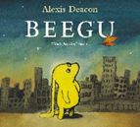  PoR  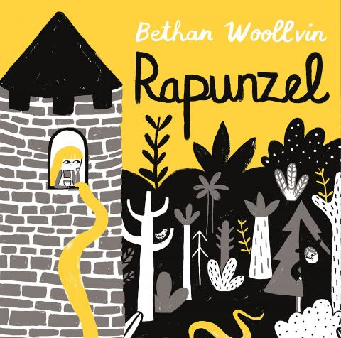  PoR |  | 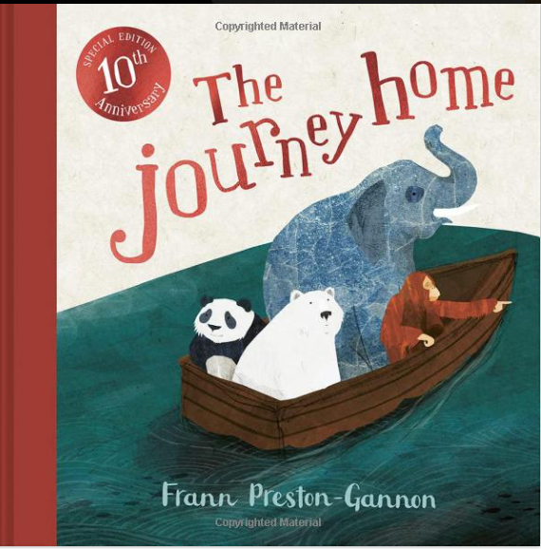  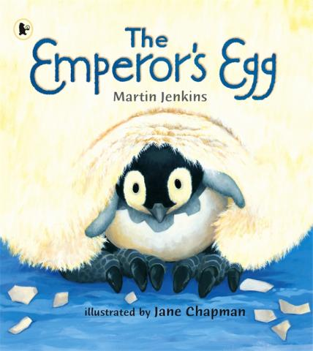  PoR | PoR  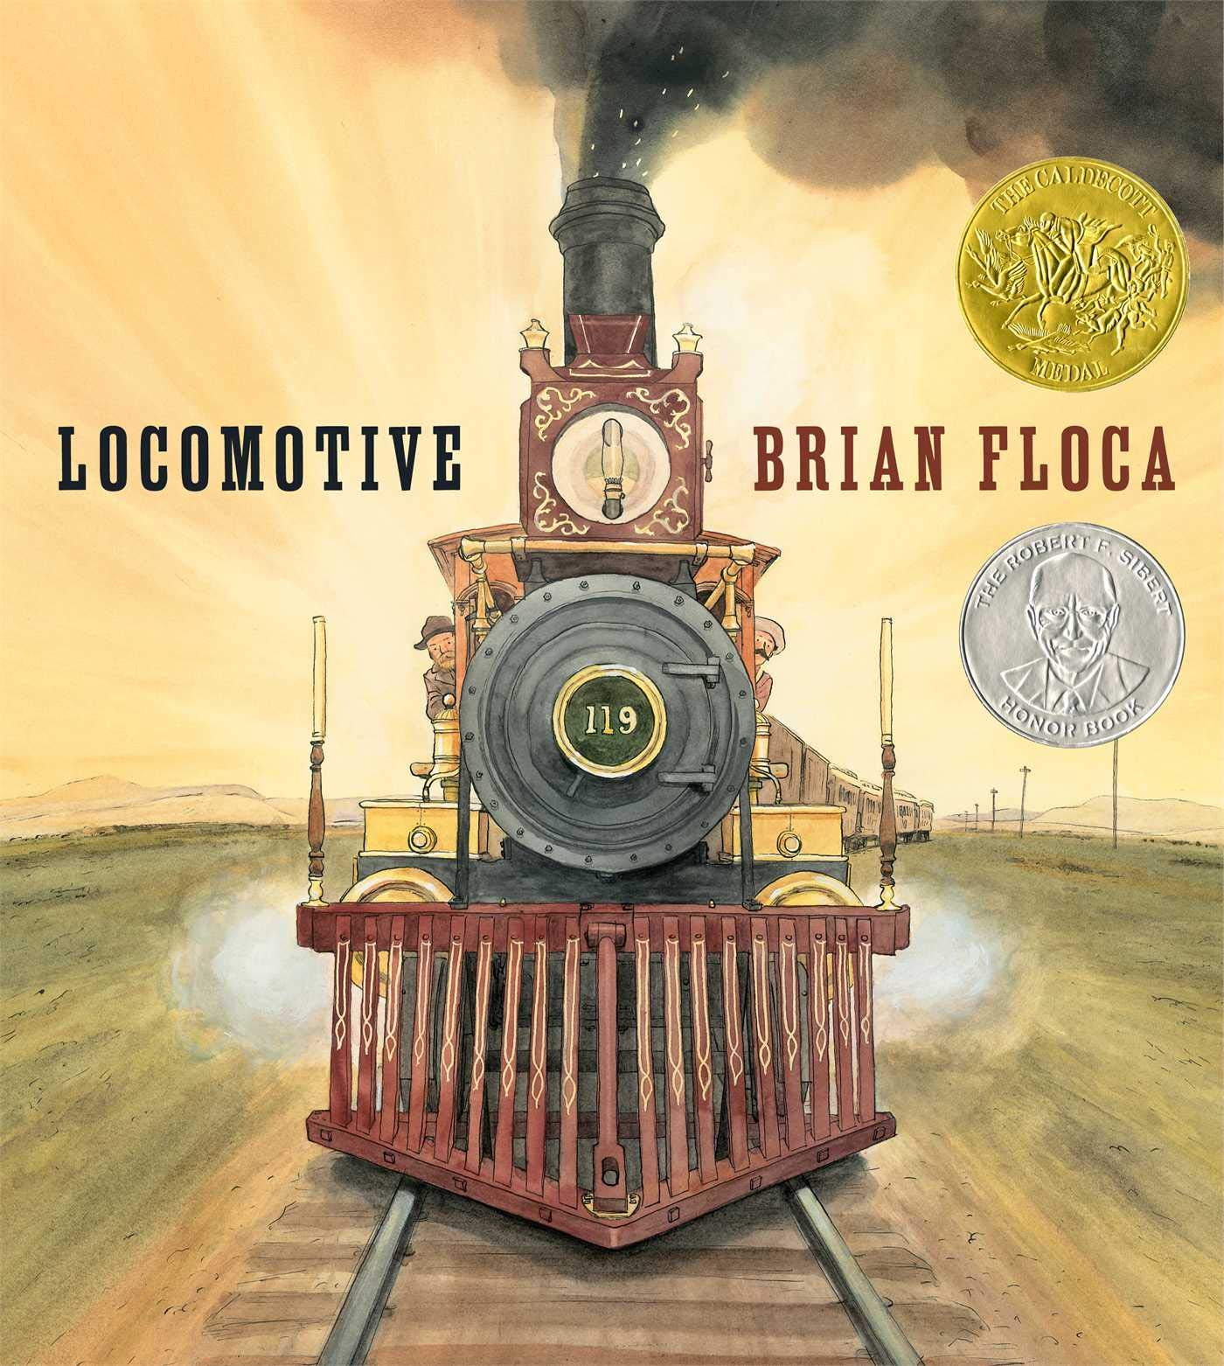 | 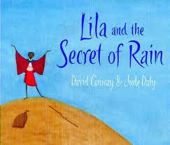  PoR  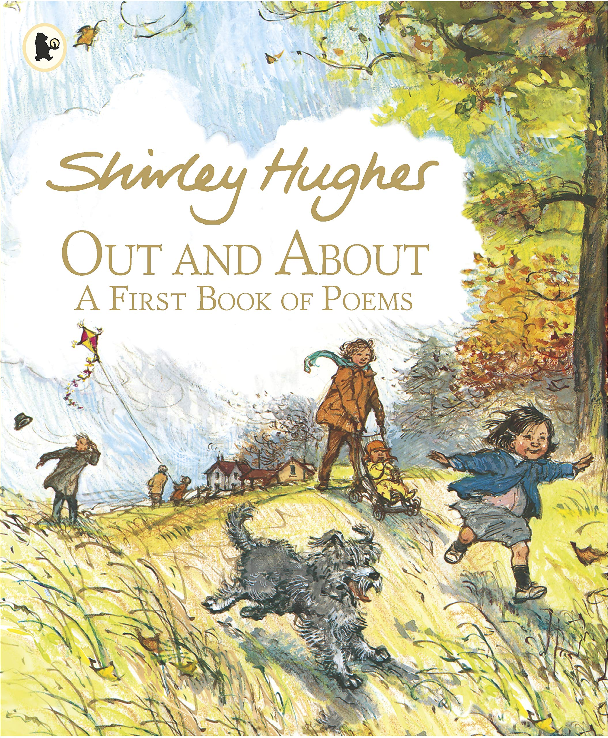 | 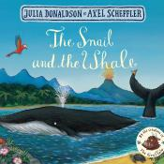  PoR | 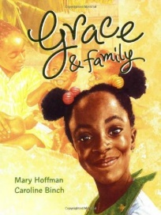  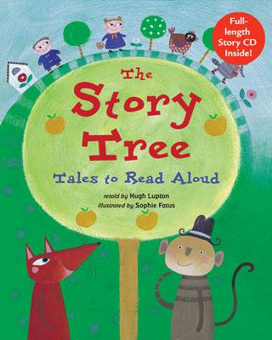
Theme | Fairy Tales |  | Poles Apart | Planes Trains and Automobiles | The Seasons | The Seaside | Where I am from?
Comprehension Objectives | Predicting, sequencing  Clarifying  Text to Self |  | Predicting, inference, sequencing, making connections. | Predicting, visualising, sequencing. | Predicting, making connections, inference, retrieval. | Predicting, sequencing, retrieval, making connections. | Predicting, inference, retelling, clarifying
Poetry  Reciting by heart | Blue Balloons and Rabbit Ears. PoR CLiPPA |  | Zim Zam Zoom! PoR CLiPPA | ‘Song of the Train’ by David McCord | Out and About Shirley Hughes- Seasonal Poems | A Great Big Cuddle  PoR CLiPPA | ‘Give Yourself a Hug’ by Grace Nichols
Composition objectives with key grammar and punctuation | Writing in role  Thought bubbles speech bubbles  • regular plural noun suffixes (-s, -es) • separation of words with spaces  • beginning to punctuate sentences using a capital letter and a full stop. |  | Signs with captions and fact files  • Capital letters for names, places, days of the week and pronoun I | Writing in role Caption writing •sentence demarcation (. ! ?)  • to combine words to make sentences, including using and  direct speech | Fact File/Glossary (about seasons/weather)  to combine words to make sentences, including using and | Instructions  •verb suffixes where root word is  unchanged (-ing, -ed, -er)  Imperative verbs | Recount and writing a new ending  • un- prefix to change meaning of adjectives/adverbs
Reading List | Various Fairy Tales |  | The Little Polar  Polar Express | Things that Go!  Traction Man at the Sea Toys in Space | One Snowy Night | Winnie at the Seaside | Stories from around the world
Essential Knowledge (National Curriculum) Year 1

Phonic and Whole Word Spelling |  | • words containing each of the 40+ phonemes taught  • common exception words  • the days of the week  • name the letters of the alphabet in order  • using letter names to distinguish between alternative spelling of the same sound
Other Word Building Spelling |  | • using the spelling rule for adding –s or –es as the plural marker  • for nouns and the third person singular marker for verbs  • using the prefix un–  • using –ing, –ed, –er and –est where no change is needed in the  • spelling of root words  • apply simple spelling rules and guidance from Appendix 1
Transcription |  | • write from memory simple sentences dictated by the teacher that include words using the GPCs and common exception words taught so far.
Handwriting |  | • sit correctly at a table, holding a pencil comfortably and correctly  • begin to form lower-case letters in the correct direction, starting and finishing in the right place  • form capital letters  • form digits 0-9  • understand which letters belong to which handwriting ‘families’ and to practise these  • leaving spaces between words
Contexts for Writing

Planning Writing |  | • saying out loud what they are going to write about • composing a sentence orally before writing it
Drafting Writing |  | • sequencing sentences to form short narratives  • re-reading what they have written to check that it makes sense
Editing Writing |  | • discuss what they have written with the teacher or other pupils
Performing Writing |  | • read their writing aloud clearly enough to be heard by their peers and the teacher
Vocabulary |  | • joining words and joining clauses using "and"
Grammar |  | regular plural noun suffixes (-s, -es) • verb suffixes where root word is unchanged (-ing, -ed, -er)  • un- prefix to change meaning of adjectives/adverbs  • to combine words to make sentences, including using and  • Sequencing sentences to form short narratives  • separation of words with spaces  • sentence demarcation (. ! ?)
Punctuation |  | • beginning to punctuate sentences using a capital letter and a full stop, question mark or exclamation mark  • using a capital letter for names of people, places, the days of the week, and the personal pronoun ‘I’
Grammatical Terminology |  | • letter, capital letter, word, singular, plural , sentence punctuation, full stop, question mark, exclamation mark
Year 2 | Autumn 1 |  | Autumn 2 | Spring 1 | Spring 2 | Summer 1 | Summer 2
Quality Text | 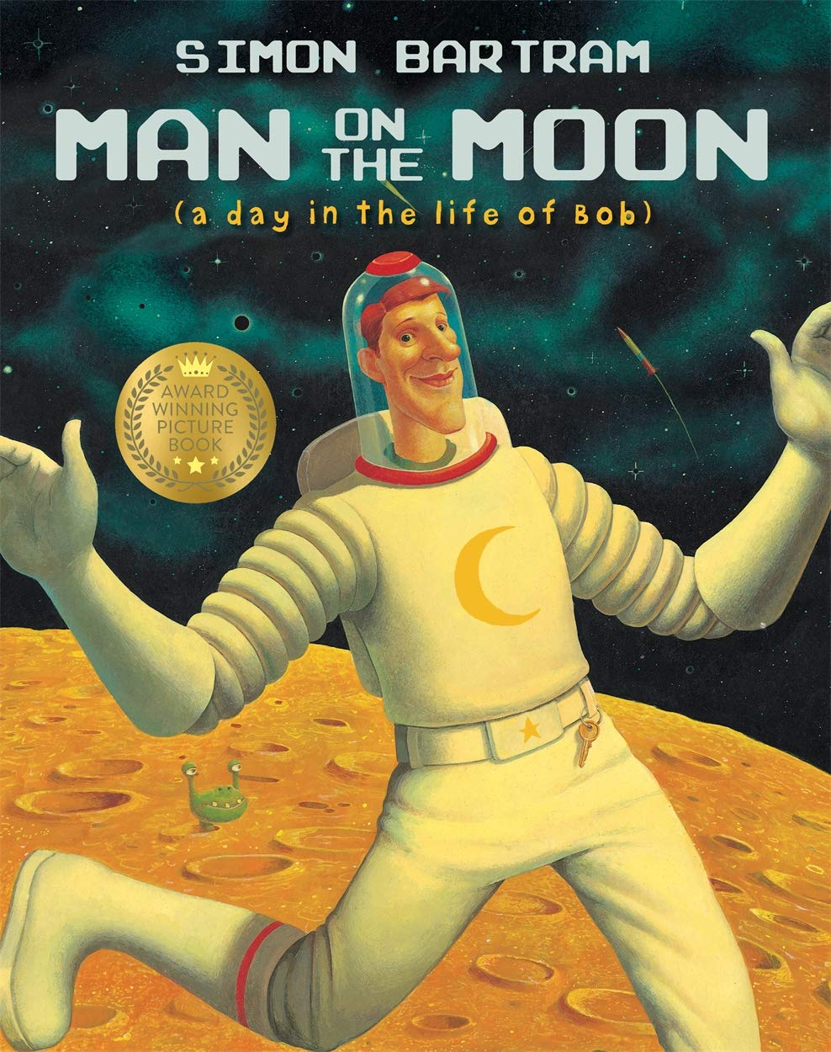  PoR |  | 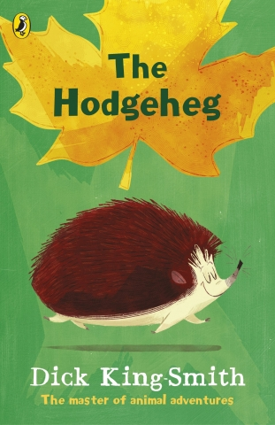  PoR | 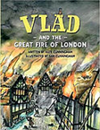  PoR | 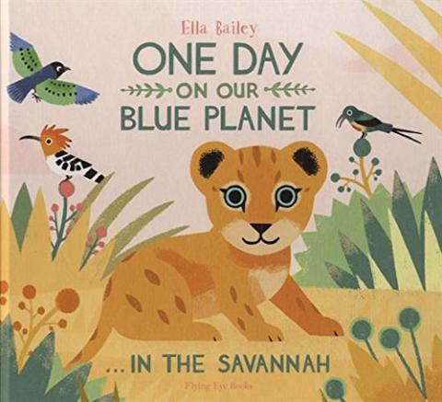  PoR | 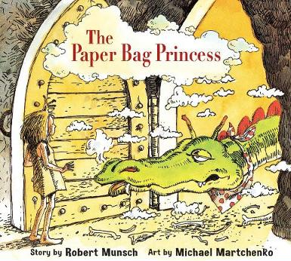 | 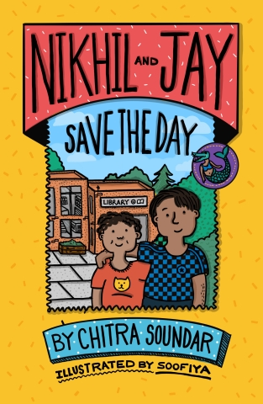  PoR
Theme | People who changed the world |  | The UK | Great Fire of London | Africa | Castles and Ruins | India
Comprehension Objectives | Discussing and clarifying the meaning of new words, linking new meanings to known vocabulary.  Answering and asking questions |  | Listen to, discuss, and express views about a wide range of stories.  Answering and asking questions | Introduction to non-fiction texts that are structured differently. | Draw on what is already known, or background information and vocabulary.  Answering and asking questions | Predicting what might happen next based on what has been read so far.  Answering and asking questions | Discuss favourite words and phrases.  Answering and asking questions
Poetry  Reciting by heart with intonation | Poems about what to be when we grow up.  ‘Thinker My Puppy Poet’ PoR CLiPPA |  | The Laughter Forecast’ by Sue Cowling  The Proper Way to Meet a Hedgehog and Other How-To Poems  PoR CLiPPA | The Great Fire of London’ by Paul Perro  Jelly Boots Smelly Boots PoR CLiPPA | Where Zebras Go by Sue Hardy-Dawson PoR CLiPPA | Poems to Perform  PoR CLiPPA | ‘My Colourful Land’ by Guarav Bhaduri
Composition objectives with key grammar and punctuation | Persuasion  • subordination (using when, if, that, or because) and coordination (using or, and, or but) |  | Report writing Instructions  • apostrophes for omission & singular possession | Narrative- Writing in role  • past tense  • expanded noun phrases to describe and specify  • subordination (using when, if, that, or because) and coordination (using or, and, or but) | Diary and descriptions  • sentences with different forms: statement, question, command  • expanded noun phrases to describe and specify  • commas in lists | Story Writing and Plays  • suffixes to form new words (-ful, -er, -ness)  • sentences with different forms: statement, question, command. exclamation  • past progressive tense | Report writing, captions and labels  • commas in lists  • subordination (using when, if, that, or because) and coordination (using or, and, or but)
Reading List | Cakes in Space 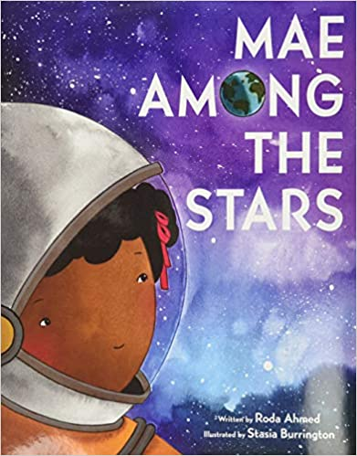 |  | 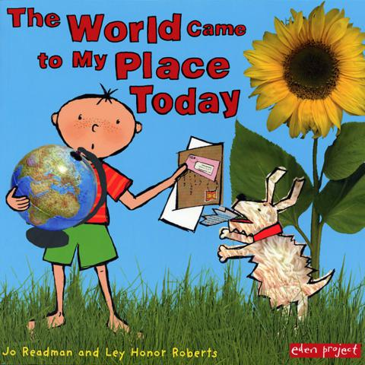 | 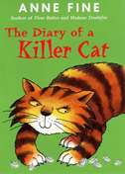 | 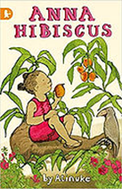 | 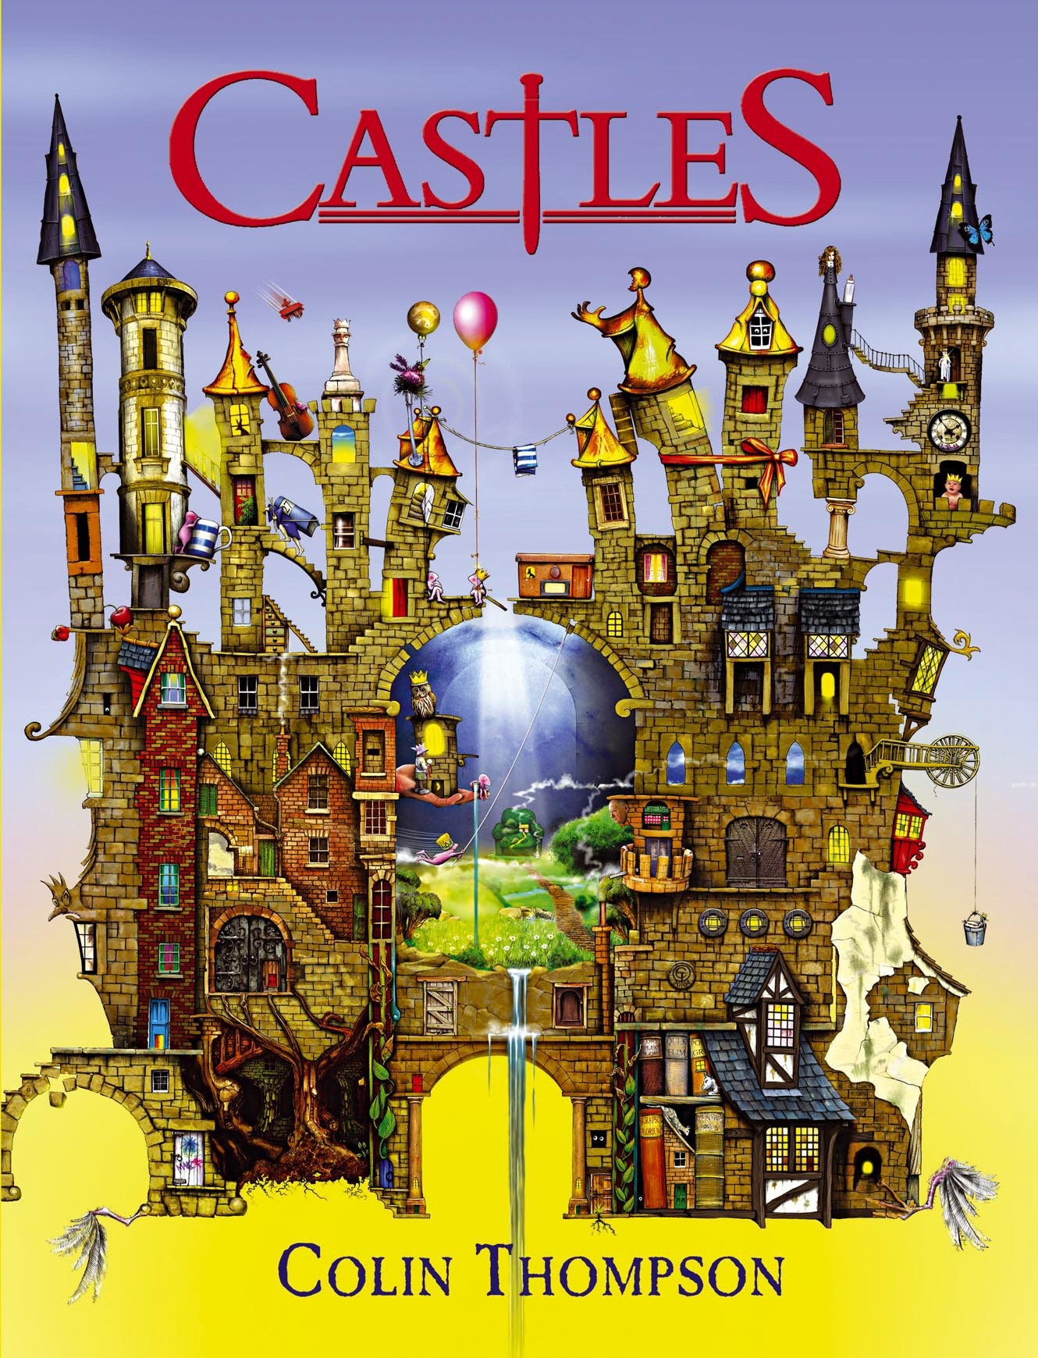
Essential Knowledge (National Curriculum) Year 2

Phonic and Whole Word Spelling |  | • segmenting spoken words into phonemes and representing  • these by graphemes, spelling many correctly  • learning new ways of spelling phonemes for which 1 or more  • spellings are already known, and learn some words with each  • spelling, including a few common homophones  • learning to spell common exception words  • distinguishing between homophones and near-homophones
Other Word Building Spelling |  | • learning the possessive apostrophe (singular)  • learning to spell more words with contracted forms  • add suffixes to spell longer words, including –ment, –ness,  • –ful, –less, –ly  • apply spelling rules and guidelines from Appendix 1
Transcription |  | • write from memory simple sentences dictated by the teacher  • that include words using the GPCs, common exception words  • and punctuation taught so far.
Handwriting |  | • form lower-case letters of the correct size relative to one another  • start using some of the diagonal and horizontal strokes needed to join letters and understand which letters, when adjacent to one another, are best left unjoined  • write capital letters and digits of the correct size, orientation and relationship to one another and to lower-case letters  • use spacing between words that reflects the size of the letters
Contexts for Writing |  | • writing narratives about personal experiences and those of others (real and fictional)  • writing about real events  • writing poetry  • writing for different purposes
Planning Writing |  | • planning or saying out loud what they are going to write about
Drafting Writing |  | • writing down ideas and/or key words, including new vocabulary  • encapsulating what they want to say, sentence by sentence
Editing Writing |  | • evaluating their writing with the teacher and other pupils  • rereading to check that their writing makes sense and that verbs to indicate time are used correctly and consistently, including verbs in the continuous form  • proofreading to check for errors in spelling, grammar and punctuation
Performing Writing |  | • read aloud what they have written with appropriate intonation to make the meaning clear
Vocabulary |  | • expanded noun phrases to describe and specify
Grammar |  | • sentences with different forms: statement, question, exclamation, command  • the present and past tenses correctly and consistently including the progressive form  • subordination (using when, if, that, or because) and coordination (using or, and, or but)  • some features of written Standard English  • suffixes to form new words (-ful, -er, -ness)  • sentence demaracation  • commas in lists  • apostrophes for omission & singular possession
Punctuation |  | • learning how to use both familiar and new punctuation correctly, including full stops, capital letters, exclamation marks, question marks, commas for lists and apostrophes for contracted forms and the possessive (singular)
Grammatical Terminology |  | • noun, noun phrase, statement, question, exclamation, command, compound, adjective, verb, suffix , adverb tense (past, present) , apostrophe, comma

Year 3 | Autumn 1 |  | Autumn 2 | Spring 1 | Spring 2 | Summer 1 | Summer 2
Quality Text | 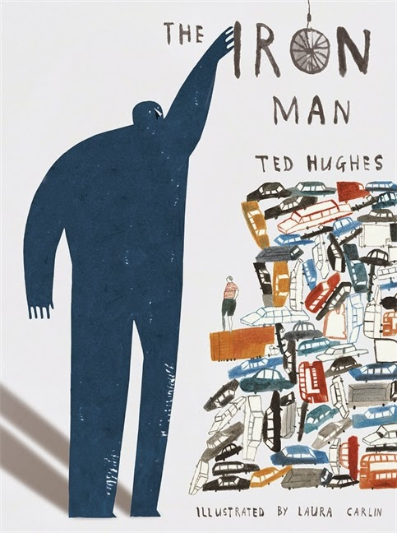PoR |  | 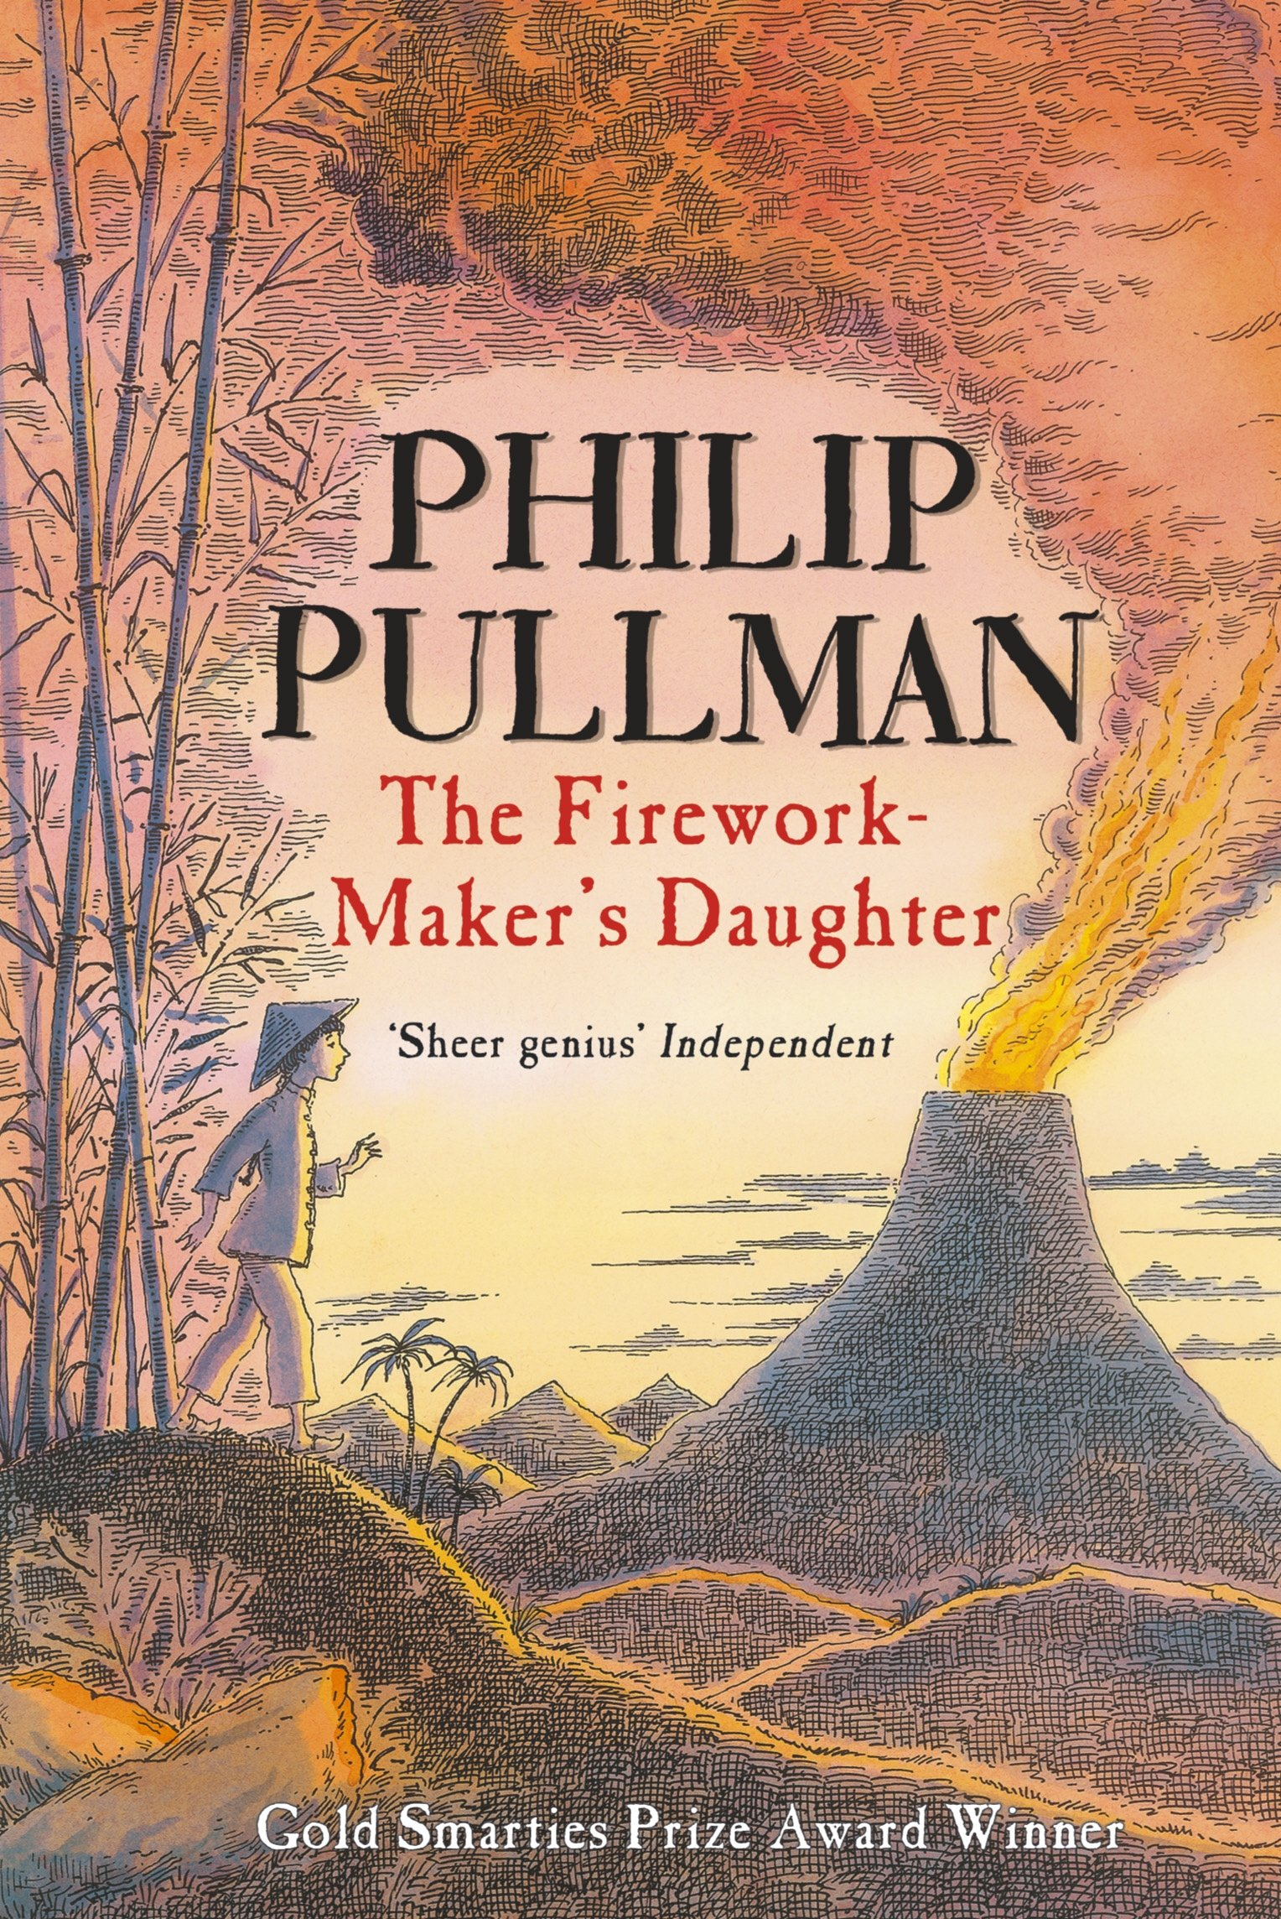  PoR | 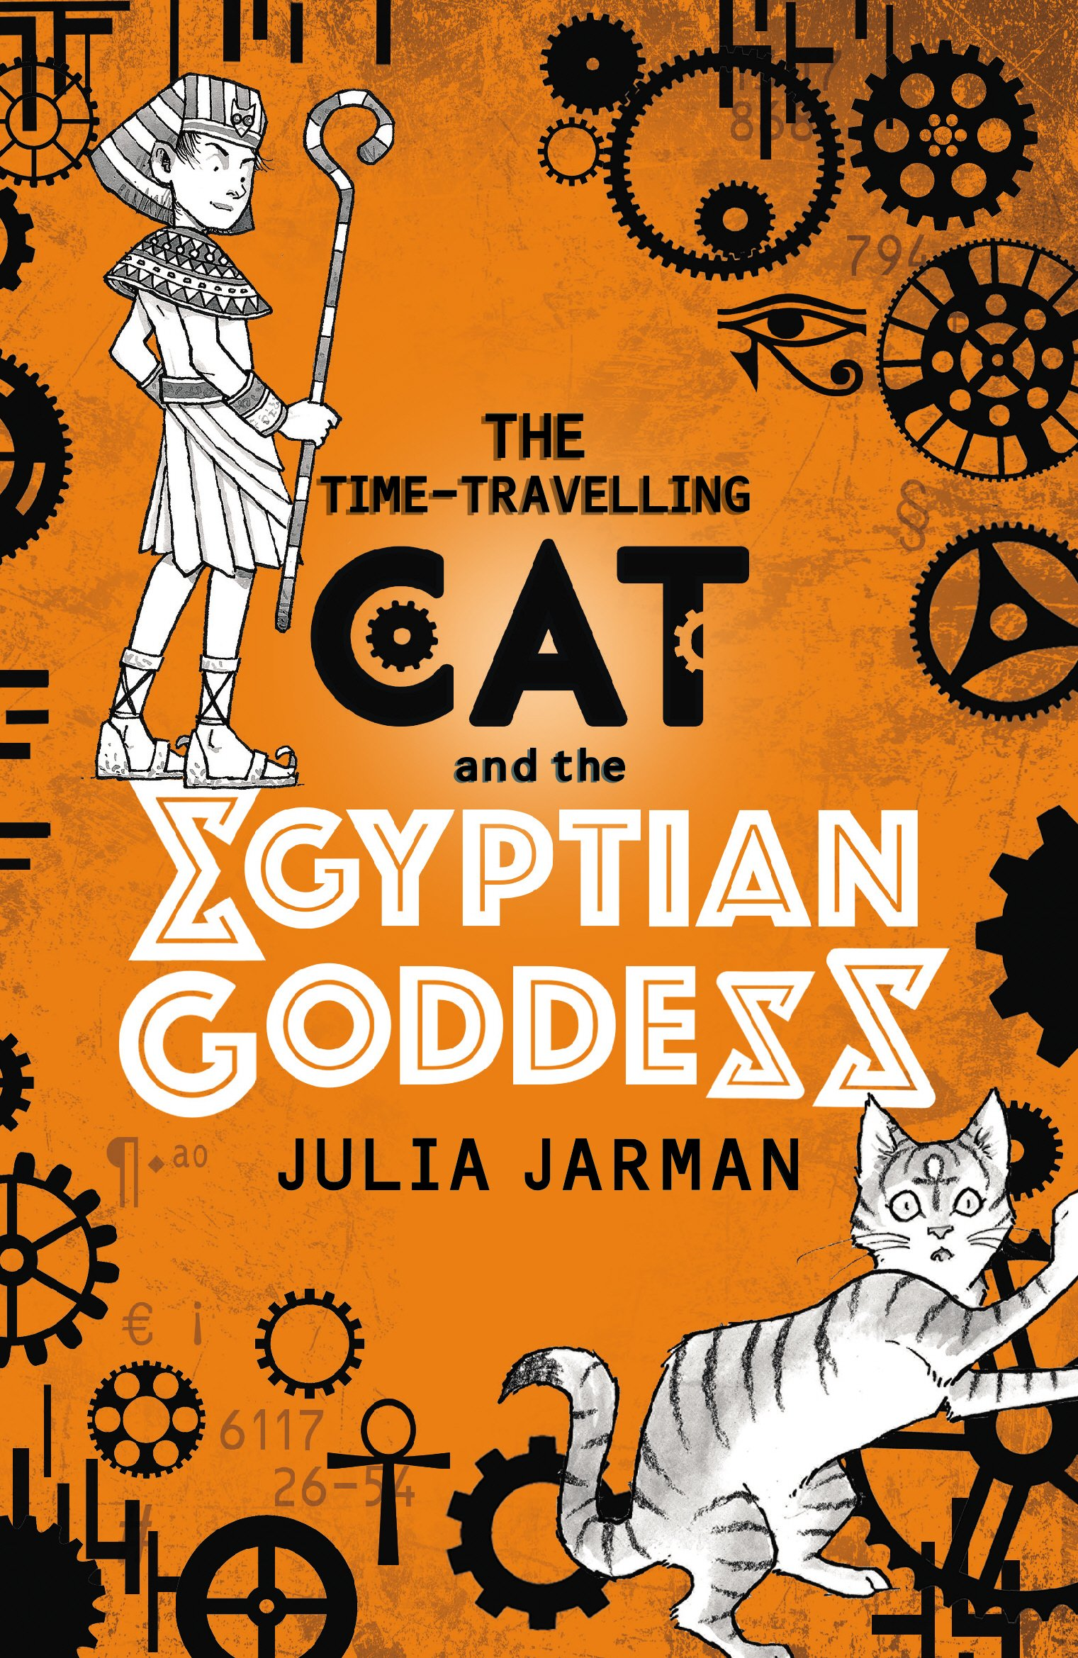  PoR | 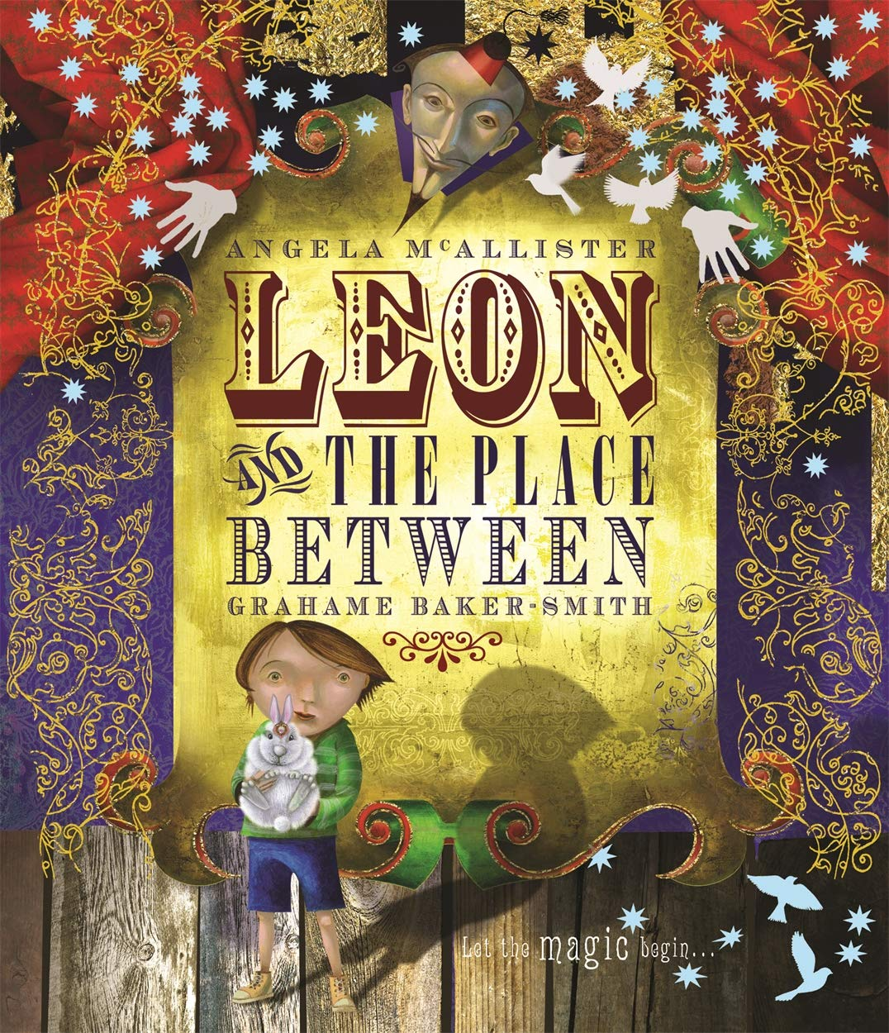  PoR | 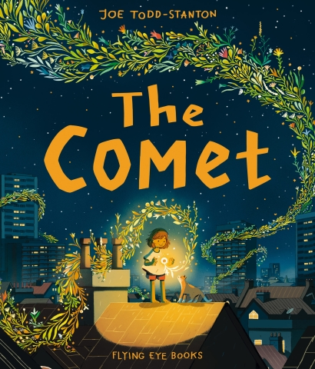  PoR | 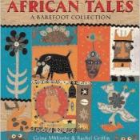  PoR
Theme | Stone Age |  | Pollution | Egyptians | Spain | Life at home | Deserts
Comprehension Objectives | Inference  Retrieval |  | Prediction and Inference  Text to Self | Summarising &  vocabulary clarification | Complex inference  Clarification | Text to World | All Skills
Poetry  Reciting with intonation, actions and dynamics | Poems to Perform  CLiPPA |  | Cherry Moon by Zaro Weil | McCavity the Mystery Cat TS Eliot | Magic Box  Kit Wright  Bright Bursts of Colour CLiPPA | The Dragon with a Big Nose by Kathy Henderson CLiPPA | Poetry Pie by Roger McGough PoR
Composition objectives with key grammar and punctuation | Diary and Report  extending the range of sentences with more than one clause by using a wider range of conjunctions, including when, if, because, although |  | Narrative Setting Description and Retell  using conjunctions, adverbs and prepositions to express time and cause (and place | Narrative story writing and alternative endings  form nouns using prefixes (super-, anti-)  using conjunctions, adverbs and prepositions to express time and cause (and place) | Plays and poetry  using and punctuating direct speech  (i.e. Inverted commas) | Reports and Instructions  use the correct form of ‘a’ or ‘an’  word families based on common words (solve, solution, dissolve, insoluble | Traditional tales story writing  • using and punctuating direct speech (i.e. Inverted commas)
Reading List | Ug |  | One Plastic Bag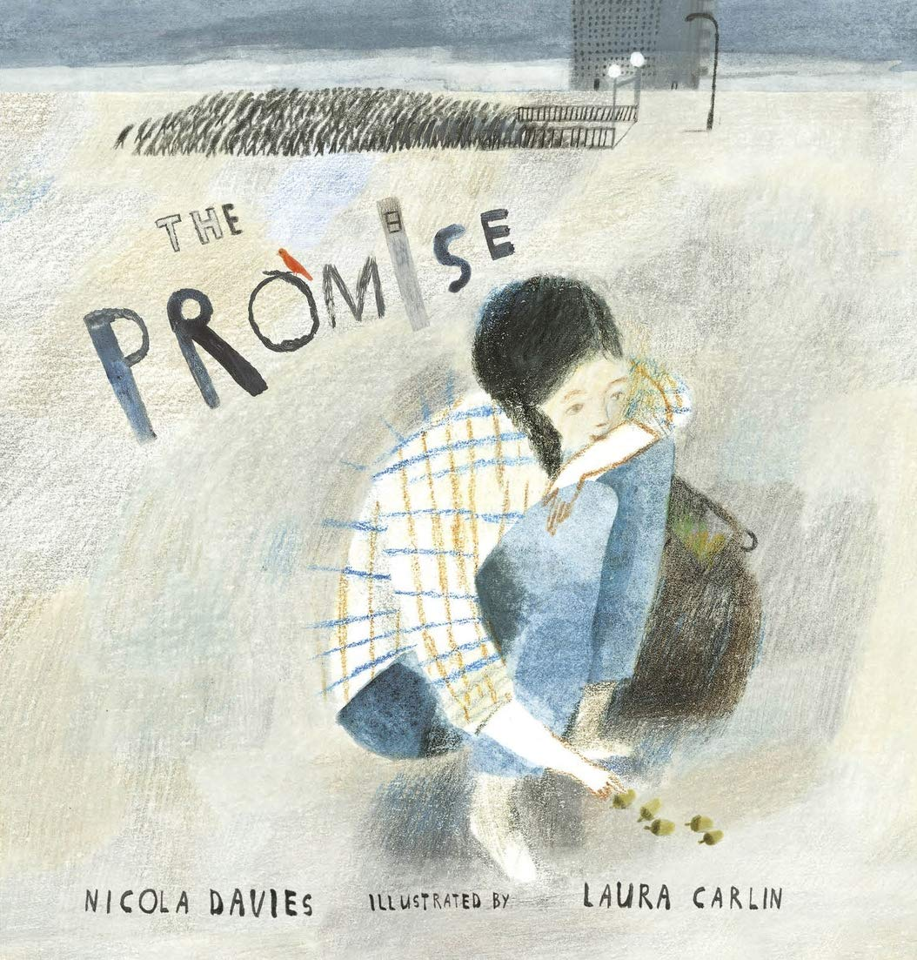 | Non-fiction books on Egyptains | Charlotte’s Web | A Walk in London
Essential Knowledge (National Curriculum) Year 3

Phonic and Whole Word Spelling |  | • spell further homophones  • spell words that are often misspelt (Appendix 1)
Other Word Building Spelling |  | • use further prefixes and suffixes and understand how to add them.  • place the possessive apostrophe accurately in words with regular plurals and in words with irregular plurals.  • use the first 2 or 3 letters of a word to check its spelling in a dictionary
Transcription |  | • write from memory simple sentences, dictated by the teacher, that include words and punctuation taught so far.
Handwriting |  | • use the diagonal and horizontal strokes that are needed to join letters and understand which letters, when adjacent to one another, are best left unjoined.  • increase the legibility, consistency and quality of their handwriting.
Contexts for Writing |  | • discussing writing similar to that which they are planning to write in order to understand and learn from its structure, vocabulary and grammar.
Planning Writing |  | • discussing and recording ideas  • composing and rehearsing sentences orally (including dialogue), progressively building a varied and rich vocabulary and an increasing range of sentence structures
Drafting Writing |  | • organising paragraphs around a theme  • in narratives, creating settings, characters and plot  • in non-narrative material, using simple organisational devices (headings & subheadings)
Editing Writing |  | • assessing the effectiveness of their own and others’ writing and suggesting improvements  • proposing changes to grammar and vocabulary to improve consistency, including the accurate use of pronouns in sentences  • proofread for spelling and punctuation errors
Performing Writing |  | • read their own writing aloud, to a group or the whole class, using appropriate intonation and controlling the tone and volume so that the meaning is clear.
Vocabulary |  | • extending the range of sentences with more than one clause by using a wider range of conjunctions, including when, if, because, although  • choosing nouns or pronouns appropriately for clarity and cohesion and to avoid repetition  • using conjunctions, adverbs and prepositions to express time and cause (and place)
Grammar |  | • using the present perfect form of verbs in contrast to the past tense  • form nouns using prefixes (super-, anti-)  • use the correct form of 'a' or 'an'  • word families based on common words (solve, solution, dissolve, insoluble)
Punctuation |  | • using and punctuating direct speech (i.e. Inverted commas)
Grammatical Terminology |  | • adverb, preposition conjunction, word family, prefix, clause, subordinate clause, direct speech, consonant, consonant letter vowel, vowel letter, inverted commas (or ‘speech marks’)

Year 4 | Autumn 1 |  | Autumn 2 | Spring 1 | Spring 2 | Summer 1 | Summer 2
Quality Text | 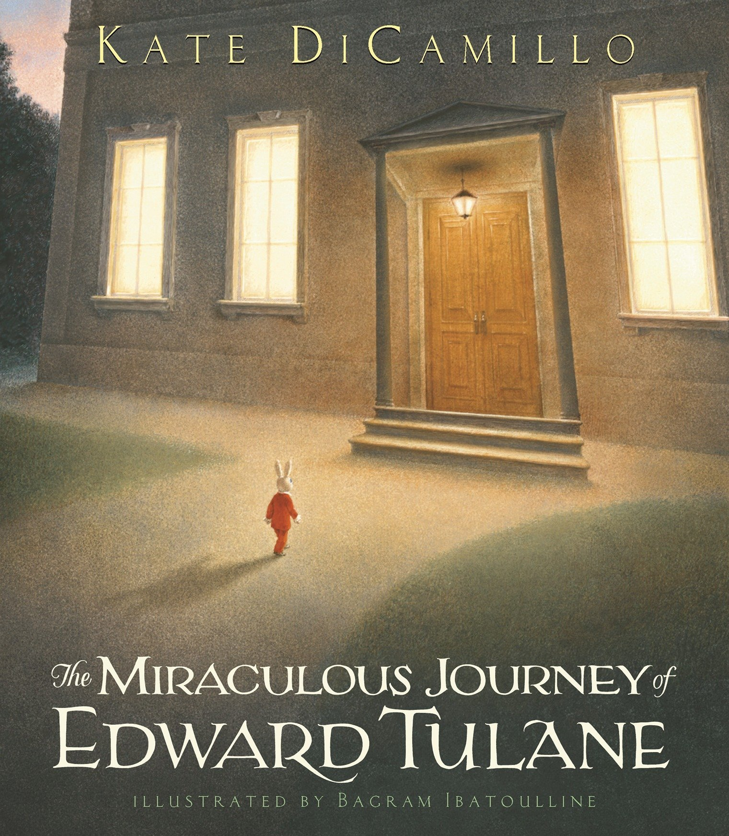  PoR |  | 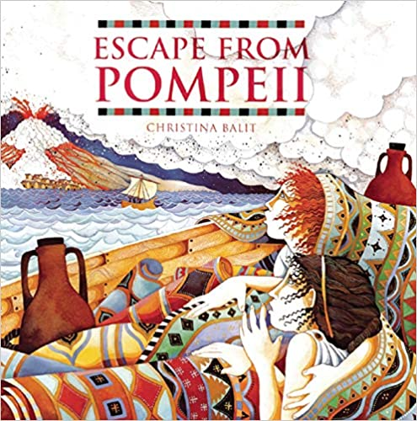 | 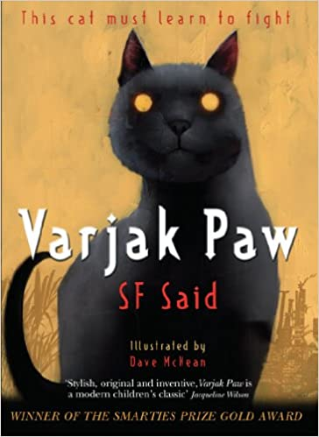  PoR | 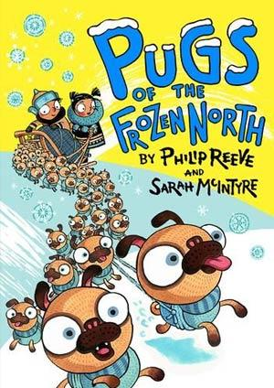  PoR | 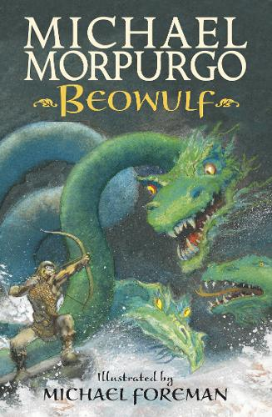 | 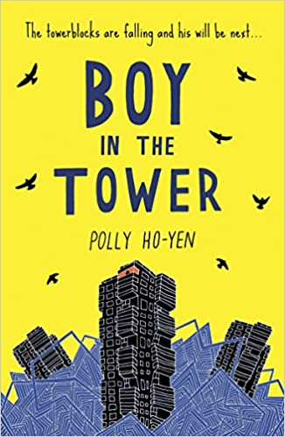  PoR
Theme | Romans |  | Volcanic Eruptions | Ancient Civilisations | Countries of the World | Saxons | World Resources
Comprehension Objectives | Inference  Retrieval  Vocabulary |  | Prediction and Inference  Text to Self | Summarising  And Vocabulary | Complex inference | Text to world | All skills
Poetry  Reciting with intonation, actions and dynamics | A Kid in My Class by Rachel Rooney CLiPPA |  | Midnight Feasts: Tasty Poems chosen by A.F. Harrold, illustrated by Katy Riddell | Werewolf Club Rules CLiPPA | Moon Juice | Dancing in the Rain by John Lyons poet from Trinidad PoR CLiPPA | My Life as a Goldfish CLiPPA
Composition objectives with key grammar and punctuation | Writing in role narrative  Story  • extending the range of sentences with more than one clause by using a wider range of conjunctions, including when, if, because, although |  | Reports  • using fronted adverbials  • using commas after fronted adverbials  • extending the range of sentences with more than one clause by using a wider range of conjunctions, including when, | Instructions and Letters  • using and punctuating direct speech (including punctuation within and surrounding inverted commas) | Discussion and Letters  • difference between plural and possesive -s  • indicating possession by using the possessive apostrophe with singular and plural nouns | Plays and  Persuasion  • choosing nouns or pronouns appropriately for  clarity and cohesion and to avoid repetition | Newspaper reports and debates  • Standard English verb inflections (I did vs I done)  • extended noun phrases, including with prepositions
Reading List | Non Fiction  books on Romans |  |  | The Stone Mouse by Jenny Nimmo | Oliver and the Seawigs | Storm Kevin Crossley-Holland PoR | Non fiction and newspaper reports
Essential Knowledge (National Curriculum) Year 4

Phonic and Whole Word Spelling |  | • spell further homophones  • spell words that are often misspelt (Appendix 1)
Other Word Building Spelling |  | • use further prefixes and suffixes and understand how to add them  • place the possessive apostrophe accurately in words with regular plurals and in words with irregular plurals  • use the first 2 or 3 letters of a word to check its spelling in a dictionary
Transcription |  | • write from memory simple sentences, dictated by the teacher, that include words and punctuation taught so far.
Handwriting |  | • use the diagonal and horizontal strokes that are needed to join letters and understand which letters, when adjacent to one another, are best left unjoined  • increase the legibility, consistency and quality of their handwriting
Contexts for Writing |  | • discussing writing similar to that which they are planning to write in order to understand and learn from its structure, vocabulary and grammar
Planning Writing |  | • discussing and recording ideas  • composing and rehearsing sentences orally (including dialogue), progressively building a varied and rich vocabulary and an increasing range of sentence structures
Drafting Writing |  | • organising paragraphs around a theme in narratives, creating settings, characters and plot  • in non-narrative material, using simple organisational devices
Editing Writing |  | • assessing the effectiveness of their own and others’ writing and suggesting improvements  • proposing changes to grammar and vocabulary to improve consistency, including the accurate use of pronouns in  • sentences  • proofread for spelling and punctuation errors
Performing Writing |  | • read their own writing aloud, to a group or the whole class, using appropriate intonation and controlling the tone and volume so that the meaning is clear
Vocabulary |  | • extending the range of sentences with more than one clause by using a wider range of conjunctions, including when, if, because, although  • choosing nouns or pronouns appropriately for clarity and cohesion and to avoid repetition
Grammar |  | • using fronted adverbials  • difference between plural and possessive -s  • Standard English verb inflections (I did vs I done)  • extended noun phrases, including with prepositions  • appropriate choice of pronoun or noun to create cohesion
Punctuation |  | • using commas after fronted adverbials  • indicating possession by using the possessive apostrophe with singular and plural nouns  • using and punctuating direct speech (including punctuation within and surrounding inverted commas)
Grammatical Terminology |  | • determiner, pronoun, possessive pronoun, adverbial

Year 5 | Autumn 1 |  | Autumn 2 | Spring 1 | Spring 2 | Summer 1 | Summer 2
Quality Text | 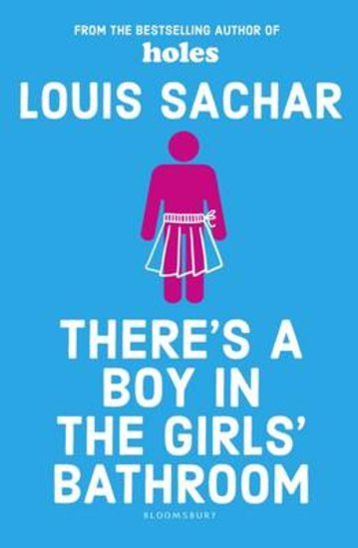 |  | 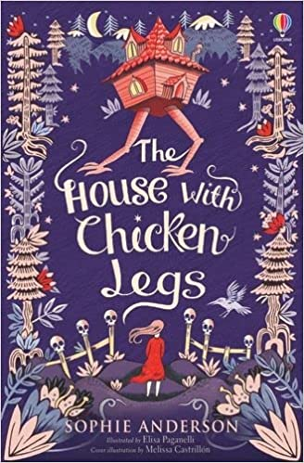  PoR | 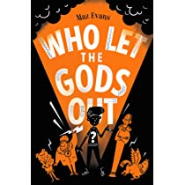  PoR | 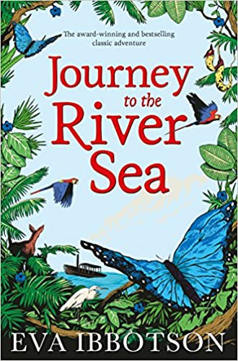  PoR | 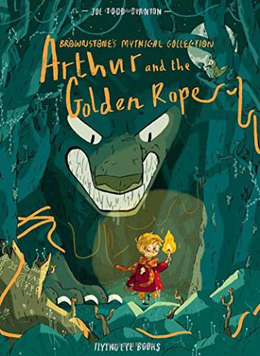  PoR | 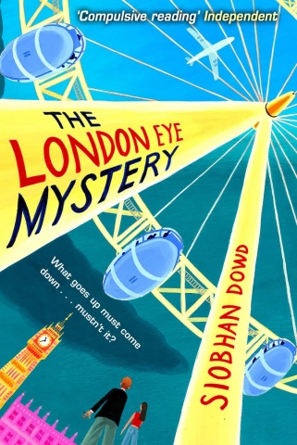  PoR
Theme | British Empire |  | Mexico | Ancient Greece | Rivers | Vikings | Britain of Today
Comprehension Objectives | Inference  Retrieval |  | Prediction and Inference  Text to Self | Summarising  And Vocabulary | Complex inference | Text to World | All Skills
Poetry  Learning a wider range to perform by heart  Recite  showing understanding by actions intonation and dynamics which makes the meaning clear for the audience | Cosmic Disco  Grace Nichols CLiPPA |  | Poems about Day of the Dead  Video and artefact stimulus | The Rainmaker Danced by John Agard PoR CLiPPA | Poems the Wind Blew in CLiPPA | The Highwayman  PoR | Making a difference
Writing Composition Objectives | Diary & Letters  • using relative clauses beginning with who, which, where, when, whose, that or with an implied (ie omitted) relative pronoun |  | Poetry & Reports  • using commas to clarify meaning or  avoid ambiguity in writing | Plays and Narrative  • using brackets, dashes or commas to indicate parenthesis  • devices to build cohesion, including adverbials of time, place and number | Discussion & Debate  • using the perfect form of verbs to mark relationships of time and cause  • using brackets, dashes or commas to indicate parenthesis | Non Chronological Reports  • verb prefixes  • converting nouns or adjectives | Persuasion  • using modal verbs or adverbs to indicate degrees of possibility
Reading List | 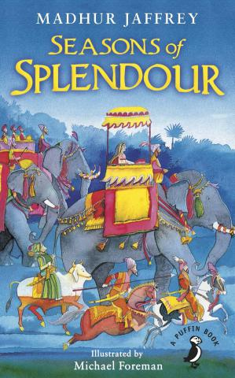 |  | Day of the Dead on Literacy Shed | Greek Myths  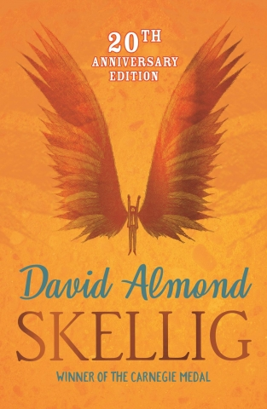 | The Explorer | 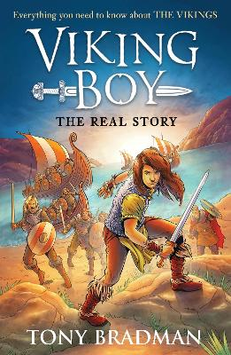
Essential Knowledge (National Curriculum) Year 5

Phonic and Whole Word Spelling |  | • spell some words with ‘silent’ letters  • continue to distinguish between homophones and other words which are often confused  • use knowledge of morphology and etymology in spelling and understand that the spelling of some words needs to be learnt specifically, as listed in Appendix 1
Other Word Building Spelling |  | • use further prefixes and suffixes and understand the guidance for adding them  • use dictionaries to check the spelling and meaning of words  • use the first 3 or 4 letters of a word to check spelling, meaning or both of these in a dictionary
Transcription

Handwriting |  | • choosing which shape of a letter to use when given choices and deciding whether or not to join specific letters  • choosing the writing implement that is best suited for a task
Contexts for Writing |  | • identifying the audience for and purpose of the writing, selecting the appropriate form and using other similar writing as models for their own  • in writing narratives, considering how authors have developed characters and settings in what pupils have read, listened to or seen performed
Planning Writing |  | • noting and developing initial ideas, drawing on reading and research where necessary
Drafting Writing |  | • selecting appropriate grammar and vocabulary, understanding how such choices can change and enhance meaning  • in narratives, describing settings, characters and atmosphere and integrating dialogue to convey character and advance the action  • précising longer passages  • using a wide range of devices to build cohesion within and across paragraphs  • using further organisational and presentational devices to structure text and to guide the reader
Editing Writing |  | • assessing the effectiveness of their own and others’ writing  • proposing changes to vocabulary, grammar and punctuation to enhance effects and clarify meaning  • ensuring the consistent and correct use of tense throughout a piece of writing  • ensuring correct subject and verb agreement when using singular and plural, distinguishing between the language of speech and writing and choosing the appropriate register  • proofread for spelling and punctuation errors
Performing Writing |  | • perform their own compositions, using appropriate intonation, volume, and movement so that meaning is clear.
Vocabulary |  | • use a thesaurus  • using expanded noun phrases to convey complicated information concisely
Grammar |  | • using the perfect form of verbs to mark relationships of time and cause  • using relative clauses beginning with who, which, where, when, whose, that or with an implied (ie omitted) relative pronoun  • converting nouns or adjectives into verbs  • verb prefixes  • devices to build cohesion, including adverbials of time, place and number
Punctuation |  | • using commas to clarify meaning or avoid ambiguity in writing  • using brackets, dashes or commas to indicate parenthesis
Grammatical Terminology |  | • modal verb, relative pronoun, relative clause, parenthesis, bracket, dash, cohesion, ambiguity

Year 6 | Autumn 1 |  | Autumn 2 | Spring 1 | Spring 2 | Summer 1 | Summer 2
Quality Text | 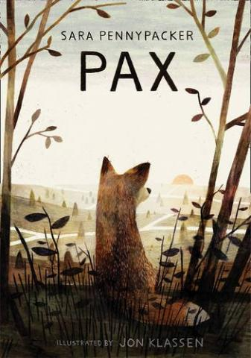  PoR |  | 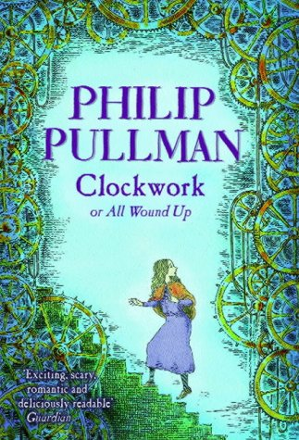  Pandora Discovered Literacy Shed | 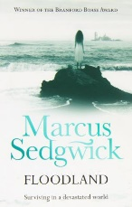  PoR | 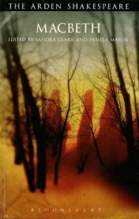  PoR | 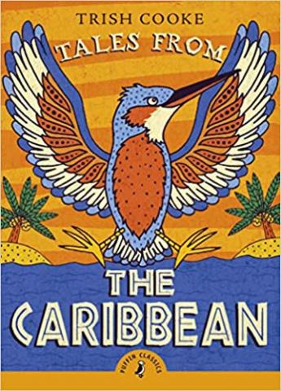  PoR | 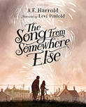  PoR
Theme | War |  | Terrain | Extreme Weather | Monarchy | Building a new Britain | Water
Comprehension Objectives | Inference  Retrieval |  | Prediction and Inference  Text to Self | Summarising  And vocabulary clafification | Complex inference | Text to World | All Skills
Poetry Learning a wider range to perform by heart  Recite  showing understanding by actions intonation and dynamics which makes the meaning clear for the audience | Poetry of WW2 |  | Dark Sky Park collection CLiPPA  (poems about nature and terrain) | Let in the Stars in  CLiPPA  The Lady of Shalott | Bright Bursts of Colour by Matt Goodfellow CLiPPA | Poetry of Benjamin Zepheniah  Dancing in the Rain Poems from Trinidad CLiPPA Clippa | Everything All at Once by Steven Camden- CLiPPA- Transition poems
Composition Objectives with key grammar and punctuation | Diary and Letters Formal and informal  • using the perfect form of verbs to mark relationships of time and cause  • use of ellipsis |  | Imaginative reports and Persuasion  • Using hyphens to avoid ambiguity  • Using semi-colons and dashes to mark independent clauses | Balanced Debates Discussion and Letters  • Using colons to separate independent clauses  • differences in informal and formal language  recognising vocabulary and structures that are appropriate | Plays, Narrative and Poetry  • Using a semi-colon to replace but  • Using bullet points consistently  • using passive verbs to affect the presentation of information in a sentence | Balanced Debates Narrative Stories and Biographies  • for formal speech and writing, including subjunctive forms | Reports Poetry Performance  • Using a colon to introduce a list  • synonyms & Antonyms
Reading List | 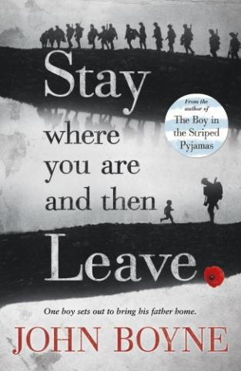  PoR |  | The Dam  The Portal |  | 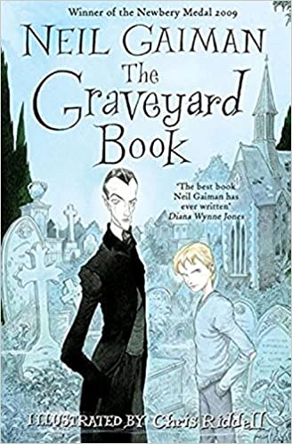 | Overlap The Graveyard Book and NL | Northern Lights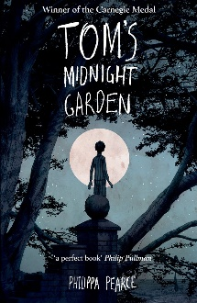
Essential Knowledge (National Curriculum) Year 6

Phonic and Whole Word Spelling |  | • spell some words with ‘silent’ letters  • continue to distinguish between homophones and other words which are often confused  • use knowledge of morphology and etymology in spelling and understand that the spelling of some words needs to be learnt specifically, as listed in Appendix 1
Other Word Building Spelling |  | • use further prefixes and suffixes and understand the guidance for adding them  • use dictionaries to check the spelling and meaning of words  • use the first 3 or 4 letters of a word to check spelling, meaning or both of these in a dictionary
Transcription

Handwriting |  | • choosing which shape of a letter to use when given choices and deciding whether or not to join specific letters  • choosing the writing implement that is best suited for a task
Contexts for Writing |  | • identifying the audience for and purpose of the writing, selecting the appropriate form and using other similar writing as models for their own  • in writing narratives, considering how authors have developed characters and settings in what pupils have read, listened to or seen performed
Planning Writing |  | • noting and developing initial ideas, drawing on reading and research where necessary
Drafting Writing |  | • selecting appropriate grammar and vocabulary, understanding how such choices can change and enhance meaning  • in narratives, describing settings, characters and atmosphere and integrating dialogue to convey character and advance the action  • précising longer passages  • using a wide range of devices to build cohesion within and across paragraphs  • using further organisational and presentational devices to structure text and to guide the reader
Editing Writing |  | • assessing the effectiveness of their own and others’ writing  • proposing changes to vocabulary, grammar and punctuation to enhance effects and clarify meaning  • ensuring the consistent and correct use of tense throughout a piece of writing  • ensuring correct subject and verb agreement when using singular and plural, distinguishing between the language of speech and writing and choosing the appropriate register  • proofread for spelling and punctuation errors
Performing Writing |  | • perform their own compositions, using appropriate intonation, volume, and movement so that meaning is clear.
Vocabulary |  | • use a thesaurus  • using expanded noun phrases to convey complicated information concisely  • using modal verbs or adverbs to indicate degrees of possibility
Grammar |  | • recognising vocabulary and structures that are appropriate for formal speech and writing, including subjunctive forms  • using passive verbs to affect the presentation of information in a sentence  • using the perfect form of verbs to mark relationships of time and cause  • differences in informal and formal language  • synonyms & Antonyms  • further cohesive devices such as grammatical connections and adverbials  • use of ellipsis
Punctuation |  | • using hyphens to avoid ambiguity  • using semicolons, colons or dashes to mark boundaries between independent clauses  • using a colon to introduce a list  • punctuating bullet points consistently
Grammatical Terminology |  | • subject, object, active, passive, synonym, antonym, ellipsis, hyphen, colon, semi-colon, bullet points

