St Peter and St Paul Catholic Primary School
Nursery
Long term curriculum plan with the progression of skills and knowledge

The themes/topics shown may change according to the children’s needs and interests.

Themes | Autumn 1  Marvellous Me!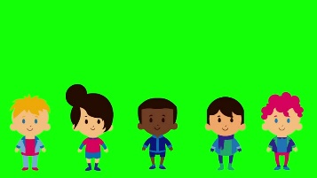 | Autumn 2  Reach for the Stars!  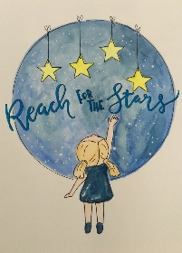 | Spring 1  My Favourite Toys  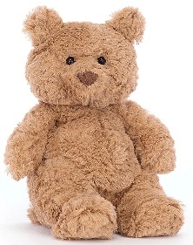 | Spring 2  We Are Bakers | Summer 1  Ready Steady Sow!  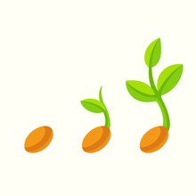 | Summer 2  Mad About Minibeasts  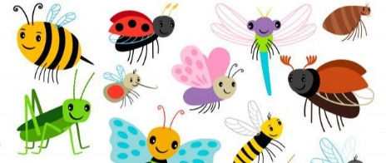
Areas of learning and development
PERSONAL, SOCIAL AND EMOTIONAL DEVELOPMENT
EYFS Statutory Educational Programme:
Children’s personal, social and emotional development (PSED) is crucial for children to lead healthy and happy lives, and is fundamental to their cognitive development. Underpinning their personal development are the important attachments that shape their social world. Strong, warm and supportive relationships with adults enable children to learn how to understand their own feelings and those of others.
Children should be supported to manage emotions, develop a positive sense of self, set themselves simple goals, have confidence in their own abilities, to persist and wait for what they want and direct attention as necessary. Through adult modelling and guidance, they will learn how to look after their bodies, including healthy eating, and manage personal needs independently. Through supported interaction with other children they learn how to make good friendships, co-operate and resolve conflicts peaceably. These attributes will provide a secure platform from which children can achieve at school and in later life.

Self-regulation  Skills and knowledge | Finding ways to calm themselves and/or be calmed by a familiar adult.  Expressing a range of emotions. | Beginning to have a sense of who they are.  To begin to self-regulate during transition times but may struggle.  To begin to show ‘effortful control’, beginning to wait rather than grab | Beginning to explore a range of emotions.  To begin to sort out minor conflicts and begin to accept that not everyone can be chosen. | To be increasingly able to follow rules and not always need to be reminded of the rules by an adult. | To begin to sort out minor conflicts and begin to accept that not everyone can be chosen.  To begin to solve conflicts.  To be increasingly able to follow rules and not always need to be reminded of the rules by an adult. | Talk about their feelings using words like ‘happy’, ‘sad’, ‘angry’ or ‘worried’. Begin to understand how others might be feeling.  Talk about their feelings using words like ‘happy’, ‘sad’, ‘angry’ or ‘worried’.
Managing self  Skills and knowledge | Play with one or more other children. | Play with one or more other children, extending and elaborating play ideas. | Find solutions to conflicts and rivalries | Begin to remember and follow rules with some understanding | Be increasingly independent in meeting their own care needs | Be increasingly independent in meeting their own care needs
Building relationships  Skills and knowledge | Develop their sense of responsibility and membership of a community. | Develop their sense of responsibility and membership of a community. | Develop their sense of responsibility and membership of a community. | Become more outgoing with unfamiliar people, in the safe context of their setting | Show more confidence in new social situations | Show more confidence in new social situations
PHYSICAL DEVELOPMENT
EYFS Statutory Educational Programme:
Physical activity is vital in children’s all-round development, enabling them to pursue happy, healthy and active lives. Gross and fine motor experiences develop incrementally throughout early childhood, starting with sensory explorations and the development of a child’s strength, co-ordination and positional awareness through tummy time, crawling and play movement with both objects and adults.
By creating games and providing opportunities for play both indoors and outdoors, adults can support children to develop their core strength, stability and balance, spatial awareness, co-ordination and agility. Gross motor skills provide the foundation for developing healthy bodies and social and emotional well-being. Fine motor control and precision helps with hand-eye co-ordination which is later linked to early literacy. Repeated and varied opportunities to explore and play with small world activities, puzzles, arts and crafts and the practice of using small tools, with feedback and support from adults, allow children to develop proficiency, control and confidence.
PE Lesson Focus | Parachute games | Working with a partner 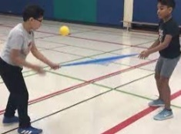 | Negotiating space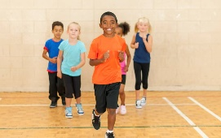 | Using apparatus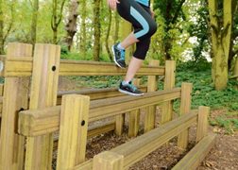 | Dance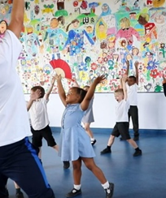 | Team Games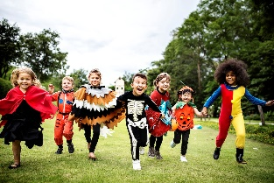
Gross motor skills  Skills and knowledge | To independently use a range of appropriate resources (crawl in tunnels, use Lego etc).  To run, jump, climb and begin to use stairs independently. | To sit on push-along toys, scooters and trikes.  To develop their manipulation and control, exploring different tools and materials | To want to be increasingly independent, e.g. dressing and undressing.  To know that their playing is developing their body, “Biggest bendy bits to smallest.”  To use large and small motor skills to do things independently - zips, buttons, pour drinks etc. | Begin to throw and release objects overarm.  To participate in finger and action rhymes.  To walk a greater distance.  To roll, crawl, jump and run. To use large movements, e.g. with ribbons.  To self-select things that they want to use.  To work with others, e.g., to move a big box.  To create lines and circles, pivoting from the shoulder and elbow.  To have explored Dough Gym to include low-load control.  To develop their shoulder, elbow and wrist pivot. | To develop their proprioception and control of their body - body movements, use of space and fundamental movement abilities.  To develop their hand/eye coordination.  To develop their movements to balance, ride and use balls paintbrush. | To climb using alternate feet, including climbing stairs.  To balance on one leg, momentarily.  To hop, skip and climb. To begin to work in a team or group.  To increasingly remember a sequence of movements related to rhythm and rhyme  To understand how to use equipment safely. To grasp and release with two hands to throw and catch a large ball.  To comfortably hold a pencil, pen or paintbrush.
Fine motor skills  Skills and knowledge | To develop their manipulation and control, exploring different tools and materials.  Pick up objects with a Palmer Grip. | Sit comfortably and hold scissors in their preferred hand.  To open and close the scissors smoothly with no paper to cut | Use large and small motor skills to do things independently - zips, buttons, pour drinks etc.  Point with their first finger, sharing their attention with an adult.  Participate in finger and action rhymes. Self-select things that they want to use. | To use one-handed tools and equipment - snipping with scissors with support.  To show the `thumb up’ of holding scissors.  To make one simple snip on a piece of paper, initially with support and then independently.  To experiment with marks | To understand how to use equipment safely.  To use one-handed tools and equipment - snipping with scissors independently  . To hold mark making tools with thumb and all fingers. | To hold the paper when cutting with their non-dominant hand to help and hold the paper that they are cutting.  To cut a straight and curved line.  To cut a circle, square and complex shape.  To have a dominant hand. To arch their palm; have in-hand manipulation fluidity; use thumbs in opposition and have finger isolation
Communication and Language
EYFS Statutory Educational Programme:
The development of children’s spoken language underpins all seven areas of learning and development. Children’s back and forth interactions from an early age form the foundations for language and cognitive development. The number and quality of the conversations they have with adults and peers throughout the day in a language-rich environment is crucial. By commenting on what children are interested in or doing, and echoing back what they say with new vocabulary added, practitioners will build children’s language effectively.
Reading frequently to children, and engaging them actively in stories, non-fiction, rhymes and poems, and then providing them with extensive opportunities to use and embed new words in a range of contexts, will give children the opportunity to thrive. Through conversation, storytelling and role play, where children share their ideas with support and modelling from their teacher, and sensitive questioning that invites them to elaborate, children become comfortable using a rich range of vocabulary and language structures.

Role Play Area and Big Talk Focus | Role Play  My House  Big Talk  Who lives in my house?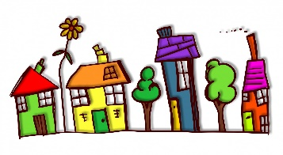 | Role Play  A Space Station  Big Talk  What can I see in the sky? | Role Play  The Toy Shop  Big Talk  What toys do my grandparents remember?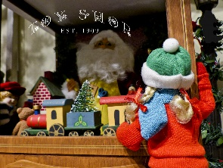 | Role Play  Biscuit Bear’s Bakery  Big Talk  What are the biscuits doing? | Role Play  Garden centre  Big Talk  What does a plant need to grow?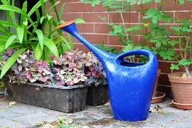 | Role Play  Science Lab  Big Talk  What does a scientist do?
Listening and attention, understanding | To focus for a while although can be easily distracted.  To concentrate intently on an activity of their own choosing for a short period. | To engage in pretend play.  To understand and act on longer sentences.  To listen to a simple story with the help of pictures. | To understand simple questions: who, what, where but generally not why.  To understand simple sentences. To listen to a simple story with the help of pictures.  To understand and act on longer sentences.  To respond to instructions with more elements, e.g., “Pick up the blocks and put them in the box. To know lots of stories | To retell a longer story.  To enjoy longer stories and can remember much of what happens.  To pay attention although may find it difficult to pay attention to more than one thing at a time. | To listen to others 1-2-1 or small groups when the conversation interests them.  To be able to follow simple instructions. To show an understanding of prepositions such as under, on top or behind.  To respond to instructions with more elements, e.g., “Pick up the block | Enjoy listening to longer stories and can remember much of what happens. Pays attention to more than one thing at a time although this can be difficult. Understands a question or instruction that has two parts. Understands ‘why’ questions.
Speaking | To try speaking to an adult although may become frustrated when they cannot make themselves understood. To start to say how they feel using simple words and actions/gestures. To talk but may just flit from topic to topic. | To use speech sounds p, b, m, w but may still be learning to pronounce l, r, w, y, f, th and have difficulty with words like ‘banana’. | To use a wider range of words.  To sing a lot of songs.  To start a conversation.  To join in with repeated refrains in rhymes and stories.” | To try and use the correct tense although may muddle them up, e.g., “I bringed a bag  To use a wider range of words. To sing a lot of songs. To use the ‘why’ question.  To try and use the correct tense although may muddle them up, e.g., “I bringed a bag.” | To use longer sentences of 4-6 words.  To express their point of view. To start a conversation.  To use words to problem-solve and organise their thoughts.  To join in with repeated refrains in rhymes and stories. | Use a wider range of vocabulary.  Sing a large repertoire of songs.  Know many rhymes  Talk about familiar books and tell a long story.  Use longer sentences of four to six words.  Express a point of view and to debate when they disagree with an adult or a friend.  Start a conversation with an adult or a friend and continue it for many turns. Uses talk to organise themselves and their play.
LITERACY
EYFS Statutory Educational Programme
It is crucial for children to develop a life-long love of reading. Reading consists of two dimensions: language comprehension and word reading. Language comprehension (necessary for both reading and writing) starts from birth. It only develops when adults talk with children about the world around them and the books (stories and non-fiction) they read with them, and enjoy rhymes, poems and songs together. Skilled word reading, taught later, involves both the speedy recognition of familiar printed words (decoding) and the speedy recognition of familiar printed words. Writing involves transcription (spelling and handwriting) and composition (articulating ideas and structuring them in speech, before writing).

Focus Books  Reception  Nursery | 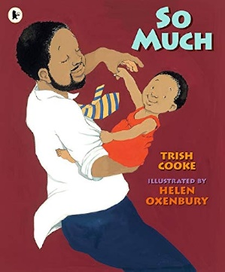 | 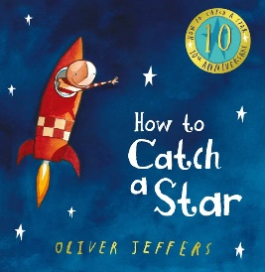 | 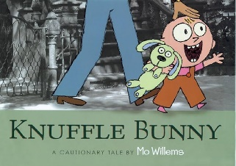 | 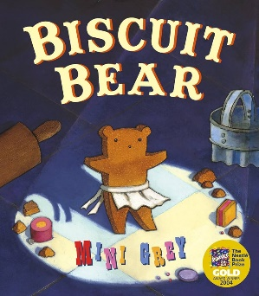 | 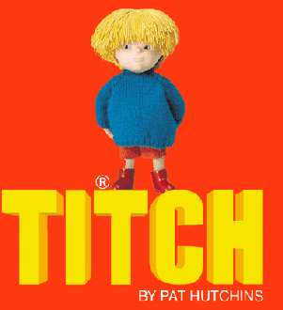 | 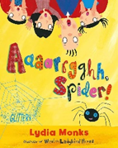
Literacy  Reading (language comprehension) | Enjoying sharing books with adults.  To repeat words and phrases.  To ask questions about simple stories.  To touch and handle books and digital devices.  To notice pictures and symbols. Recognise what they stand for. | Have favourite stories they love to share.  To react and respond to illustrations, characters and narratives through sharing books, using questions and imaginative play.  To handle a book carefully | Engage with print around them - digital and media texts.  To talk about stories. | Using their memory of story to retell and recount and perform, interpret and invent based on what they have seen and heard. | Become increasingly familiar with a storyline and increasingly predict when they work with memorable texts.  To become an oral storyteller and reenact a text. These skills help them to develop a growing awareness of what is involved for being | Understanding that print has meaning, it can have different purposes, and we read English text from left to right and from top to bottom, the names of the different parts of a book and page sequencing.  Engaging in extended conversations about stories,
Phonics | Level 1 Twinkl | Level 1 Twinkl | Level 1 Twinkl | Level 1 Twinkl | Level 1 Twinkl | Level1 Twinkl
Literacy  Writing | . To add meaning to marks they make.  To make marks to be their name.  To enjoy the sensory experience of making marks.  To distinguish between the marks that they make.  To enjoy drawing and writing on screen and on paper and in different textures, e.g., sand or shaving foam.  To enjoy free drawing. To copy movements. | To add meaning to marks they make  To make marks to be their name.  To imitate adults’ writing by making continuous lines circles or shapes. | To identify the initial letter of their name. To begin to make letter type shapes to represent the initial sound of their name | To write some of or their entire name. To write some letters accurately. To show an interest in words and illustrations in the environment.  To begin to navigate apps and websites on digital media using drop down menus. | To show an interest in letters on a keyboard and begin to make letter type shapes to represent the initial sound of their name | Uses some of their print and letter knowledge in their early writing, e.g. writing a pretend shopping list that starts at the top of the page or writing ‘m’ for mummy. Writes some or all of their name. Write some letters accurately.
MATHEMATICS
EYFS Statutory Educational Programme
Developing a strong grounding in number is essential so that all children develop the necessary building blocks to excel mathematically. Children should be able to count confidently, develop a deep understanding of the numbers to 10, the relationships between them and the patterns within those numbers.
By providing frequent and varied opportunities to build and apply this understanding – such as using manipulatives, including small pebbles and tens frames for organising counting – children will develop a secure base of knowledge and vocabulary from which mastery of mathematics is built. In addition, it is important that the curriculum includes rich opportunities for children to develop their spatial reasoning skills across all areas of mathematics including shape, space and measures. It is important that children develop positive attitudes and interests in mathematics, look for patterns and relationships, spot connections, ‘have a go’, talk to adults and peers about what they notice and not be afraid to make mistakes.

 | One Two Three! | Patterns and Shapes | 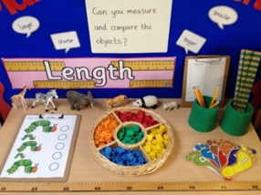  Comparing Groups | Shopkeepers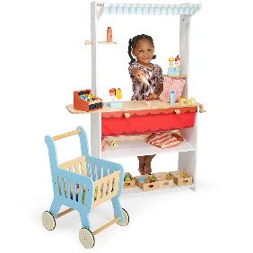 | Tremendous Ten 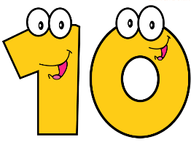 | Sequences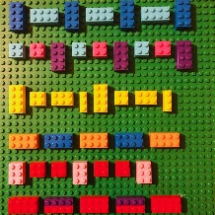es
Numbers  Skills and knowledge | To combine objects.  To take part in finger number rhymes.  To react to changes in a group up to 3.  To show counting like behaviour.  To count in everyday contexts.  To notice numbers around them, both inside and out.  To develop an awareness of numbers through rhymes and in their surroundings. | To give 2 or 3 objects from a group.  To begin to count on their fingers. To point or touch each item, saying one number for each item, using the stable order 1, 2, 3, 4, 5.  To use some number names in play and be fascinated with big numbers. | To compare groups of up to 5 objects. To show finger numbers to 5.  To know the `cardinal principle’ The cardinal principle. Children understand that the number name assigned to the final object in a group is the total number of objects in that group | To subitise to 3.  To solve everyday problems to 5.  To link numerals and amounts, e.g. showing the right number of objects to match the numeral, up to 5.  To separate a group of objects in different ways and know that the total is still the same | To begin to know that a bigger number can be created out of smaller numbers.  recognise numerals 0-10.  To compare quantities within ten | To understand the `order relevance’ principle that the order they count the objects in is irrelevant; there will still be the same number To experiment with their own symbols and marks as well as numerals. To solve real world mathematical problems with numbers up to 5.  Counting as far as they can go.
Numerical patterns | To show an interest in patterns, songs and rhymes. | To talk about patterns around them. | To begin to predict what might happen in a predictable situation. | To join in with simple patterns in rhymes, games, dances, stories and predict what may come next | To extend a simple ABABAB pattern. To notice and correct an error in a simple pattern. To explore repeating patterns in everyday objects. | To identify the patterns around them, e.g. stripes on clothes, designs on rugs and wallpaper. Uses informal language like ‘pointy’, ‘spotty’, ‘blobs’, etc. Extends and creates ABAB patterns – stick, leaf, stick, leaf. Notices and corrects an error in a repeating pattern. Begins to describe a sequence of events, real or fictional, using words such as ‘first’, ‘then...
UNDERSTANDING THE WORLD
EYFS Statutory Educational Programme
Understanding the world involves guiding children to make sense of their physical world and their community. The frequency and range of children’s personal experiences increases their knowledge and sense of the world around them – from visiting parks, libraries and museums to meeting important members of society such as police officers, nurses and firefighters. In addition, listening to a broad selection of stories, non-fiction, rhymes and poems will foster their understanding of our culturally, socially, technologically and ecologically diverse world. As well as building important knowledge, this extends their familiarity with words that support understanding across domains. Enriching and widening children’s vocabulary will support later reading comprehension.
Topics | What can my body do?  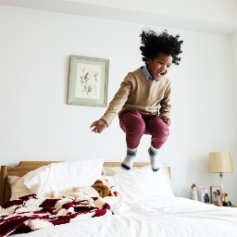 | Jobs People Do | Changes Around Me | Long Long Ago  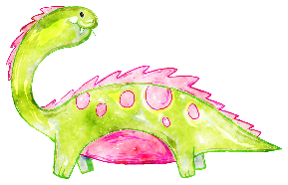 | Healthy Lunch Box  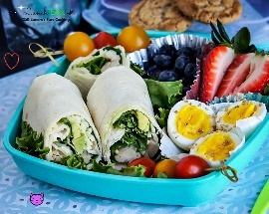 | Animal Homes  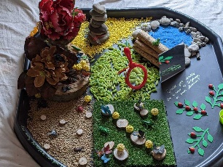
Trips and Special Events (hooks for learning) Cooking | Focus on the Caribbean- Live show  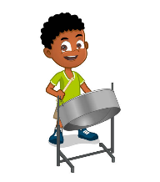  Pineapple upsidedowncake  Vegetable soups  Recipes with coconut | Trip to the theatre/Fire Station  Learning about Diwali  EYFS Nativity  Festival foods from around the world | Trip to London Zoo.  Breads sweet and savoury | Inspiration Day Archeological Dig!  Biscuits sweet and savoury | Trip to Kew Gardens  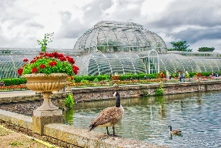  Sandwiches and salads | Trip to the seaside Minnis Bay / Camley Street  Ice cream &  fruit salads
Past and present | To enjoy playing with small world, building on their first-hand experiences. | To begin to make sense of their own life-story . | To begin to make sense of their family history  Think about what life was like for their grandparents | To be introduced to the idea that there was a world before humans when dinosaurs walked the Earth. | To begin to grasp the idea of a timeline for their own life. | To grown in understanding of their own and their family’s life story.
The Natural World | To explore and respond to their environment, natural phenomena and natural materials.  To use their senses.  To explore materials.  To talk about what they see using a wide vocabulary. | To talk about what they see using a wide vocabulary.  To know that things can be used in different ways.  To talk about some of the things they have observed such as plants, animals and natural objects. | To talk about materials and changes they notice.  To talk about materials and changes they notice | To explore how things work.  To begin to understand the need to respect and care for the world.  To explore and talk and about different forces they can feel. | To plant and care for seeds and plants. To understand the life-cycle of a plant and animal. | Use all their senses in hands-on exploration of natural materials. Explore collections of materials with similar and/or different properties.  Talk about what they see, using a wide vocabulary  Plant seeds and care for growing plants. Understands the key features of the life cycle of a plant and an animal.
People, Culture & Communities | To enjoy playing with small world, building on their first-hand experiences.  To enjoy looking at photographs of themselves and other familiar people  To make connections between the features of their family and other families | In pretend play, to imitate everyday actions and events from their own family and cultural background.  To be interested in different occupations. | To begin to make sense of their own life-story and family history. | To know there are different countries in the world and talk about the differences they have experienced or seen in photos.  To comment and ask questions about their world such as the place where they live. | To continue to develop a positive attitude about the differences between people. | To talk about different countries in the world and talks about the differences they have experienced or seen in photos.  To know there are different countries in the world and talk about the differences they have experienced or seen in photos
Expressive arts and design
EYFS Statutory Educational Programme
The development of children’s artistic and cultural awareness supports their imagination and creativity. It is important that children have regular opportunities to engage with the arts, enabling them to explore and play with a wide range of media and materials. The quality and variety of what children see, hear and participate in is crucial for developing their understanding, self-expression, vocabulary and ability to communicate through the arts. The frequency, repetition and depth of their experience are fundamental to their progress in interpreting and appreciating what they hear, respond to and observe.

 | I can see a Rainbow | Starry Night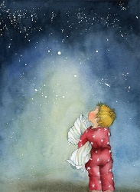 | It’s a Jungle!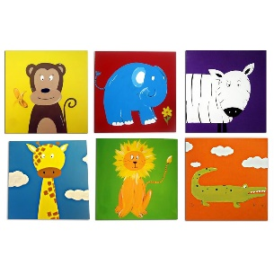 | Marvellous Models 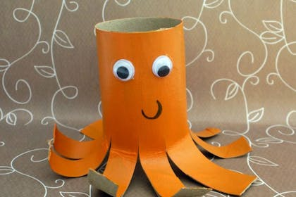 | It’s Showtime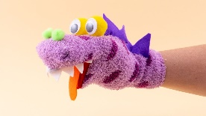 | Tutti Frutti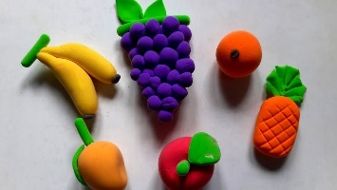
Creating with materials  To sing loudly. To ‘pitch match’. | To start to make marks intentionally.  To explore colours.  To create using small world and construction. To show a range of emotions in their drawings.  To use their senses to explore different materials.  . | To give meaning to the marks they make.  To use their senses to explore different materials.  To respond to their senses. | Develop their own ideas and then decides which materials to use to express them.  Joins different materials and explores different textures.  Creates closed shapes with continuous lines and begins to use these shapes to represent objects | To make simple models and talk about them  To join materials and explore textures  To freely explore different materials and think about how they may use them. | To explore using 2D and 3D structures.  To develop their own ideas.  To create closed shapes with continuous lines. | To draw with increasing complexity and detail. To use their drawings to represent ideas like movements and loud noises.  To respond to their senses.  Develop their own ideas and then decides which materials to use to express them.  Show different emotions in their drawings – happiness, sadness, fear, etc.
Being imaginative and expressive | To respond emotionally and physically to music.  To move and dance to music. | To create sound effects and movements, e.g., the sound of a car.  To enjoy taking part in action songs | To explore their voice. To enjoy songs and rhymes.  To use words to describe sounds and music. | To explore different sound makers.  To take part in pretend play.  To begin to develop stories using small world and equipment | To maybe create their own songs. To create sounds, movements and drawings to accompany stories.  Remember entire songs. | Listen with increased attention to sounds. Respond to what they have heard, expressing their thoughts and feelings.  Sing the pitch of a tone sung by another person (‘pitch match’)  Sing the melodic shape (moving melody, such as up and down, down and up) of familiar song Begin to develop complex stories using small world equipment like animal sets, dolls and dolls houses, etc
British values | Fundamental British Values underpin what it is to be a citizen in a modern and diverse Great Britain valuing our community and celebrating diversity of the UK.  Mutual respect  We are all unique.  We respect differences between different people and their beliefs in our community, in this country and all around the world.  All cultures are learned, respected, and celebrated.  Mutual tolerance  Everyone is valued, all cultures are celebrated and we all share and respect the opinions of others. Mutual tolerance of those with different faiths and beliefs and for those without faith.  Done through celebrations.  Books –, The Rainbow Fish, The Ugly Duckling  Festivals and celebrations – Diwali, St Nicholas’s Day, Christmas around the world, Chinese New Year, Easter around the world  St Andrew’s Day, St David’s Day, St Patrick’s Day, St George’s Day, Remembrance Day  Rule of law  We all know that we have rules at school that we must follow.  We know who to talk to if we do not feel safe.  We know right from wrong.  We recognise that we are accountable for our actions.  We must work together as a team when it is necessary.  Individual liberty  We all have the right to have our own views.  We are all respected as individuals.  We feel safe to have a go at new activities.  We understand and celebrate the fact that everyone is different.  Democracy  We all have the right to be listened to.  We respect everyone and we value their different ideas and opinions.  We have the opportunity to play with who we want to play with.  We listen with intrigue and value and respect the opinions of others.

