St Peter and St Paul Catholic Primary School
Reception
Long term curriculum plan with the progression of skills and knowledge

The themes/topics/trips shown may change slightly according to the children’s needs and interests.

Themes | Autumn 1  What is your Superpower? | Autumn 2  Zoom to the Moon! | Spring 1  Explorers |  | Spring 2  Dinosaur Detectives  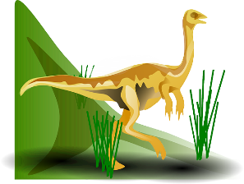 | Summer 1  Food Glorious Food!  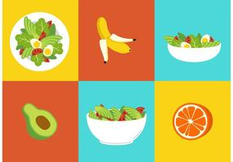 | Summer 2  Commotion in the Ocean  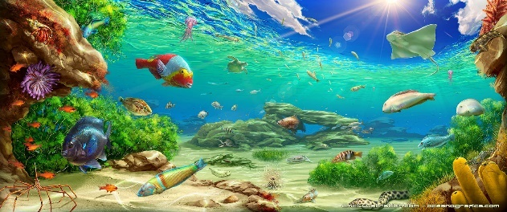
Areas of learning and development
PERSONAL, SOCIAL AND EMOTIONAL DEVELOPMENT
EYFS Statutory Educational Programme:
Children’s personal, social and emotional development (PSED) is crucial for children to lead healthy and happy lives, and is fundamental to their cognitive development. Underpinning their personal development are the important attachments that shape their social world. Strong, warm and supportive relationships with adults enable children to learn how to understand their own feelings and those of others.
Children should be supported to manage emotions, develop a positive sense of self, set themselves simple goals, have confidence in their own abilities, to persist and wait for what they want and direct attention as necessary. Through adult modelling and guidance, they will learn how to look after their bodies, including healthy eating, and manage personal needs independently. Through supported interaction with other children they learn how to make good friendships, co-operate and resolve conflicts peaceably. These attributes will provide a secure platform from which children can achieve at school and in later life.

Self-regulation  Skills and knowledge | Introducing ourselves and getting to know each other.  Identifying and talking about their feelings  Selecting and using activities and resources with support.  Becoming more outgoing with unfamiliar people.  Following simple instructions. | Explaining what has happened when they are upset.  Understanding gradually how others might be feeling.  Showing more confidence in new social situations.  Independently selecting activities and resources. | Expressing feelings and considering the feelings of others.  Controlling their impulses when waiting for their turn. |  | Learning that mistakes are an important part of learning.  Managing their own feelings, e.g. strategies for staying calm in the face of frustration. | Thinking about how others might feel in particular scenarios.  Waiting with increased patience when necessary. | Understanding the importance of respecting class rules and behaving correctly towards others.  Understanding how feelings change over time (good and not so good feelings).  Developing strategies that help them deal with their changing feelings and emotions.
Managing self  Skills and knowledge | Trying new activities with friends.  Following school and class rules with adult support.  Being increasingly independent in meeting their own care needs (using the toilet, washing hands etc.) | Remembering rules without needing an adult to remind them.  Beginning to understand consequences of their behaviour.  Putting on own shoes.  Pulling zip up and down (might need help to insert or separate).  Using the toilet independently.  Washing their hands well and understanding why this is important.  Beginning to make healthy choices. | Trying new activities independently.  Beginning to persevere when something is challenging.  Understanding that rules are there to keep us safe and make things fair.  Understanding road safety.  Taking T-shirts/jumpers off and putting them on independently. |  | Putting on socks and shoes correctly.  Fastening zips independently.  Understanding that people need to look after their body and mind - exercise, sleep, eating healthily, sleep and rest.  Identifying healthy and less healthy food.  Understanding how less healthy food and drink can affect their health (e.g. teeth). | Choosing and enjoying more challenging activities.  Recognising when their behaviour was not in accordance with the rules.  Showing resilience and perseverance in the face of challenge.  Dressing and undressing independently (might need help with small buttons and laces).  Knowing and talking about the different factors that support their health and well-being. | Trying different approaches when solving problems.  Being able to explain why they haven’t followed the rule.  Understanding there will be a consequence when they have made a bad choice.  Knowing how to stay safe in the sun.
Building relationships  Skills and knowledge | Sharing and taking turns (sometimes with adult support).  Asking for help from a familiar adult. | Forming some closer friendships and initiating play with others.  Showing empathy in simple ways, e.g. trying to help a friend who is hurt or upset.  Playing with one or more other children, extending and elaborating play ideas.  Beginning to understand that children have different viewpoints and opinions. | Taking turns without adult support.  Initiating conversations with others. Listening to others’ ideas and responding appropriately.  Beginning to solve small problems through speaking to each other. |  | Being able to explain to their peer if they don’t like what they’re doing.  Understanding that everyone should be treated with respect.  Understanding that some actions and words might hurt others’ feelings. | Solving small conflicts through speaking to each other and being assertive.  Helping others who are in need of help. | Showing understanding of another child’s perspective in discussion.  Playing cooperatively in a larger group.
PHYSICAL DEVELOPMENT
EYFS Statutory Educational Programme:
Physical activity is vital in children’s all-round development, enabling them to pursue happy, healthy and active lives. Gross and fine motor experiences develop incrementally throughout early childhood, starting with sensory explorations and the development of a child’s strength, co-ordination and positional awareness through tummy time, crawling and play movement with both objects and adults.
By creating games and providing opportunities for play both indoors and outdoors, adults can support children to develop their core strength, stability and balance, spatial awareness, co-ordination and agility. Gross motor skills provide the foundation for developing healthy bodies and social and emotional well-being. Fine motor control and precision helps with hand-eye co-ordination which is later linked to early literacy. Repeated and varied opportunities to explore and play with small world activities, puzzles, arts and crafts and the practice of using small tools, with feedback and support from adults, allow children to develop proficiency, control and confidence.
PE Lesson Focus | Parachute games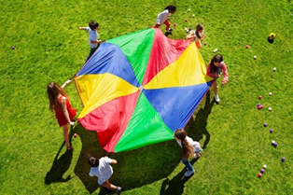 | Working with a partner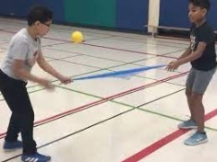 | Negotiating space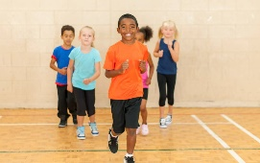 |  | Using apparatus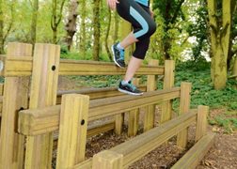 | Dance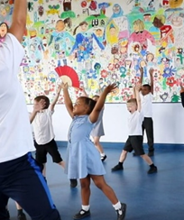 | Team Games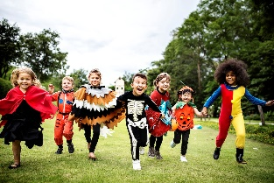
Gross motor skills  Skills and knowledge | Going up steps and stairs, or climbing up apparatus, using alternate feet.  Developing their ability to skip, hop and stand on one leg.  Travelling in different ways and directions.  Balancing on tiptoes.  Underarm throw with a beanbag/small ball.  Using large muscle movements to wave flags, paint and make marks.  Beginning to remember patterns of movements which are related to music and rhythm. Using hands and face to show emotion (clapping, stomping, and nodding). | Continuing to develop their upper arm and shoulder strength, and ability to move and rotate their lower arms and wrists independently.  Riding a bike with stabilisers and maintaining balance.  Catching a large ball.  Walking along a low wide balance beam independently.  Holding a balance for 3 seconds.  Developing a wide range of movements, including jumping, running, rolling, hopping, skipping and climbing.  Jumping forwards and landing on two feet with increasing control.  Becoming more independent as they get dressed and undressed. | Progressing towards a more fluent style of moving, with developing control.  Developing the overall body strength, co-ordination and balance.  Squashing and squeezing an object with different body parts.  Travelling in different shapes (curled and stretched).  Using props to develop performance.  Using their core muscle strength to achieve a good posture when sitting at a table or sitting on the floor. |  | Balancing on unstable surface with increasing control.  Walking along a narrow balance beam.  Hopping on alternate feet.  Catching a beanbag or small ball.  Travelling on front and back.  Using body to create shapes. | Using a range of wheeled resources to balance, sit or ride on, pull and push.  Patting and bouncing a ball.  Controlled throwing and catching in the air.  Travelling on hands and feet.  Skipping rhythmically.  Using movements to retell a story or represent a character (moving slowly, quickly, in a way that looks like a wave etc.)  Riding and maintaining balance while manoeuvring around obstacles. | Confidently using a range of large and small apparatus indoors and outside.  Developing confidence, competence and precision when engaging in activities that involve a ball.  Confidently moving across the obstacle course.  Travelling with feet higher than head.  Developing and refining a range of ball skills, including throwing, catching, kicking, passing and aiming.
Fine motor skills  Skills and knowledge | Snipping paper and learning to open and close the blades.  Developing their pencil grip – may mark make in palmer grip.  Making marks in different directions.  Using one-handed resources.  Showing a preference for a dominant hand. | Making marks from left to right.  Shape-like marks  Drawing recognisable pictures.  Starting to move towards tripod grip.  Using a dominant hand.  Snipping paper moving forward.  Beginning to cut curved lines.  Using a fork to stab food. | Developing and further refining their fine motor skills.  Cutting square and circle shapes.  Using a knife to cut soft food.  Developing correct letter and numeral formation (starting point and direction). |  | Developing their small motor skills so that they can use a range of tools competently.  Spreading butter onto toast using the back of a spoon.  Using a comfortable grip with good control when holding pencils.  Developing correct letter and numeral formation. | Using a knife to cut a variety of foods, holding the knife correctly.  Spreading using a knife.  Drawing objects in proportion to each other, e.g. a house is bigger than a person.  Drawing pictures with more detail.  Cutting more complex shapes.  Developing correct letter and numeral formation (starting point, direction and size). | Holding pencils effectively – tripod grip.  Using a knife and fork independently.  Drawing detailed pictures.  Developing the foundations of a handwriting style which is fast, accurate and efficient.  Positioning letters on the line.  Forming most lower-case and capital letters correctly.
Communication and Language
EYFS Statutory Educational Programme:
The development of children’s spoken language underpins all seven areas of learning and development. Children’s back and forth interactions from an early age form the foundations for language and cognitive development. The number and quality of the conversations they have with adults and peers throughout the day in a language-rich environment is crucial. By commenting on what children are interested in or doing, and echoing back what they say with new vocabulary added, practitioners will build children’s language effectively.
Reading frequently to children, and engaging them actively in stories, non-fiction, rhymes and poems, and then providing them with extensive opportunities to use and embed new words in a range of contexts, will give children the opportunity to thrive. Through conversation, storytelling and role play, where children share their ideas with support and modelling from their teacher, and sensitive questioning that invites them to elaborate, children become comfortable using a rich range of vocabulary and language structures.

Role Play and Big Talk Topics this term: | Role Play  Dressing as superheros Big Talk  What’s your power?  Vocabulary to do with families and feelings  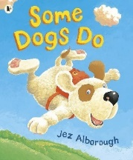  Songs and rhymes to do with body parts | Role Play  Post office for Christmas  Big Talk  What’s in the box?  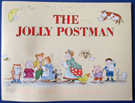  Nativity songs and rhymes to do with shape | Role Play  Travel agents  Big Talk  Where in the world do you want to go?  Language of transport and exploration |  | Role Play  Tardis  Big Talk  Where would you go in a Time machine? | Role Play  Shopkeepers  Big Talk  How much does that cost? 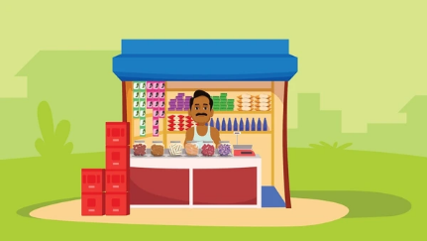 | Role Play  Pirate Ship  Big Talk  What can I see under the sea?  A Poem a Day  2 poetry recitations:  There’s a Hole at the Bottom of the Sea  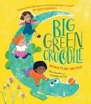
Listening and attention, understanding | Beginning to take turns in speaking and listening to others.  Knowing how to show they are listening.  Understanding how to listen carefully and why listening is important.  Listening to stories and retelling some key events.  Understanding a question or instruction with two parts. | Understanding why it is important to listen.  Developing active listening skills.  Beginning to pay attention to more than one thing at a time.  Beginning to express their point of view, using words as well as actions.  Asking questions to find out more and to check they understand what has been said to them.  Understanding ‘why’ questions.  Linking what has been said to their own experiences to keep conversation going.  Retelling simple stories. | Linking ideas.  Commenting and engaging in conversations about the text, talking about main events and what might happen next.  Asking meaning of new words.  Listening to longer stories and retelling main events. |  | Describing events in some detail.  Listening without stopping what they are doing.  Waiting for the person talking to stop before responding.  Responding appropriately to what has been said.  Commenting and engaging in conversations about the text, talking about what might happen next and making links to own experiences.  Following instructions with more than two parts. | Developing social phrases.  Actively listening to other points of view.  Engaging in story times and non-fiction books.  Retelling the story – some as exact repetition and some in their own words. | Taking turns in much longer conversations.  Explaining their point of view clearly when they disagree with an adult or friend.  Understanding humour.
Speaking | Joins in with repeated refrains and key phrases.  Speech is clear and understood.  Using talk to organise themselves and their play.  Developing their communication, but may continue to have problems with irregular tenses and plurals, such as ‘runned’ for ‘ran’. | Singing a large repertoire of songs.  Using longer sentences of four to six words.  Linking ideas.  Retelling simple stories.  Repeating new vocabulary in a context of a story.  Starting a conversation and continuing it for many turns. | Explaining the meaning of new words.  Using talk to explain how things work and why they might happen.  Asking questions to clarify their understanding.  Commenting and engaging in conversations about the text, talking about main events and what might happen next.  Using new vocabulary through the day. |  | Using talk to help work out problems and organise thinking and activities.  Connecting one idea or action to another using a range of connectives.  Commenting and engaging in conversations about the text, talking about what might happen next and making links to own experiences.  Showing awareness of the past, present and future tense. | Developing social phrases.  Articulating ideas and thoughts in well-formed sentences.  Describing events in more detail.  Retelling the story – some as exact repetition and some in their own words. | Using new vocabulary in different contexts.  Explaining their point of view clearly when they disagree with an adult or friend.  Retelling longer stories.  Talking about selected non-fiction texts to develop a deep familiarity with new knowledge and vocabulary.  Participating in discussions, offering their own ideas, and using recently introduced vocabulary.
LITERACY
EYFS Statutory Educational Programme
It is crucial for children to develop a life-long love of reading. Reading consists of two dimensions: language comprehension and word reading. Language comprehension (necessary for both reading and writing) starts from birth. It only develops when adults talk with children about the world around them and the books (stories and non-fiction) they read with them, and enjoy rhymes, poems and songs together. Skilled word reading, taught later, involves both the speedy recognition of familiar printed words (decoding) and the speedy recognition of familiar printed words. Writing involves transcription (spelling and handwriting) and composition (articulating ideas and structuring them in speech, before writing).

Literacy  Reading (language comprehension and word reading) | Understanding the five key concepts about print:  Engaging in conversations about stories, learning new vocabulary.  Identifying the main characters in the story.  Level 2 Twinkl Phonics | Identifying the main events, settings and characters in the story.  Commenting and engaging in conversation about the text,  Ordering 3-4 pictures from the story.  Level 2/3 Twinkl Phonics | Identifying the main events, settings and characters in the story.  Commenting and engaging in conversation about the text, talking about what might happen next.  Level 3 phonics |  | Identifying the main events, settings and characters in the story.  Relating text to self/ simple inference  Level 3 Twinkl Phonics | Retelling a story through role play, using some new vocabulary and some exact words from the text.  Level 3 revision Twinkl phonics  Developing fluency in reading words with digraphs and trigraphs. | Retelling a story through role play, using some new vocabulary and some exact words from the text.  Text to World making inferences  Anticipating key events in the story.  Level 3/4 Twinkl Phonics
Focus Books | 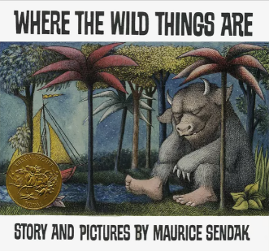 | 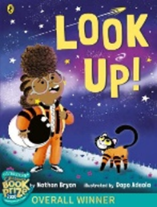 | 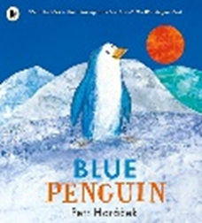 |  | 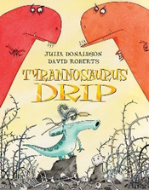 | 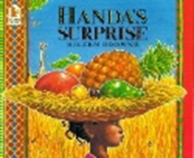 | 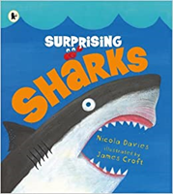
Literacy  Writing | Mark making  Drawing pictures – lines and simple shapes.  Adding some marks to their drawing, which they give meaning to.  Making marks on their picture to stand for their name.  Using some of their print and letter knowledge in their early writing.  Writing some of their name.  Writing some letters correctly.  Writing initial letters in words.  Beginning to write simple 2 and 3 letter words. | Drawing recognisable pictures.  Writing their name.  Continuing to practise writing simple words and learnt tricky words.  Beginning to write simple phrases.  Continuing to learn how to write letters correctly (starting point and direction). | Correct spelling of words that can be sounded out (high frequency words with phase 2 sounds first).  Continuing to write simple phrases with phase 2 letters.  Writing simple words with known digraphs.  Continuing to learn how to write letters correctly (starting point and direction). |  | Correct spelling of words that can be sounded out (high frequency words with known letters from phase 2 and 3).  Writing phrases and simple sentences.  Using finger spaces in phrases and sentences.  Continuing to learn how to write lower-case letters correctly (starting point and direction, size).  Learning to write capital letters correctly. | Correct spelling of words that can be sounded out (high frequency words).  Correct spelling of words that cannot be sounded out yet (tricky words).  Using a capital letter at the beginning of each sentence.  Continuing to learn how to write letters correctly (starting point and direction, size and position). | Correct spelling of words that can be sounded out (high frequency words).  Correct spelling of words that can be sounded out (tricky words).  Using a capital letter and a full stop in each sentence.  Re-reading what they have written to check it makes sense.  Writing letters correctly (starting point and direction, size and position).
MATHEMATICS
EYFS Statutory Educational Programme
Developing a strong grounding in number is essential so that all children develop the necessary building blocks to excel mathematically. Children should be able to count confidently, develop a deep understanding of the numbers to 10, the relationships between them and the patterns within those numbers.
By providing frequent and varied opportunities to build and apply this understanding – such as using manipulatives, including small pebbles and tens frames for organising counting – children will develop a secure base of knowledge and vocabulary from which mastery of mathematics is built. In addition, it is important that the curriculum includes rich opportunities for children to develop their spatial reasoning skills across all areas of mathematics including shape, space and measures. It is important that children develop positive attitudes and interests in mathematics, look for patterns and relationships, spot connections, ‘have a go’, talk to adults and peers about what they notice and not be afraid to make mistakes.

Topics | Numbers to 10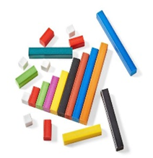 | 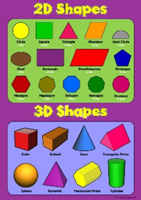 | 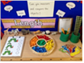  Measuring |  | 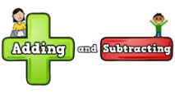 | Ordering Numbers  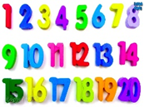 | Shopkeepers
Numbers  Skills and knowledge | Developing fast recognition of up to 3 objects (subitising).  Show ‘finger numbers’ to 5.  Beginning to explain the composition of numbers 2 and 3 with support of visual aids.  Beginning to use a 5s frame model. | Developing fast recognition of up to 5 objects (subitising).  Composition of numbers 2 and 3 (5s frames, parts and whole).  Representation of 4 and 5. | Representing 1-10 in a variety of ways – fingers, counters on a 10s frame, Numicon, cubes, dots on a dice etc.  Composition of 4 and 5 with support of visual aids.  Composition of 6, 7 and 8 with support of visual aids.  Combining two groups together to find the total. |  | Composition of 9 and 10.  Using conceptual subitising when there is more than 5 items in a set.  Comparing numbers to 10.  Beginning to use a 10s frame and part-whole model to represent some addition and subtraction sums with support.  Beginning to recall number bonds to 5. | Confidently subitise rather than count small groups of objects.  Instant recall of number bonds to 5.  Building numbers beyond 10.  Ordinal numbers – 1st, 2nd and 3rd.  Adding 2 single digit numbers using known number facts or number track.  Addition and subtraction facts (numbers to 5). | Instant recall of some number bonds to 10.  Problem solving using money and real life situations  Addition and subtraction facts (numbers 5-10).  Instant recall of some number bonds beyond 5.
Numerical patterns | Sorting/matching - sort groups of objects according to different criteria e.g. by colour, size and shape.  Compare quantities using language ‘more than’ and ‘fewer than’.  Understanding the concept of 1 more (with objects to 3).  Reciting numbers past 5.  Saying one number for each item in order (1-5).  Knowing that the last number tells you how many there are in total.  Linking numerals and amounts to 3.  Identifying patterns around them.  Copying and continuing AB patterns.  Noticing and correcting an error in a repeating pattern.  Beginning to describe a sequence of events (first, then).  Describing the size or shape of real-life objects using simple mathematical vocabulary, e.g. big/little, large/small round/straight.  Comparing capacity – full and empty | Understanding the concept of 1 more and 1 less/fewer with concrete objects to 5.  Reciting numbers to 10.  Ordering numbers 1-5.  Developing the key skill of counting objects and saying how many there are after counting (up to 10).  Linking numerals and amounts up to 5.  Counting out up to 5 objects from a larger group.  Exploring 2D and 3D shapes, using informal and mathematical language.  Name 2D shapes and explain their properties using mathematical language e.g. sides, corners.  Combining shapes to make new ones.  Follow prepositional instructions through games and songs  Extending and creating AB patterns.  Describing a familiar route. | Using and understanding the terms shorter/taller, larger/smaller longer shorter  Saying one number for each item in order (1-10).  Counting out up to 10 objects from a larger group.  Begin to compare numbers and  quantities up to 10 using and understanding the terms more than, greater than, fewer, less than in practical contexts.  Understanding the term equal when comparing two groups of objects.  Distributing items evenly, e.g. 3 in each bag.  Instant recall of 1 less/1 more than a given number to 5.  1 more/1 less with concrete objects to 10.  Sequencing 3 items according to these criteria.  Copy and continue AB, ABB and ABBC patterns. Noticing and correcting an error in a repeating pattern. |  | Showing accuracy when counting up to 10 objects.  Linking numerals and amounts up to 10.  Counting back from 10.  Ordering numbers to 10.  Instant recall of 1 less/1 more than a given number to 10.  Doubling 1-5, using concrete objects.  Beginning to count in 2s with support.  Understanding that even numbers can be split into two equal groups.  Time - Understand yesterday/today/tomorrow.  Identifying straight and curved sides on 2D shapes, and flat and curved faces on 3D shape.  Creating repeating patterns – AB, ABB and ABBC. | Reciting numbers to 20.  Counting back from 15.  Counting on from a given number to 20.  Counting back from a given number to 10.  Recognise numerals to 15.  Counting in 2s to 10.  Doubling numbers 1-5 confidently and beginning to recall some double facts from memory.  Exploring sharing into equal groups in practical contexts, commenting on what they notice.  Understanding that odd numbers cannot be split into two equal groups.  Beginning to recognise some coins and their value. Count 1p coins in 1s and 2p coins in jumps of 2 with support.  Composing and decomposing shapes. | Reciting numbers to 20 and beyond.  Counting back from 20.  Counting back from a given number to 20.  Recognises numerals to 20.  Doubling 6-10, using concrete objects.  Exploring patterns when adding odd and even numbers.  Exploring patterns when doubling and sharing objects.  Visualising and building shapes.
UNDERSTANDING THE WORLD
EYFS Statutory Educational Programme
Understanding the world involves guiding children to make sense of their physical world and their community. The frequency and range of children’s personal experiences increases their knowledge and sense of the world around them – from visiting parks, libraries and museums to meeting important members of society such as police officers, nurses and firefighters. In addition, listening to a broad selection of stories, non-fiction, rhymes and poems will foster their understanding of our culturally, socially, technologically and ecologically diverse world. As well as building important knowledge, this extends their familiarity with words that support understanding across domains. Enriching and widening children’s vocabulary will support later reading comprehension.
Topics | My Body 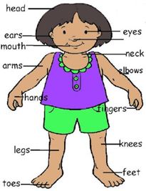 | People Who Help Us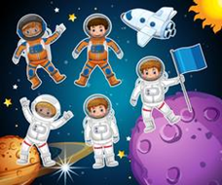 | The Seasons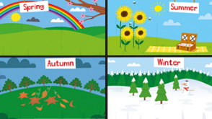 | Archeological Dig!  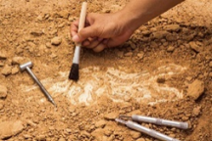 |  | Tropical Fruit Salad | Life Cycles 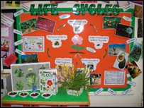
Trips and Special Events (hooks for learning) Cooking | Focus on the Caribbean- Live show  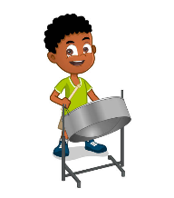  Pineapple upsidedowncake  Vegetable soups  Recipes with coconut | Trip to the theatre/Fire Station  Learning about Diwali  EYFS Nativity  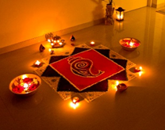  Festival foods from around the world | Trip to London Zoo.  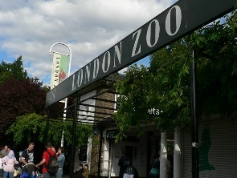  Breads sweet and savoury | Inspiration Day Archeological Dig!  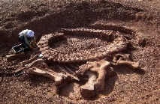  Biscuits sweet and savoury |  | Trip to Kew Gardens  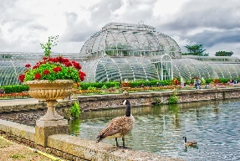  Sandwiches and salads | Trip to the seaside Minnis Bay / Camley Street  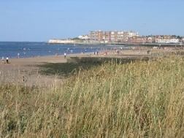  Ice cream &  fruit salads
Past and present | Talking about past events in their life, e.g. When I went to nursery… My summer holidays… When I went to the park etc.  Beginning to talk about how they have changed over time, e.g. when I was in preschool and now.  Describing who is in their family (significant people in their life).  Beginning to discuss similarities, differences and changes (e.g. notices changes such as a new haircut or new shoes or something they could not do before that they now can). | Discussing different occupations of family members.  Talking about upcoming events in their life.  Beginning to discuss how areas have changed from when older family members were young to now (e.g. roads, new houses etc).  Beginning to use vocabulary for time – today, yesterday, tomorrow.  Describing the changes that occur in autumn.  Understanding that times of the day go in order and repeat every day, e.g. morning is always before lunch time.  Knowing that some special events repeat every year at the same time (birthdays, Bonfire Night, Remembrance Day).  Beginning to compare special days to previous celebrations (e.g. birthdays). | Describing the changes that occur in each season of the year (natural world)  Describing and observing the changes that occur in winter.  Discussing how objects have changed since their grown-ups were children, e.g. schools, toys, telephones etc  Talking about a wider range of occupations, e.g. people who help us.  Beginning to describe similarities and differences between occupations. | Thinking about what the world was like when dinosaurs roamed the planet and no humans lived on Earth. Looking at and creating a basic timeline.  Describing the changes that occur in spring.  Knowing that there are 7 days in a week.  Knowing that living things do not stay the same over time (life cycles – plants and animals, seasons, organic things decay over time).  Using words and phrases that relate to time such as before, tomorrow, yesterday etc.  Learn what extinct means |  | Life cycle of a plant-knowing all the stages  Knowing the days of the week in order.  Describing the changes that occur in summer.  Knowing that there are months in a year.  Knowing that the length of day and night changes depending on the season. | Describing the changes that occur in each season of the year (natural world) and how these also affect us (e.g. clothing we wear, how to stay safe in the sun).  Knowing that there are four seasons that repeat and go in order.  Life cycle of a butterfly – knowing all the stages.  Knowing they have grown from a baby into a child and that they will get older.  Talking about how their bodies and skills have changed from when they were a baby.
The Natural World | Exploring collection of materials with similar or different properties.  Talking about what they see, using a wide vocabulary.  Exploring how things work.  Talking about the environment around them.  Beginning to understand the need to respect and care for the natural environment and all living things.  Talking about changes they notice, e.g. weather. | Discussing how to care for living things.  Looking at and discussing the features of animals that hibernate (hedgehogs and ground squirrels).  Answering questions about what they have observed.  Making observations about how things are different at night compared to during the day (flowers close up, animals, light etc.)  Understanding what the word ‘nocturnal’ means.  Describing the changes that occur in autumn.  Describing and comparing different materials and their properties. | Observes and discusses natural processes such as melting ice.  Observing how materials change from one state to another – butter (cooking - making biscuits).  Can talk about how and why ice is formed.  Investigating how light travels through different materials and shadows.  Talking about the environment in Antarctica  Knowing that the weather can be different in different countries. |  | Describing the changes that occur during the spring.  Noting and recording the weather.  Exploring and talking about different forces they can feel (e.g. kites and wind).  Life cycle of a plant – describing the stages.  Understanding the need to respect and care for the natural environment and all living things  Talking about the environment in different countries using Google Maps  and describing how it is different to ours.  Making observations about the world around them and trying to record these through drawings. | Describing the changes that occur during the summer.  Knowing that most plants start growing from a seed or bulb.  Knowing that plants need water, warmth and light to grow and survive.  Knowing that a seed produces roots to allow water to get into the plant and shoots to produce leaves to collect sunlight. Making observations about plants and recording these through drawings  Can talk about differences in environment (city v countryside and when comparing different countries).  Life cycle of a chicken – knowing all the stages.  Talking about different habitats and why they are good for certain living things (e.g. hedgehogs, farm animals, jungle animals etc.). | Describing the changes that occur in each season of the year (natural world) and how these also affect us (e.g. clothing we wear, how to stay safe in the sun).  Talking about different forces they can feel (floating and sinking).  Observes and discusses natural processes such as light travelling through transparent materials, an object casting a showdown, a magnet attracting an object and a boat floating on water.  Talking about underwater worlds and how these are habitats for different creatures, depending on where they are in the world.  Showing understanding of how humans can impact the environment (e.g. buildings, pollution) and what we can do to help.  Knows that living things do not stay the same over time (life cycles, seasons, organic things decay over time).  Life cycle of a human – knowing all the stages (baby, toddler, child, teenager, adult and elderly).
People, Culture & Communities | People who help us at school (e.g. teachers) – developing their knowledge about different occupations  Belonging - This is my school and class.  Learning each other’s names.  Understanding that our class is made up of children who are all different, with different backgrounds, homes, beliefs, colour skin and accents.  Understanding that all people are unique and it is okay to be different.  Understanding that some of our friends have family in other countries.  Understanding that maps show where places are.  Knowing that there are different countries in the world. | Developing their knowledge about different occupations,  Knowing that every home has its own address.  Learning about different families.  Learning about the place where they live (city) and their local area.  If they have family they visit abroad or have been on holiday, they talk about their experiences.  Knowing that they live in Islington.  Talking about where they live in relation to their school and how busy the environment is.  Beginning to draw information from a simple map.  Identifying some Christian symbols.  Understanding why Christmas is celebrated and important to Christians.  Learning that people have different beliefs and celebrate special times in different ways. For example, while most people in England celebrate Christmas, not all countries do. | Drawing simple maps to explain their journey to school/ park/special places.  Identifying features on a simple map.  Talking about how and why Chinese people celebrate Chinese New Year.  Continue developing positive attitudes about the differences between people (e.g. Chinese people v English people).  Understanding the importance of treating people fairly and celebrating diversity. |  | Discussing how Easter is celebrated around the world (e.g. England, Poland) | Understanding we live in Islington that is part of London and where this is in England.  Knowing that more than one house is in a village or town and that cities have lots of houses.  Beginning to describe contrasting locations.  Describing daily life on a farm.  Understanding why some people celebrate Shauvot (June)  Continue to recognise some similarities and differences between life in this country and life in other countries. | Understanding that a world map shows all the countries in the world and how these are represented by colour (countries and seas are represented by different colours).  Finding England on a world map.  Find coastal towns we know or have been to  Talking about differences in celebrations, buildings, food and clothing when comparing England, China, India, Poland and Eritrea etc.
Expressive arts and design
EYFS Statutory Educational Programme
The development of children’s artistic and cultural awareness supports their imagination and creativity. It is important that children have regular opportunities to engage with the arts, enabling them to explore and play with a wide range of media and materials. The quality and variety of what children see, hear and participate in is crucial for developing their understanding, self-expression, vocabulary and ability to communicate through the arts. The frequency, repetition and depth of their experience are fundamental to their progress in interpreting and appreciating what they hear, respond to and observe.

Term specific provision | A Taste of the Caribbean  Colour mixing  Dancing to steel pans Danny Go superhero dance  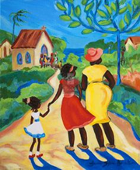  ‘I Have a Body’ and the colours of the rainbow songs | Repeating patterns  Rocket pictures with shapes  Christmas themes wrapping paper ornaments and cards  Danny Go Sleigh Ride /Rocket songs  Chrismas Nativity production performance and dance | Carnival of the Animals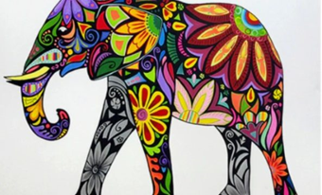  African art inspiration  Learning to move like animals/dragons Chinese New Year inspired art  ‘Come to my Animal Tea Party’ Song |  | Dinosaur Stomp!  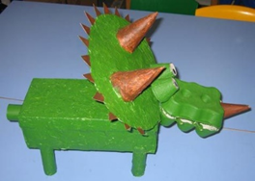  Dinosaurs from junk  Spring Class Assembly  ‘The Dinosaurs Song’ | A Bowl of Fruit  Clay playdough fruit modelling  Making birds of paradise  Kew gardens inspires art Marrianne North artist focus  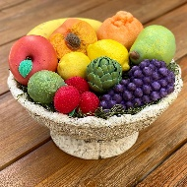  Songs about food | Yummy Ice Cream  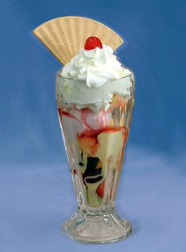  Performance Poetry  Summer Class Assembly
Creating with materials | Shaping paper with our hands (tearing).  Using scissors to cut straight lines.  Using scissors to cut curved and zigzag lines.  Using glue sticks to join paper.  Using PVA glue to join paper (index finger and brush).  Using paints and brushes to make a range of marks.  Painting what they can see and from imagination.  Naming colours, including black, grey and white.  Knowing primary colours. | Using PVA glue to join paper (spreader and cotton bud).  Choosing colours for a purpose.  Drawing lines – straight, curved, zigzag and wavy.  Knowing that a drawing can show a person, object, animal or place.  Using drawing to represent ideas like movement or loud noises.  Articulating what they are doing to an adult.  Developing simple patterns by printing with objects, using range of materials.  Using fabric, boxes, tubes and joining materials to make props. | Using masking tape to join paper.  Mixing colours to make new colours.  Drawing with precision around the outline of shapes (stencils).  Drawing what they can see.  Drawing with increasing complexity and detail, such as representing face with a circle.  Planning what they will create and what they will need to do so.  Creating a simple collage (tearing paper and cutting paper with scissors).  Using different props for different characters.  Mixing wet and dry ingredients and observing changes.  Measuring using cups and spoons.  Preparing ingredients hygienically. |  | Joining paper, using split pins and treasury tags.  Making repeated patterns, using natural objects.  Knowing that a print is a copy of something.  Making prints, using paint and shaving foam.  Joining different materials and exploring different textures.  Using different materials (larger sizes), sparkly fabric, hessian, fur, ribbons, feathers to add to costumes and make their own (e.g. own masks, material as skirts or scarves).  Spreading butter onto toast using the back of a spoon. | Reviewing own work and making improvements, explaining why changes are better (design, make, evaluate and improve).  Spreading butter or jam onto toast using a table knife.  Showing different emotions in their drawings. | Using variety of art tools with greater accuracy.  Chopping and mashing (playdough and bananas).  Making 3D figures out of play dough or clay.  Using props that are very specific and for a purpose to add detail or convey meaning in their stories (some are made by pupils).  Investigating the most effective ways of joining fabrics.  Using fabrics to weave.
Being imaginative and expressive | Taking part in simple pretend play.  Talking about stories and using new vocabulary in different contexts.  Participating in small world play related to rhymes and stories.  Joining in with nursery rhymes. | Using own experiences to develop a storyline.  Remembering and singing entire songs.  Singing in a group, trying to keep in time.  Clapping and stamping to a beat.  Naming a wide range of instruments and talking about the different sounds they make (loud, quiet, banging, squeaky etc.)  Learning Christmas songs and actions – The Nativity | Developing their own ideas and then deciding which materials to use to express them.  Begin to develop complex stories using small world equipment like animal sets, doll house etc.  Singing in a group, matching pitch and following melody.  Singing the pitch of a tone sung by another person.  Keeping a steady beat whilst singing, tapping their knees or dancing to music.  Using instruments to create sounds.  Recognise signals when playing instruments.  Dancing from other cultures (dragon dance). |  | Retelling stories with others.  Creating their own songs or improvising a song around one they know.  Singing by themselves, matching pitch and following melody.  Playing instruments in time to music.  Listening to different pieces of music and checking how they change their mood.  Tuned percussion instruments - Identify violins, drums, trombones. | Moving in time with music and responding to changes.  Retelling stories with other, changing some of the details.  Performing songs in a group and solo.  Make imaginative and complex ‘small worlds’ with blocks and construction kits, such as a city with different buildings and a park, or a farm.  Listening to and describing different types of music. | Replicating simple dances and creating their own dance moves.  Putting a sequence of actions together.  Changing the tempo and dynamics whilst playing instruments.  Recognising some instruments in music.
British values | Fundamental British Values underpin what it is to be a citizen in a modern and diverse Great Britain valuing our community and celebrating diversity of the UK.  Mutual respect  We are all unique.  We respect differences between different people and their beliefs in our community, in this country and all around the world.  All cultures are learned, respected, and celebrated.  Mutual tolerance  Everyone is valued, all cultures are celebrated and we all share and respect the opinions of others. Mutual tolerance of those with different faiths and beliefs and for those without faith.  Done through celebrations.  Books – Hair Love Handa’s Surprise, Bringing the Rain to Kapiti Plain, Elmer, Tyrannosaurus Drip  Festivals and celebrations – Diwali, St Nicholas’s Day, Christmas around the world, Chinese New Year, Easter around the world  St Andrew’s Day, St David’s Day, St Patrick’s Day, St George’s Day, Remembrance Day  Rule of law  We all know that we have rules at school that we must follow.  We know who to talk to if we do not feel safe.  We know right from wrong.  We recognise that we are accountable for our actions.  We must work together as a team when it is necessary.  Individual liberty  We all have the right to have our own views.  We are all respected as individuals.  We feel safe to have a go at new activities.  We understand and celebrate the fact that everyone is different.  Democracy  We all have the right to be listened to.  We respect everyone and we value their different ideas and opinions.  We have the opportunity to play with who we want to play with.  We listen with intrigue and value and respect the opinions of others.

