**Our topics for RE this term are: ‘Families and Celebrations’ and ‘Following Jesus’. These topics will lead us to Passover and the Easter story.**

**Our Science topics for this term** **are ‘What is the best material for…’ and ‘The Changing Seasons: Spring and Summer’ Observing and recording changes and weather patterns.**

**In Spring 1, our History topic is Learning from Transport Past and Present. We will be learning about the impact of the Bristol bus boycott of Rosa Parks and compare and contrast it with our present experiences. As well as the**

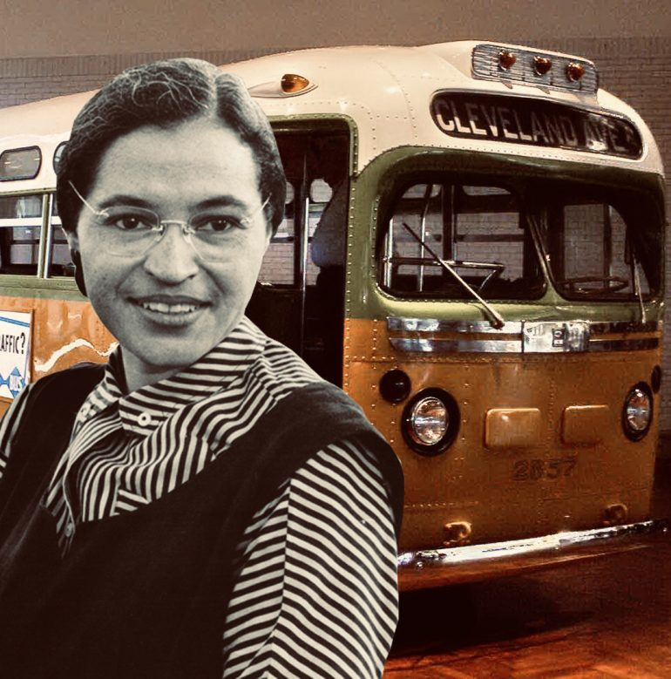 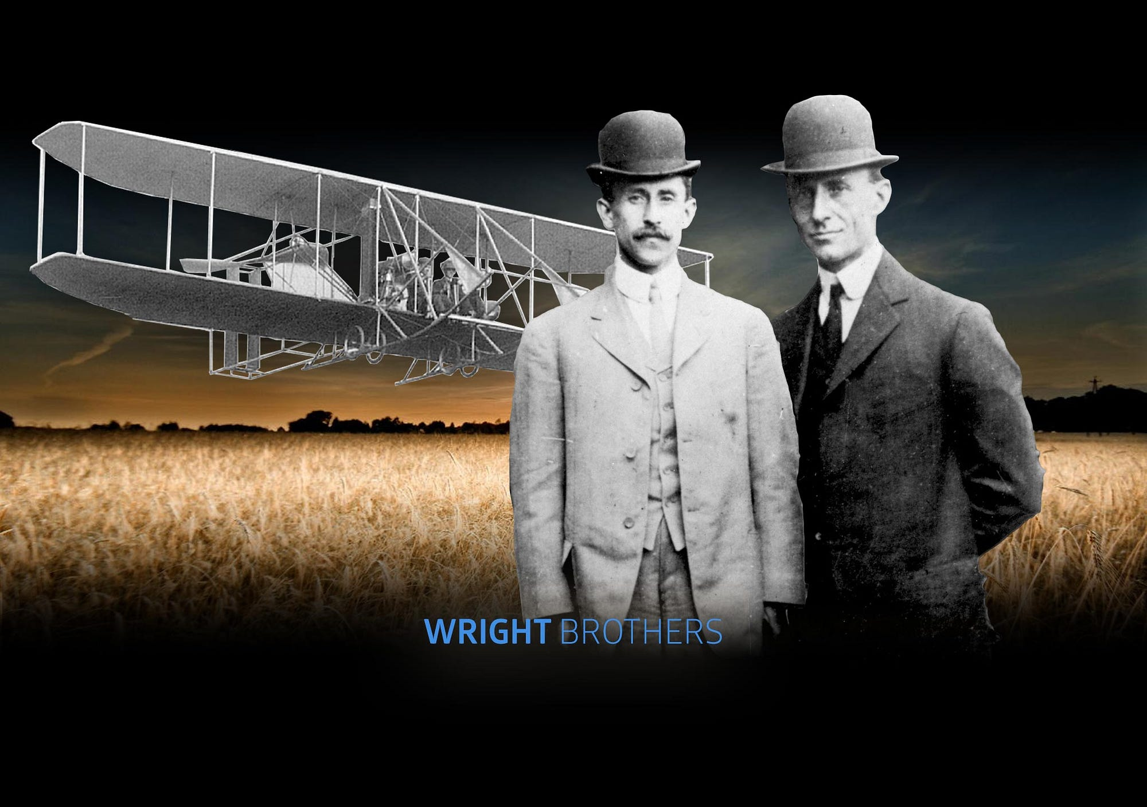

**The Wright brothers-credited with inventing the world’s first airplane.**

**In Spring 2, our Geography topic is called ‘Springing into Life’. We will be learning about where our food comes from, the local features and routes on a map, and how to read simple compass directions.**

**Important days:**

**Trips – Tate Gallery 7th February**

**Saatchi Gallery 1st March**

**Class Assembly - 14th March**

**Parents’ Evening – 20th March**

**Homework is given out on a Friday returned on a Tuesday to be marked. All homework is set on the Google Classroom and it is to be completed in our blue homework books.**

**Please ensure you sign your child’s reading record so that their book can be changed. The children have the opportunity to change their books every day. Spellings will be given out on a Friday with a test the following Thursday.**

**For this half term, PE is on Monday and Thursday. Fair share care and duel win and lose are the themes.**

**Welcome back for the Spring Term! We have lots of new topics to learn about as well as exciting trips planned.**

**Have a look at the different topics we will be studying!**

**Please remember to read every day, it is incredibly important!**

**Year 1 Spring Term 2024**



**In Maths this term we will continue to work on addition and subtraction, and explore two-digit number composition and begin to work on**

**multiplication, division and money.**

**English: This term our books are:**

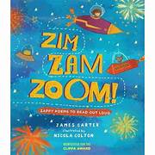 **and** 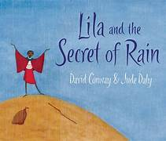 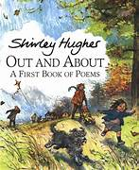

**We will base our learning across English on these books. We will write character and setting descriptions and retell the stories.**

**This spring term in Art and DT, we will be studying**

Our topics in Art and DT this term are Collage and Food.

This half-term, the children will study the work of Henri Matisse and contemporary artist Beatriz 

In Spring 2, the children will learn about healthy eating and do some cooking! Including Taste Education!