**Our Science topic in Autumn 1 is ‘Plants.’ We will be learning about the parts of plants, their functions, requirements for life and growth, water transportation within plants and the life cycle of flowering plants. In Autumn 2, we will be learning about ‘Animal including humans’.**

**In Autumn 1 our topic is ‘Meet the Flintstones! Changes from Stone Age to Iron Age’. We will be learning about Prehistoric Britain.**

**In Autumn 2, our Geography topic is ‘Pollution Solution’ where we will be learning about how we can help biodiversity.**

**English: This term our books are:**

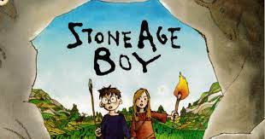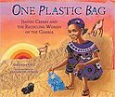

**The writing objectives are diary entries, reports, narrative setting description and retell. The comprehension objectives are prediction, retrieval and inference.**

**Important days:**

**Class Assembly – 9th November**

**Parents Evening – 7th November**

**Christmas Play – 14th December**

**Homework is given out on a Friday and must be returned on a Tuesday so it can be marked.**

**All homework is set on the Google Classroom and it is to be completed in our homework books.**

**Reading books are changed when the children have finished the book. Please sign your child’s reading record so that their book can be changed.**

**Spellings will be given out on a Friday with a test the following Thursday.**

**For this half term, PE is football with Arsenal. PE will be on Tuesday and Wednesday for this term.**

**Year 3 Autumn Term 2023**

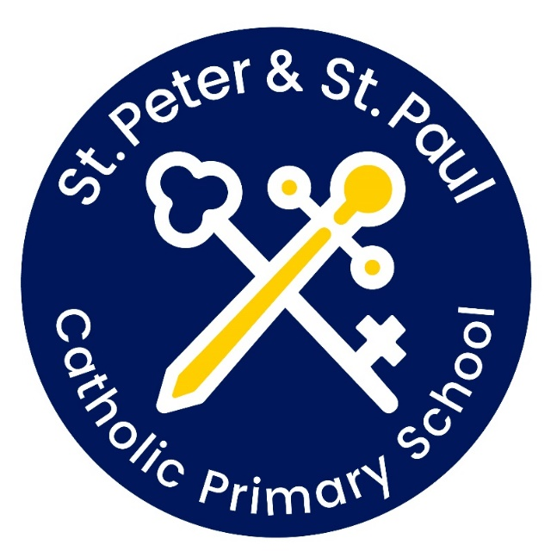

**Our Art and DT topic in Autumn 1 is ‘We are painters’. We will be looking at primary, secondary and tertiary colours; the colour wheel and how to create tones and mood. Our artist focus is Paul Klee.**

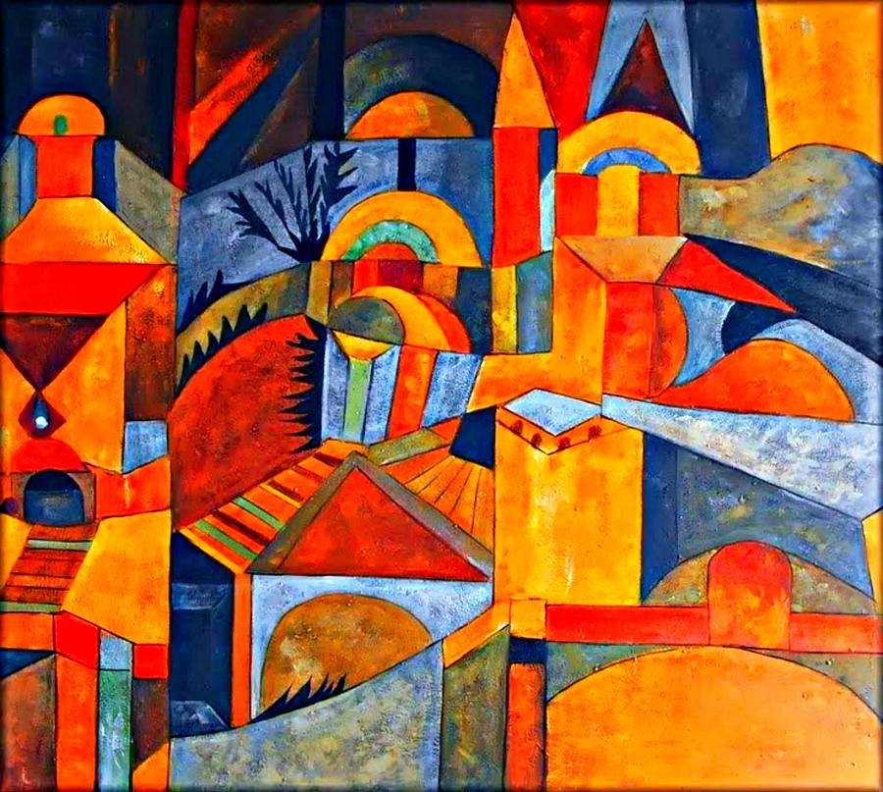

**In Autumn 2, we will be learning all about collage – shapes and patters.**

**This term in Maths we will be looking at number and place value of 3-digit numbers. We will be learning how to add and subtract numbers with up to 3-digit numbers using the column method. By the end of the term, children will learn multiplication and division of 2, 4 and 8 time tables and their relationship.**

**Our topics for RE this term are: ‘The Christian Family’ and ‘Mary, Mother of God’. In other faiths, we will be learning about Jewish Passover and what it means to be Christian, Muslim or Hindu in Britain today.**

**Welcome to the Autumn Term! We have lots of new topics to learn about as well as exciting trips and visitors planned.**

**Have a look at the different topics we will be studying!**

**Please remember to read every day, it is incredibly important!**

