Spring Term 2024
Maths
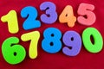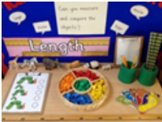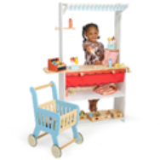

Spring 1  Reception will continue to learn how to count beyond 20 and to add and subtract within 5. They will be introduced to units of measure and the language of comparing: less /more/ longer/ shorter  In Nursery children will be learning about the cardinal principle (the last number is the amount of objects when counting) and comparing groups of up to 5 objects. | Spring 2  This half term the children in Reception will be learning their number bonds some will be adding and subtracting to 10 and 20  In Nursery we will continue with numbers to 10 and forming digits. Children will be thinking about real life maths problems including being shopkeepers in Biscuit Bear’s Bakery.
Literacy Focus Texts
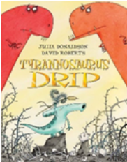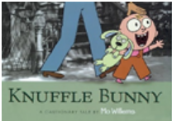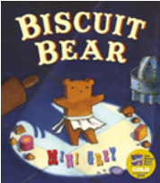

Spring 1 | Spring 2
We will be continuing in Reception to learn level 3 digraphs and trigraphs.  Nursery will be continuing with phonics at level 1 which is sound recognition and attention skills as well as learning about stories in digital and media forms. | This term the children in Reception will be beginning to write in sentences with full stops and capital letters. The children in Nursery will be using their memory of story to retell and recount and perform, interpret and invent based on what they have seen and heard.

A Message from the Teachers
Welcome to Spring Term!

We are looking forward to another busy and fun packed term!
Thank you for your excellent support during the Autumn. Remember the team are always here to answer and questions or queries. If you have a new Nursery child or your still haven’t managed to access it, please do access our Google Classroom where you will find summaries of our weekly learning journeys, pictures and videos. The Wednesday Word is posted weekly to help you in home worship with your child.
All assemblies are also uploaded onto the Google Classroom.

Reminders:

Cookery contribution £3 per half term please give this to an adult at the door in the morning.

Trips and permission for trips is via Parent Pay

Remember no earrings or jewellery allowed.

How Can My Parent Help Me?
Talk: Encourage your child to listen to what others have to say without interrupting, and to talk about their interests. Access the website Tiny Happy People to see great activities to support your child’s early development
Reading: Your child’s reading book (Rhino/Bug Club Reader) will be sent out on Wednesdays.
The library books to share with your child are changed on Fridays. Please read to your child every night before bed. They will not be able to independently read their Friday books.
Home Learning: Every Friday I put of the week’s learning and supporting activities to try at home on our Google classroom. It is very important you and your child can access this.
Sleep: Encourage good practices with regard to exercise, hygiene and sleep which can contribute to good health.
PE
Please send your child in PE kit into school on Thursdays

Curriculum Overview for Spring Term
Spring 1 | Spring 2
Personal, Social, and Emotional Development:


Choices and Consequences Thinking About Others
Communication and Language:
These are the themes for our role play and talk topics across the EYFS phase during Spring

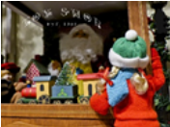
Travel Agents/ The Toy Shop/ Biscuit Bear’s Bakery /Time Machine!

Physical Development:

Negotiating Space Using Apparatus Safely

Understanding the World:
In Reception and Nursery we will be learning about the four seasons and changes in the weather. In Spring 2 both classes will learn about dinosaurs and what the Earth was like before humans.



RE
Spring 1 | Spring 2
Getting to Know Jesus  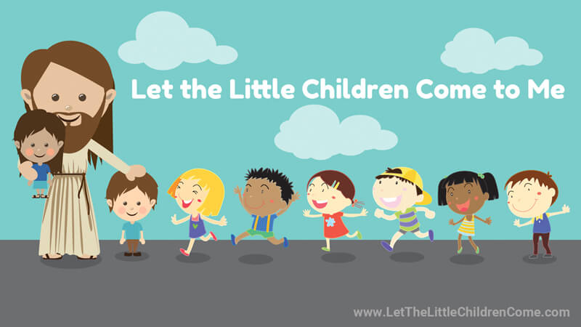 | Sorrow and Joy  

Expressive Arts and Design
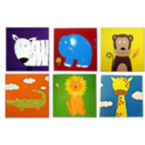  Reception African Animals  Nursery Jungle Animals | 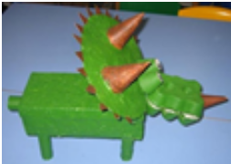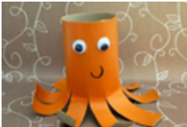  Reception dinosaur junk models  Nursery animal junk models
DATE FOR YOUR DIARY:

London Zoo trip on 22nd February 2024 £10 payable on Parent Pay

Reports go home on the 19th March 2024

Parents evening 20th March 2024

Spring Term EYFS Assembly is on 21st March

