**English: This term our books are:**

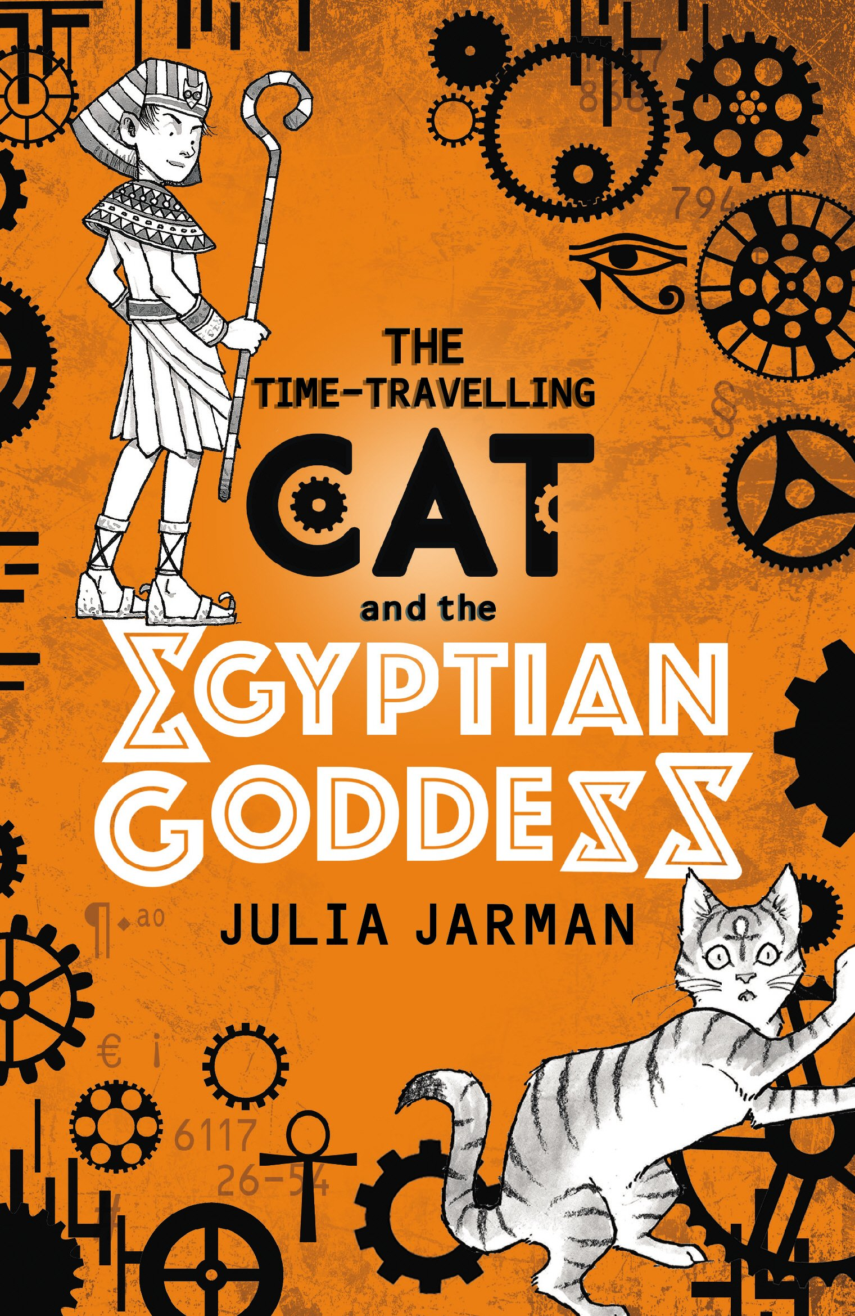 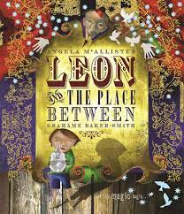

**The writing objectives are narrative story writing, alternative endings, plays and poetry. The comprehension objectives are summarising, vocabulary and complex inference.**

**Important days:**

**Our class assembly is on 29th February 2024.**

**Parents evening will take place on 29th March 2024.**

**Homework is given out on a Friday and must be returned on a Tuesday so it can be marked.**

**Spellings will be given out on a Friday with a test the following Friday.**

**All homework is set on the Google Classroom and it is to be completed in our homework books.**

**Reading books are changed every Thursday. Please sign your child’s reading record so that their book can be changed.**

**For this half term, PE is Salsa. PE will be on Tuesdays and Fridays.**

**Our Science topic in Spring 1 is ‘Geology Rocks.’ We will compare and group different kinds of rocks, describe how fossils are formed and recognise that soils are made from rocks and organic matter. In Spring 2, our topic is ‘Let there be light.’**

**Our topics for RE this term are:**

* **The Sacrament of Reconciliation**

* **Celebrating Mass.**

**This term in Maths we will be looking at multiplication and division (continued), measurement, money, statistics, length/perimeter and fractions.**

**Our Art and DT topic in Spring 1 is ‘We are sculptures’. We will be looking at clay techniques. Our focus artists are Henry Moore and Simone Leigh.**

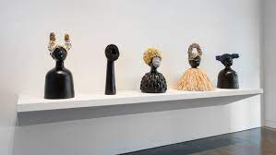

**In Spring 2, our topic is ‘We Are Cooks.’**

**In Spring 1, our topic is Walk like an Egyptian! We will be learning about the achievement of the Ancient Egyptians, River Nile, Pyramids, Gods and beliefs, Pharaohs –Tutankhamun and Hatshepsut, and The Nubian Pharaohs of Kush.**

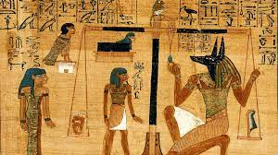

**In Spring 2, our Geography topic is ‘Spain’. We will be learning about Spain as a major European country.**

**Welcome back to the Spring Term! We have lots of new topics to learn about.**

**Have a look at the different topics we will be studying!**

**Please remember to read every day, it is incredibly important! You should also practise recalling your times tables (2, 3, 4, 5, 8 and 10)**

**Year 3 Spring Term 2024**



