

Summer Term
Maths
Summer 1  Tremendous 10  Recognising and Ordering Numbers  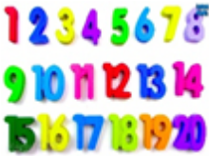  In Nursery the children will be becoming very familiar with numbers to 10  This term in Reception we will be ensuring all children have a solid grasp of number to 20.  We will also be revising number bonds and counting up to 100 | Summer 2  Sequences Odd and Even Numbers  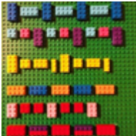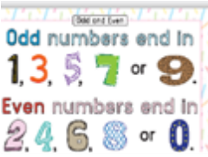  In Nursery the children will practise making sequences  In Reception during this half term I will introduce Reception to the concept of odd and even numbers. We will look at patterns in numbers- for example what happens when we count in 2s and 5s. We will also be weighing and measuring.
Literacy

Summer 1  Power of Reading Texts  Nursery Reception  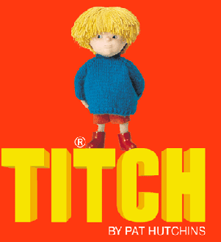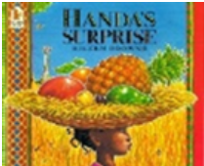 | Summer 2  Power of Reading Texts  Nursery Reception  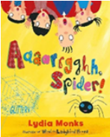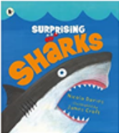

A Message From The Teacher
Welcome to Summer Term!
We have an exciting last term full of trips and exciting events as well as learning to look forward to. Thank you for your continued support; it is very much appreciated.

Miss Manzone and the EYFS Team

How Can My Parent Help Me?
Talk: Encourage your child to listen to what others have to say without interrupting, and to talk about their interests. Encourage speaking in full sentences. Introducing new vocabulary is also very helpful especially the vocabulary around our topics.
Reading: When reading stories check children are enjoying the story and are active in asking questions and understanding what was read. Your child’s Rhino Reader in Reception will be sent out on their specific day. The library books are changed on Fridays in Reception. Try to spot the phonic sounds they know as well as tricky words in their library books, even though these are books you will need to read to them. Nursery children can change their library book when they have finished and enjoyed it with you at home. The library books in Nursery are changed once a week. Please fill in the reading record to let us know what your child has read or had read to them at home.
Home Learning: Every Tuesday I will send out a newsletter and on Fridays a pictures and supporting activities to try at home on our Google classroom.
Sleep: Encourage good practices with regard to exercise, hygiene and sleep, which can contribute to good health.

Curriculum Overview for Summer Term
Personal, Social, and Emotional Development: Families and The World We Live In | 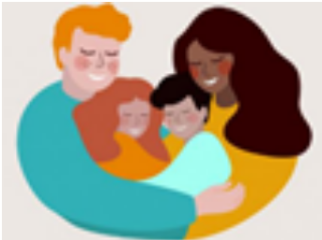
Communication and Language:  Shopkeepers  What Does a Plant need to Grow?  We are Scientists  Poetry | 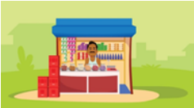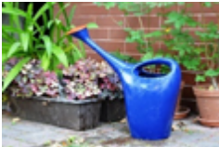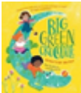
Physical Development: Dance Team Games | 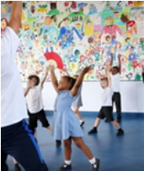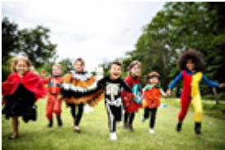
Understanding the World:  Healthy Lunch Box  Tropical Fruit Salad  Animal Homes Life Cycles | 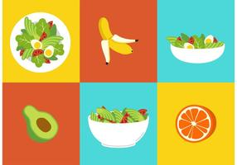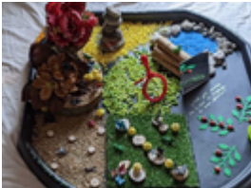
Expressive Arts and Design:  Commotion in the Ocean  Mad about Minibeasts | 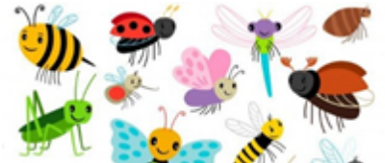
R.E
The children have daily RE teaching, worship, singing and prayers in class. In EYFS we have a weekly community collective worship on Fridays We listen to bible stories and discuss the liturgical year. In addition, we have a whole school assembly and hymn practice once a week with Ms Peters where the children have religious instruction and hymns. The Pupil Chaplaincy Team often come into EYFS to deliver liturgy and prayer. We are lucky to have a school chapel which Reception visit at least once every half term.

R.E
Summer 1: New Life   The children will begin to understand that we celebrate Easter because Jesus rose from the dead. They will be taught that at Easter we celebrate Jesus is with us. They will come to know the story of Jesus going back to his Father in heaven. The will also think of ways to show our love for Mary. | Summer 2: Our Church Family 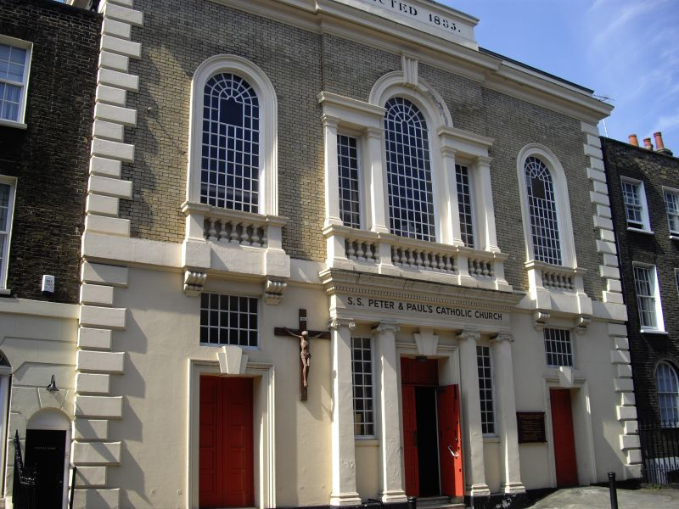  During this half term the children will experience that a church is a special place where God’s People gather to pray. They will come to know that Sunday is a special day for the Church family who come together to celebrate. They will reflect on their friendship with Jesus through Baptism.
Trips and Reminders
We Are visiting The Natural History Museum on the 3rd May to consolidate our learning on dinosaurs in Spring Term.
During the second half of Summer we will visit Kew Gardens -date TBC.
I am trying very hard to organise a trip to Minnis Bay- watch this space.
P.E: Our P.E. lesson is on Thursdays and is taken as a whole phase.
Lunch Time: During lunch we encourage the children to have conversations and to take turns and listen to each other. Lunch is an excellent opportunity to encourage healthy eating and learn the names of different types of food. We ask the children to describe flavour and textures and discuss where our food comes from. We constantly reinforce sitting skills at the table for better posture and table etiquette. We also help children to become independent when holding their cutlery and in cutting up their food.
Uniform reminder: Please label all uniforms, spare clothes, coats, black or navy trainers with velcro and bags with your child’s name. Jewellery is not part of the school uniform and needs to be removed after the weekend. Please provide a spare set of clothes, wet wipes, tissues and nappy bags for wet clothes. Remember to include socks and pants!
Thank you ☺

