Headteacher:

Tracey Peters



Friday 20th September 2024

Dear Parents/Carers,

We have come to the end of our second full week of this academic school year and it has certainly been packed with excitement and learning!

Prayer Life of the school:

Wednesday afternoon we were hosts to the Deanery Mass for all the Catholic schools in Islington. It was a lovely occasion with Bishop Nicolas Hudson celebrating mass with the different parish priests, followed by refreshments back at the school. The children who represented the school singing and welcoming our guests wore their badges with pride and received many comments on their politeness and their lovely welcoming smiles.

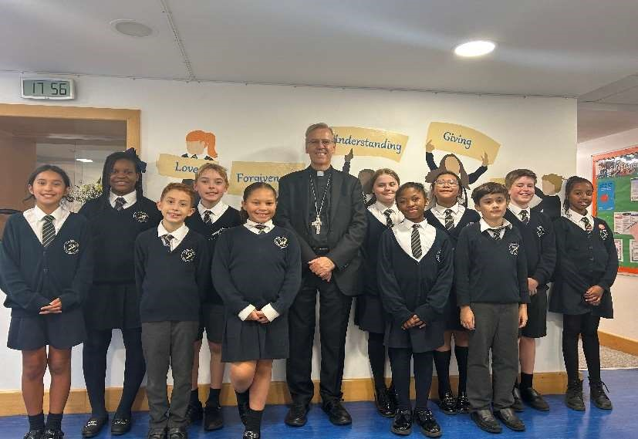

# Curriculum Meetings

You are warmly invited to a curriculum meeting to meet your child’s class teacher and to see what learning opportunities have been planned for them this term. We strongly recommend that you attend and be ready with any questions. Times are as follows:

Monday 23rd September 8:30am Year 6 Sapphire Class

Tuesday 24th September 8:30am Year 5 Ruby Class

Tuesday 24th September 2:40pm Year 4 Moonstone Class

Wednesday 25th September 8:30am Year 2 Emerald Class

Wednesday 25th September 2:40pm Year 3 Jet Class

Thursday 26th September 8:30am Year 1 Diamond Class

Friday 27th September 8:30am Reception Coral Class

Friday 27th September 2:40pm Nursery 2 Amethyst Class

Friday 4th October 2:40pm Nursery 1 Pearl Class

# Reception 2025 -2026

Admissions for Reception Class are open from 1 September with information on how to apply in the LBI letter attached. We are happy to give school tours and are grateful for any recommendations to friends and family in the community of our lovely school.

# Kittle Photographs

Kittle will be in on Monday 23rd September to take individual and sibling photographs. Please come to school in full uniform if it is your PE day please bring your kit to change into.

# Dogs in the Playground



We love to meet your cute and furry family members, but please ensure they are held in the playground and not on the floor as they can scare the children. Larger dogs need to stay outside. Many thanks.

# New School Parliament

Year 6 made wonderful, thoughtful presentations in Tuesday’s assembly. A huge welldone to all the children who wrote a speech and were brave enough to deliver it to the whole school! It was a very tough decision, but eventually the staff decided that. Conor Green would be was appointed our new Prime Minister and J’ennae Gordon would be Deputy Prime Minister.

. 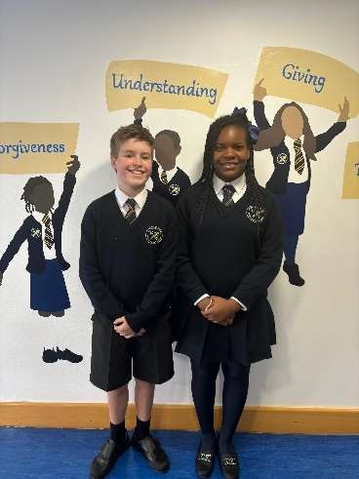

# House Captains

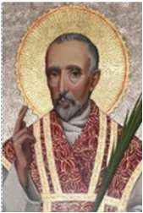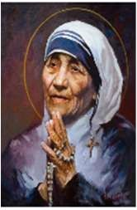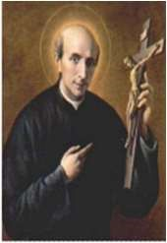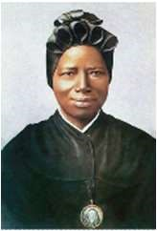

The children in the school voted for our House Captains who have now been appointed:

St. Vincent Pallotti: Eliana Adams and Edoardo Moreti

St. Teresa of Calcutta: Delina Simon and Ethan Izquierdo

St. John Southworth: Aryana Sayahy and Florencia Di Domenico Cano

St. Josephine Bakhita: Hannah Cunningham and Allison Erazo Concha

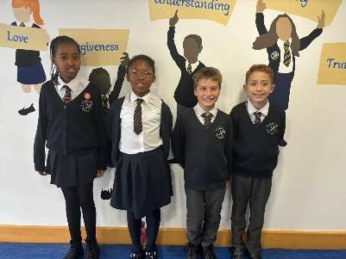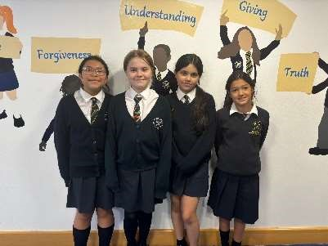

# Head Teacher’s Award

Headteacher’s Awards on Tuesday 10th September went to:

Nursery Mary and Dottie

Reception Asapha and Daisy

Year 1 Tristan and Aurora

Year 2 Holly and Mason

Year 3 Wayne and Violet

Year 4 Zara and Harrison

Year 5 Kelsi-Mai and Elnathan

Year 6 Jonathan and Alison

On Tuesday 17th September the awards went to:

Nursery Owen and Leonardo

Reception Milanni and Haven

Year 1 Oliver and Florence

Year 2 Uwaila and Kyron

Year 3 Raiya and Davina

Year 4 Francesca and Alfie

Year 5 Fidele and Eady

Year 6 Selina and Adriana

Congratulations to these children for their hard work which has impressed their teachers this week.

# Librarians

We have recently refurbished our Key Stage 2 Library which now, has artist commissioned work and a large donation of books from The Literacy Trust and is as beautiful as our Key Stage 1 library. A big thank you to our diligent librarians Sofia and Darcy who are keeping both libraries in good order.

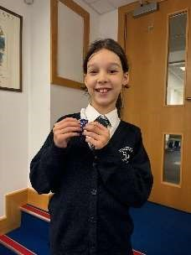 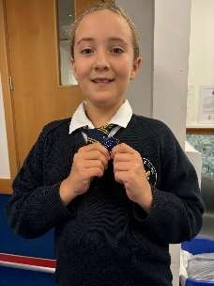

Black History Month

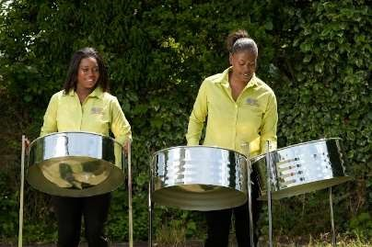

As part of our celebrations for Black History Month, we will be having another visit from The Steel Pan Agency on the 22nd of October. Our resources are stretched but we still want our children to continue to experience the wide range of workshops, trips and visitors that enhance your child’s education. We are asking for a contribution of £2 per child to go towards the cost of the workshop. If you could make the payment on ParentPay, it would be greatly appreciated.

# PTA

If you are a new parent or even a parent with children who have been in the school for a while and you are interested in joining our PTA, please let Miss Manzone know as we are looking to recruit members and outline an exciting year ahead of fundraising events.

# Attendance and Punctuality

As you know attendance across the country has fallen following the Covid pandemic. Schools across the country are trying hard to ensure children make the most of every moment of their school days. Mindful of this, we have started new initiatives at St. Peter and St. Paul to raise school attendance. We now have two boards in the school which show clearly the attendance figures of each class and we have appointed two new attendance captains: Fergus and Selina from Year 6. The class who wins the most certificates for having the highest attendance that week will earn themselves a pizza party at the end of term.

Please ensure you bring your child to school every day and you are on time. The gates open at 8:30am and close at 8:45am. After this, you are asked to sign the late book.

Term time holidays are now subject to fines due to the new government guidelines.

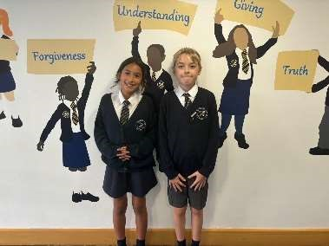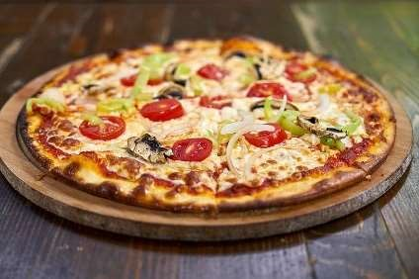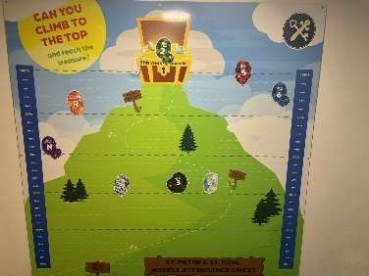

A huge congratulations to Sapphire Year 6 96.18% and a big congratulations to Amethyst who had no lates this week. Keep up the hard work!



# The Gospel on Sunday

In this Sunday’s Gospel, Jesus once again reminds the disciples – and us too – that a life of service is the best life to live. Life can be so busy, full of the things we really like doing, that it’s quite easy to forget about serving others.

“Jesus leads us to go out from ourselves more and more, to give ourselves and to serve others.” Pope Francis

“J “Jesus leads us to go out from ourselves us to go out from ourselves more and

Have a good weekend!

Kind Regards,

Miss T Peters and Miss J Manzone