
Nursery Autumn Term 2024
Maths

Autumn | Autumn 2
1,2,3 | Shapes
Literacy

Autumn 1 | Autumn 2
Focus Texts | Focus Texts

A Message From The Teacher
Welcome to Autumn Term!
We are looking forward to a busy and fun packed term! As we settle into the new look Nursery please keep up to date with news on our Google classroom and look in your child’s bag every night for letters. Please label all your children’s clothing and send in spare sets of clothes every day in case of accidents. Remember no jewellery is allowed in school besides a wristwatch.

How Can My Parent Help Me?
Talk: Encourage your child to listen to what others have to say without interrupting, and to talk about their interests.
Reading: Your child’s reading book (Rhino/Bug Club Reader) will be sent out on Wednesdays. This will start in the second half of Autumn term
The library books to share with your child are changed on Fridays. Starting this week. Please read to your child every night before bed. They will not be able to independently read their Friday books.
Home Learning: Summaries and photos will be available on our Google classroom. Passwords will follow.
Sleep: Encourage good practices with regard to exercise, hygiene and sleep, which can contribute to good health.
PE
Please send your child in PE kit into school on Thursdays.
Trips
TBC
Cooking
We try to do a cooking activity weekly. There is a £5 per term voluntary contribution. Please give it to us any morning in an envelope labelled cooking money.
Nature Kitchen
Please collect things such as chestnuts, conkers and pinecones for our nature kitchen

Curriculum Overview for Spring Term:

Personal, Social, and Emotional Development
Autumn 1 | Autumn 2
Marvellous Me | Reach for the Stars
Communication and Language:

Who Lives in My House? | What Can I See in the Sky?
Physical Development:

Parachutes | Working with my Partner

RE
Autumn 1 | Autumn 2
God’s Word  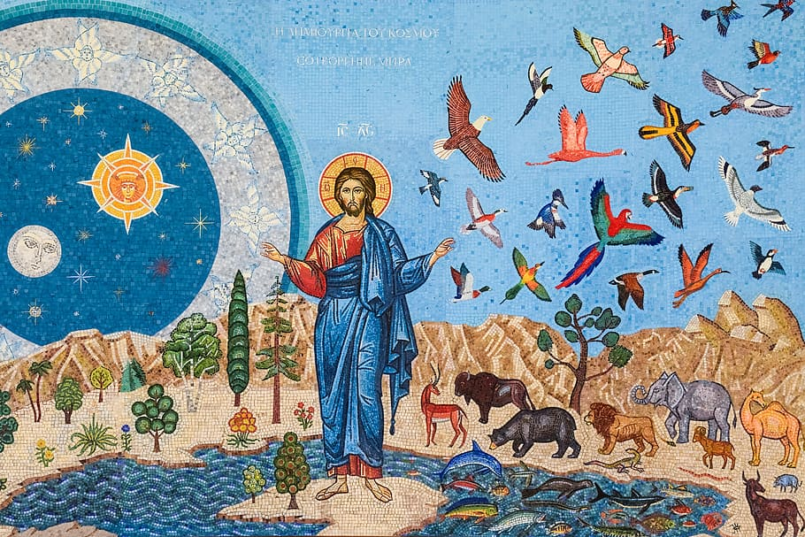 | God’s Family  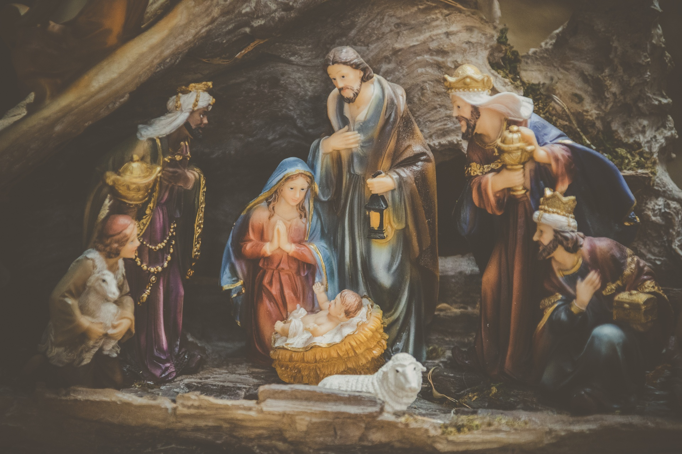

Expressive Arts and Design
I Can See a Rainbow | Starry Night
Understanding the World:
What Can my Body Do? | Jobs People Do

