
Autumn Term 2024
Maths

Autumn | Autumn 2
Numbers to10  Subitising to 5 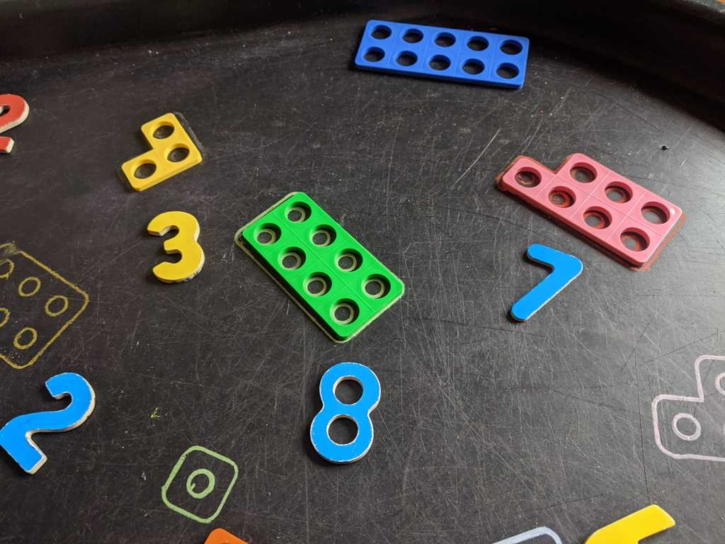 | 2D and 3D Shape  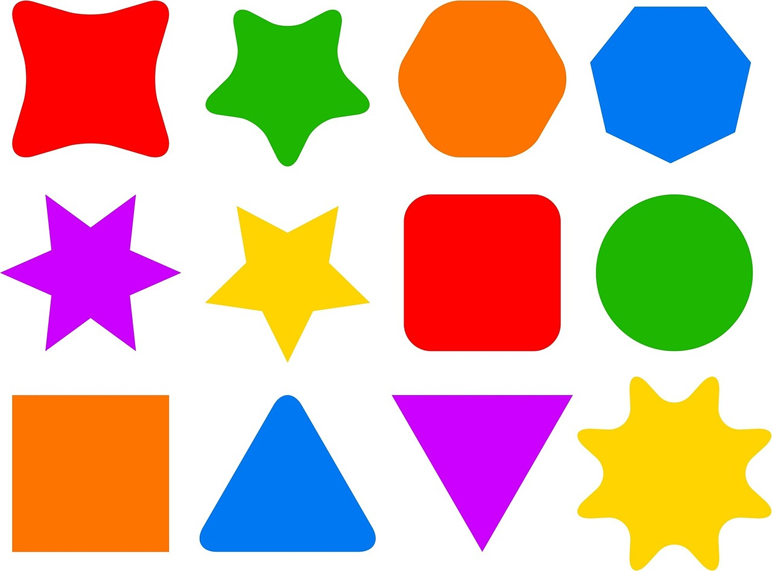
Literacy

Autumn 1 | Autumn 2
Focus Texts | Focus Texts

A Message From The Teacher
Welcome to Autumn Term!
We are looking forward to a busy and fun packed term! As we settle into Reception please keep up to date with news through Class List , Google Classroom, the weekly newsletter and letters in your child’s bag. Please label all your children’s clothing and send in spare sets of clothes every day in case of accidents. Remember no jewellery is allowed in school besides a wristwatch.

How Can My Parent Help Me?
Talk: Encourage your child to listen to what others have to say without interrupting, and to talk about their interests.
Reading: Your child’s reading book (Rhino/Bug Club Reader) will be sent out on Wednesdays. This will start in the second half of Autumn term
The library books to share with your child are changed on Fridays. Starting this week. Please read to your child every night before bed. They will not be able to independently read their Friday books.
Home Learning: Summaries and photos will be available on our Google classroom.
Sleep: Encourage good practices with regard to exercise, hygiene and sleep, which can contribute to good health.
PE
Please send your child in PE kit into school on Thursdays.
Trips and Visits
There will be a visit from a Steel Band in October a contribution of £2 can be made on Parent Pay. Reception will be visiting Little Angel Theatre on the 6th of December to see Rosie Robin and the Christmas Post. A payment of £10 is asked for this. Please do pay for your trips if you can as it will inhibit the number we can attend if we do not get enough contributions.
Cooking
I try to do a cooking activity weekly. In order to do this I ask for a £5 per term voluntary contribution. Please give it to me any morning in an envelope labelled cooking money.
Nature Kitchen
Please collect things such as chestnuts, conkers and pinecones for our nature kitchen which I try to keep seasonal where I can.

Curriculum Overview for Spring Term:

Personal, Social, and Emotional Development
Autumn 1 | Autumn 2
Looking After Me/ | I can be a Good Friend
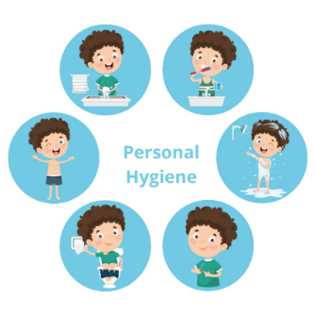
Communication and Language:

Speaking About Me | Festivals Around the World
Physical Development:

Dough Disco | Perfect Parachutes

RE
Autumn 1 | Autumn 2
God’s Word  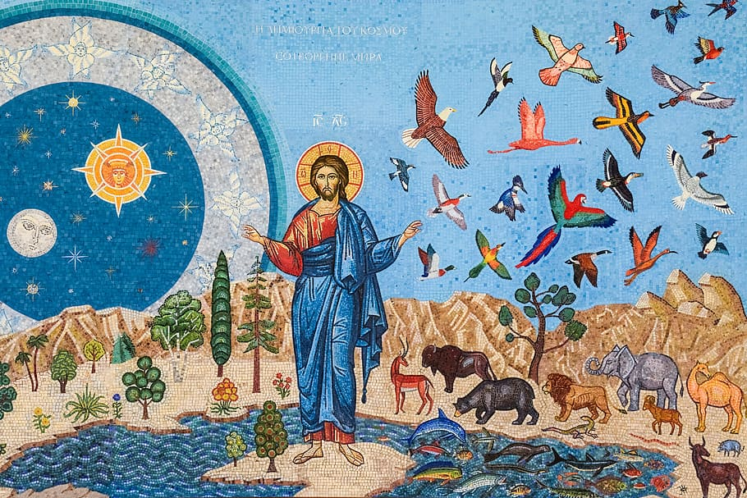 | God’s Family  

Expressive Arts and Design
A Taste of the Caribbean | Repeating Patterns
Understanding the World:
My Body | People Who help us
 | 