Diocese of Westminster
Catholic Primary Schools
Supplementary Information Form 2024-2025 Nursery Application
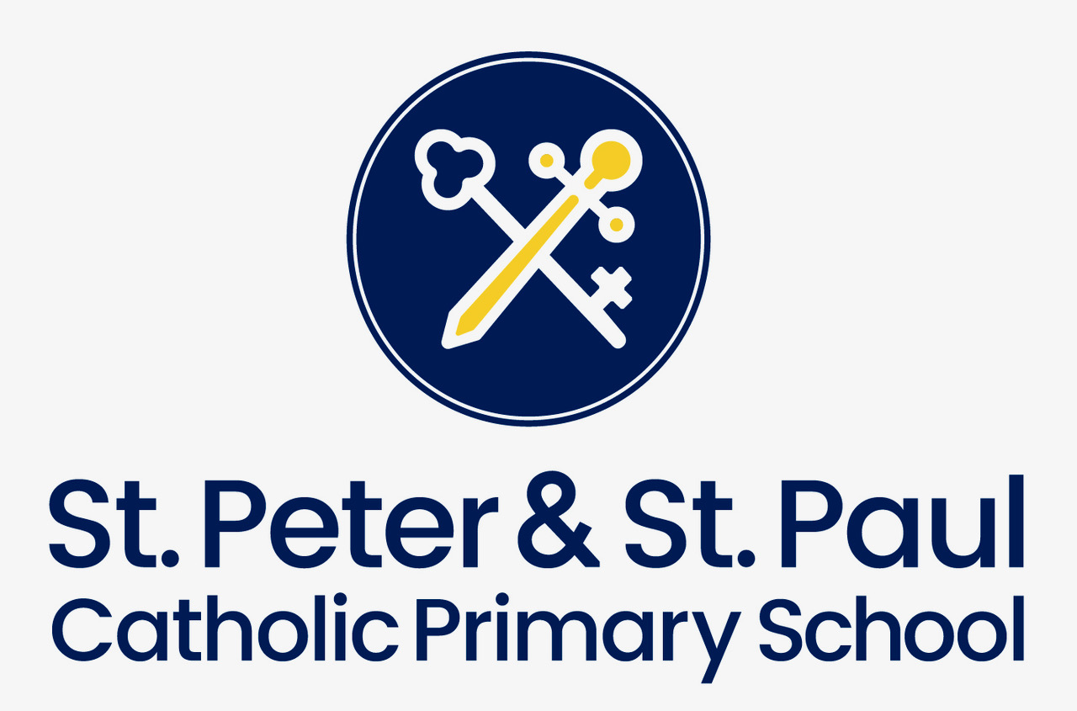

St Peters and St Pauls Catholic Primary School
Compton Street, London, EC1V 0EU Telephone: 0207 2530839

Child’s surname:  Child’s first name(s): | Preferred name:
Home Address: | Date of Birth:  Age in Sept 2023:
Postcode:
Child’s Details

Parent/Carer Details
Parent/Carer(s) name(s):

Address (if different from above):
Telephone numbers:
Email Address:
Sibling at the School | Name: Year Group:
Previous Nursery (if any):

Details of Religion where applicable
Religion of child:  (Please tick) | Catholic | Other Christian (name of denomination ) | Other faith
Catholic Parish you live in (where applicable):
Church your child was baptised (where applicable)

Faith reference or letter

I confirm that I have read and understood the Admissions Policy and that the information I have provided is correct. I understand that I must notify the school immediately if there is any change to these details and that should any information I have given prove to be inaccurate that governors may withdraw any offer of a place even if the child has already started school.

Signed……………………………………… Date…..…………………

Please note:

- Applicants from Christian denominations and other faiths may attach either a certificate of baptism or a letter from their minister or religious leader, confirming membership of that faith community.

Checklist:

Have you enclosed the following documents (please tick):

Birth Certificate

Two proofs of address in the last 3 months to include Council Tax Bill/

Rent Agreement / Mortgage Statement / Child Benefit Letter / GP Letter

Copy of Baptism Certificate or faith reference (where available)

Does your child have any educational needs and include any evidence

(where applicable)

The school is committed to protecting the information provided by parents/carers and using it only for the purpose for which it was obtained. For information on the school’s Privacy Notice please read the attached ‘Admissions Privacy Notice.’ Further information may be obtained by visiting the school website at www.stpetersandstpauls.islington.sch.uk or by contacting Maria Bennett, DPO

ADMISSIONS PRIVACY NOTICE FOR
St Peters and St Pauls Catholic Primary School is a data controller for the purposes of the Data Protection Act 2018 and is committed to dealing with your information safely and securely. We need to collect and share information in order to fulfil our obligations as an admission authority. We take our responsibility to protect your data seriously and we will use it in accordance with the legal requirements of the Data Protection Act 2018.

We will comply with the School Admissions Code, which has the force of law. In respect of in-year admissions, Islington Local Authority is the admissions authority for this school. The information you provide to us on your Supplementary Information Form (SIF), any supporting papers or appeal documentation you provide will be used to:

- Process your application
- Consider Admission Appeals
We may also use this data for the following purposes:
- Forward planning as part of school budget, forecasting and reorganisation proposals
- To assist in the development of policy proposals
- For the prevention and/or detection of crime or fraud
- For research and statistical purposes when we will ensure that statistics are developed in such a way that individual children cannot be identified
In order to administer admissions to this school the following information may be collected by us:
- Name and date of birth
- Address where the child ordinarily lives at the time of application, which will be used for distance calculation purposes
- Supplementary information i.e. information on religious affiliation and status
- Parent name and contact details
- Details of baptism and/or Catholic practice
- Information on parish of residence.
Agencies we will share the information with:
- The Department for Education, to comply with statutory data collections
- The LA, to verify the information provided so that the admission scheme\process can be accurately administered
- Admission Appeal panels
- The Schools Adjudicator, in response to any objections raised
- In Year Fair Access Panel, where applicable, to enable them to appropriately place complex admissions
- The Local Government and Social Care Ombudsman, when investigating maladministration of school admissions and admission appeals.
School Retention Policy:
The information listed above will be retained securely by the school for 8 years, after which it will be destroyed.

For further information please refer to the Privacy Policy on the School website or contact: Maria Bennett, DPO

