Summer Term 2025
Maths

Summer 1 | Summer 2
Recognising and ordering numbers to 20  sharing and capacity. Ensuring addition and subtraction facts to 5 are deeply understood. | Odd and even numbers  Measures and money  Ensuring deep understanding of numbers to ten (composition) and addition and subtraction to ten.
Literacy

Summer 1 | Summer 2
Focus Texts | Focus Texts
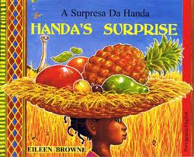  Revision of all Level 3 sounds blending, segmenting and forming all letters properly. Writing simple sentences with full stops. Labels and captions for spider diagrams and cartoons. Using exclamation marks | Revision of all Level 3 sounds, blending, segmenting and forming all letters properly including capitals. Writing simple sentences. Spelling tricky words correctly levels 2 and 3 Writing caption sand own seaside book. Using question marks and writing questions about sharks.

A Message From The Teacher
Welcome to Summer Term!
We have almost reached the end of our learning journey in Reception and I am sure you will agree how much the children have all learnt and grown! This term is a lovely one when we hope to use the outdoor area to full effect with lots of activities outside. Let’s hope for great weather!
Thank you for your continued support.
Miss Manzone ☺

How Can My Parent Help Me?
Talk: Encourage your child to listen to what others have to say without interrupting, and to talk about their interests. Engage in social chat over dinner. Ask them how their day went and listen to them. Help them with vocabulary where necessary. You can scaffold their talk by rephrasing their ideas into full sentences and getting them to say the sentence back to you.
Reading: Your child’s reading book (Rhino/Bug Club Reader) will be sent out on Wednesdays. The library books to share with your child are changed on Fridays. Please read to your child every night before bed. They will not be able to independently read their Friday books.
Sleep: Encourage good practices with regard to exercise, hygiene and sleep, which can contribute to good health.
Eating
Encourage your child to eat with a knife and fork and to sit at a table to eat.
Devices
Always put away electronic devices over dinner and try to limit screen time. Be a good role model with mobile phones by making sure they do not monopolise attention in the household. Give your child your full attention when talking to them.
Jewellery
No jewellery is permitted in school. Please take out earrings or cover over with a plater if new.

Curriculum Overview for Spring Term
Personal, Social, and Emotional Development
Summer 1 | Summer 2
Families | The World I Live in
Communication and Language
Summer 1 | Summer 2
Shop Keepers  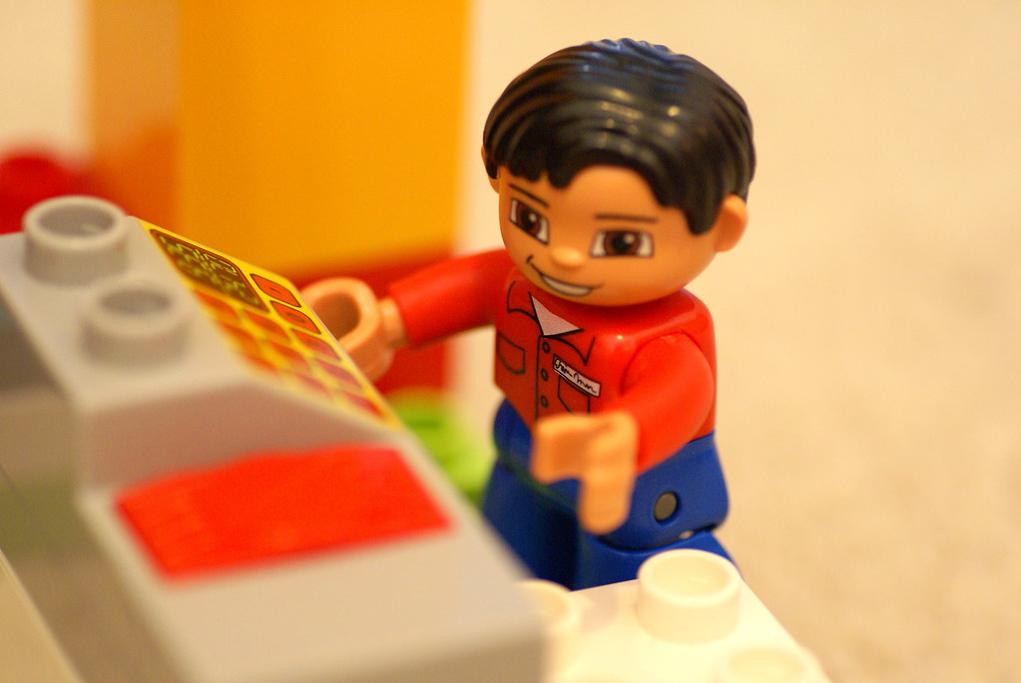 | Pirate Ship  
Physical Development:
Summer 1 | Summer 2
Fill it up! | Wonderful Writing
Understanding the World:
Summer 1 | Summer 2
Tropical Fruit Salad   | Life Cycles

RE
Summer 1 | Summer 2
  New Life |   Our Church family

Expressive Arts and Design
Summer 1 | Summer 2
A Bowl of Fruit  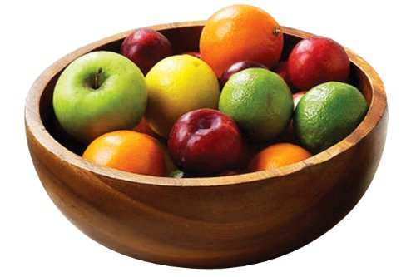 | Yummy Ice Cream  
Trips and Reminders

DATES FOR YOUR DIARY:

16th July Trip to Minnis Bay in Kent –voluntary contribution £10- for ice cream

Class assembly on creation 26-6-25

If you wish to contribute to our cooking fund please give £3 per half term or 50p a week to one of the team.

